1 вариант

The exterior (Внешнее устройство автомобиля)
1. Label the parts of the car (Соотнесите названия частей автомобиля с цифрами. Напишите перевод слов)

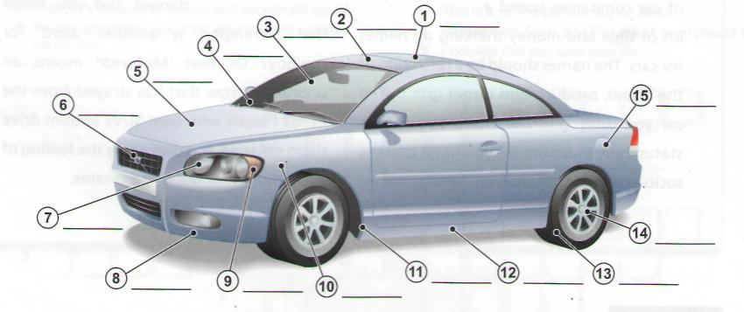
bonnet • front bumper • headlight • indicator • petrol cap or flap • roof • sill • sunroof • tyre • wheel arch • wheel trim • logo • windscreen • windscreen wiper • wing
2. Complete the sentences with words from exercise 1. (Заполните пропуски в предложениях словами из упражнения №1)
- You open the_____ to look at the engine.
- The absorb small impacts in an accident.
- Don't forget to retract the before using the car wash.
- Can you put my suitcases in the , please?
- When it starts raining, you need to switch on the .

3.Read the text and make the tasks after it.

FUEL SYSTEM
The fuel system is designed, to store liquid gasoline and to deliver it to the engine cylinders on the intake strokes in the form of vapour mixed with air. The fuel system must vary the proportions of air and gasoline vapour to meet the requirements of the various operations conditions. The fuel system consists of a tank in which the liquid gasoline is stored, a fuel line, or tube, through which the gasoline can be brought from the tank to the engine, a pump, which pulls the gasoline through the fuel line, and a carburetor, which mixes the gasoline with air. The carburetor is designed to mix each pound of gasoline with 9 to 15 pounds of air under various operating conditions.
BRAKES
It is not necessary to explain the importance of brakes. It is clear that without brakes the car is quite helpless. They must be well and strongly made. It is necessary to give them close and careful attention. There are two sets of brakes, one for ordinary service, called the service brakes, and the other for emergency use, called the emergency brakes. Sometimes both are mounted inside the same drum. Sometimes one is outside and the other - inside The service brake is operated by a pedal. The emergency brake is operated by a lever.

3. Answer the questions:
1. Describe the fuel system.
2. What are the functions of the carburetor?
3. Why the fuel system is used?

4. Fill in missing words:
1. (Топливная система) consists of a (бак) in which the (жидкий) gasoline is stored, a (топливо) line, or tube, through which the gasoline can be brought from the tank to the (двигатель).
2. The carburetor is (создан) to mix each pound of gasoline with 9 to 15 pounds of (воздух) under various operating conditions.
3. It is (необходимо) to give them close and careful (внимание).

5. True or false:
- The fuel system is designed, to store liquid gasoline and to deliver it to the engine cylinders on the intake strokes in the form of vapour mixed with air.
- Sometimes both are mounted outside the same drum.
- They must not be well and strongly made.

2 вариант
The exterior (Внешнее устройство автомобиля)
1. Label the parts of the car (Соотнесите названия частей автомобиля с цифрами. Напишите перевод слов)

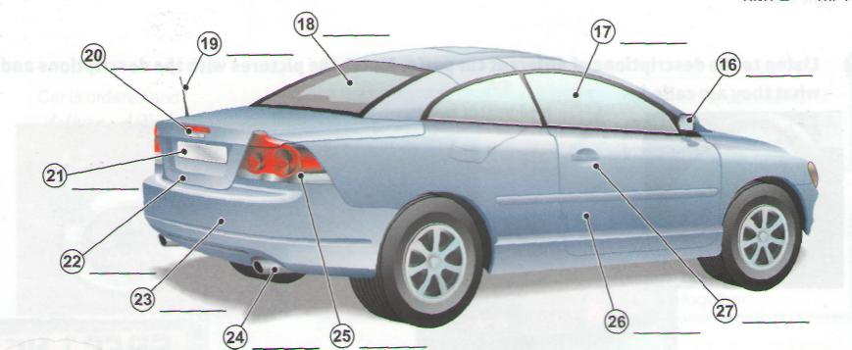
aerial • badge • boot • door • door handle • exhaust pipe • number plate • rear bumper
• rear window • wing mirror • side window • rear light
2. Complete the sentences with words from exercise 1. (Заполните пропуски в предложениях словами из упражнения №1)

- 'What model is that?' 'I don't know, I can't see the from here.'
- It is important to inflate the to the correct pressure for better fuel consumption.
- The Mercedes star is a well-known .
- Open the and let some sun and fresh air into the car.
5. I wish all drivers would use their when they want to turn right or left!

3.Read the text and make the tasks after it.

FUEL SYSTEM
The fuel system is designed, to store liquid gasoline and to deliver it to the engine cylinders on the intake strokes in the form of vapour mixed with air. The fuel system must vary the proportions of air and gasoline vapour to meet the requirements of the various operations conditions. The fuel system consists of a tank in which the liquid gasoline is stored, a fuel line, or tube, through which the gasoline can be brought from the tank to the engine, a pump, which pulls the gasoline through the fuel line, and a carburetor, which mixes the gasoline with air. The carburetor is designed to mix each pound of gasoline with 9 to 15 pounds of air under various operating conditions.
BRAKES
It is not necessary to explain the importance of brakes. It is clear that without brakes the car is quite helpless. They must be well and strongly made. It is necessary to give them close and careful attention. There are two sets of brakes, one for ordinary service, called the service brakes, and the other for emergency use, called the emergency brakes. Sometimes both are mounted inside the same drum. Sometimes one is outside and the other - inside The service brake is operated by a pedal. The emergency brake is operated by a lever.

- Answer the questions:

1. What are there are two sets of brakes?
2. Is the service brake operated by a pedal or by lever?
3. Why the car is quite helpless without brakes?

- Fill in missing words:

1. Sometimes both are mounted(внутри) the same drum.
2. The (стояночный) brake is operated by a (рычаг).
3. It is not necessary to (объяснять) the (важность) of brakes.

- True or false:

- The carburetor is designed to mix each pound of gasoline with 9 to 20 pounds of air.
- It is necessary to explain the importance of brakes.
- The fuel system consists of a tank in which the liquid gasoline is stored, a fuel line, or tube, a pump and a carburetor.

