Преобразуйте слова, напечатанные заглавными буквами в конце строк, так, чтобы они грамматически соответствовали содержанию текстов. Заполните пропуски полученными словами.

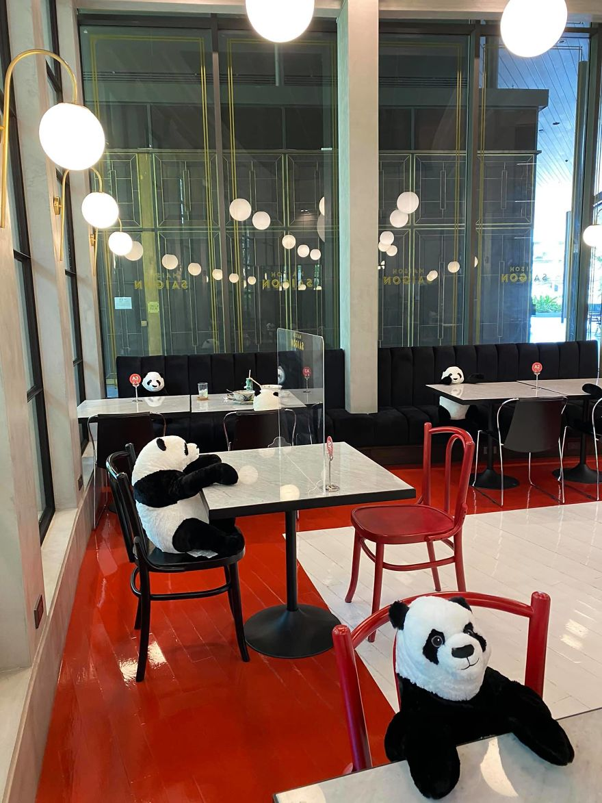 | Restaurant Finds A Genius Way To Help Their Customers  Feel Less Lonely While Social Distancing
  1  2  3  4  5  6 | A lot of places _____________ to open, but there are still some worries and concerns about _____________ social distance between people. Well, recently a Vietnamese restaurant in Thailand _____________ the perfect solution for how to keep their customers apart - pandas!  Maison Saigon placed plush pandas in the restaurant so that people have to sit at a safe distance. Also, if you come to eat alone, you have some company. The rules and regulations ______________ rapidly and most of us _____________ about what to do and how to be safe, so this idea is a charming and smart way to make sure everyone ____________ from the virus.  What do you think of this idea? Would you like to visit this restaurant? | START  KEEP  FIND  CHANGE  CONFUSE  PROTECT

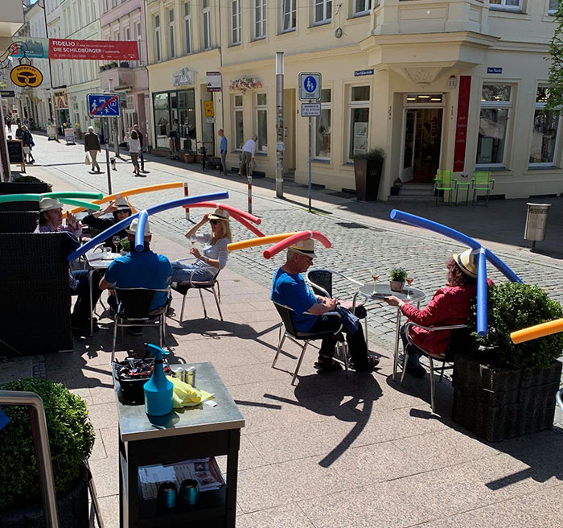 |  | Cafe In Germany Gives Customers Hats With Pool Noodles  To Keep Them Apart
  1  2  3  4  5  6  7  8  9  9  10 | European countries ________________ to slowly come alive again. One of them is Germany, where previous restrictions ________________ now. This is unsurprising as Germany has been regarded as one of the countries that _______________ with the pandemic extremely well.  On 6 May, Chancellor Angela Merkel said that the first  phase of the pandemic ___________________ over,  while __________________ everyone to remain cautious so as not to cause a second wave.  On the same date, the federal government ________________ the lifting of more restrictions which gave an opportunity for restaurants to start working with certain restrictions.  Recently, a cafe in Schwerin called “Café Rothe Schwerin” ________________ its business by _______________ its patrons outside.  The cafe made sure to space out the tables by 1.5m to keep some distance between the customers, which is what every restaurant ought to do. However, the owner of “Café Rothe Schwerin”, Jacqueline Rothe, went the extra mile. She ________________ with up an ingenious idea to make sure the patrons keep their distance - pool noodles! Yup, you read that right. The business is using pool noodles __________________  to customers’ hats to help them with social distancing!  What do you think of this idea? Would you like to visit this restaurant? | START  RELAX  DEAL  BE  ASK  ANNOUNCE  RESTART  SERVE  COME  ATTACH
Keys

A lot of places are starting to open, but there are still some worries and concerns about keeping social distance between people. Well, recently a Vietnamese restaurant in Thailand has found the perfect solution for how to keep their customers apart - pandas!

Maison Saigon placed plush pandas in the restaurant so that people have to sit at a safe distance. Also, if you come to eat alone, you have some company. The rules and regulations are changing rapidly and most of us are confused about what to do and how to be safe, so this idea is a charming and smart way to make sure everyone is being protected from the virus.

European countries are starting to slowly come alive again. One of them is Germany, where previous restrictions are being relaxed now. This is unsurprising as Germany has been regarded as one of the countries that has dealt with the pandemic extremely well.

On 6 May, Chancellor Angela Merkel said that the first phase of the pandemic was over, while asking everyone to
remain cautious so as not to cause a second wave.

On the same date, the federal government announced the lifting of more restrictions which gave an opportunity for restaurants to start working with certain restrictions. Recently, a cafe in Schwerin called “Café Rothe Schwerin” has restarted its business by serving its patrons outside.

The cafe made sure to space out the tables by 1.5m to keep some distance between the customers, which is what every restaurant ought to do. However, the owner of “Café Rothe Schwerin”, Jacqueline Rothe, went the extra mile. She came with up an ingenious idea to make sure the patrons keep their distance - pool noodles! Yup, you read that right. The business is using pool noodles attached to customers’ hats to help them with social distancing!

