5 класс
1)
1. My friends usually…….. football after school.
a. plays b. play c. playing
2. I…… in the lake next summer.
a. swim b. swam c. will swim
3. The children…… at the Zoo yesterday.
a. was b. were c. are
4. His dog is….. than my dog.
a. big b. bigger c. the biggest
5. I think, roses are very….. flowers.
a. beautiful b. more beautiful c. the most beautiful
6. I have…… little sisters.
a. a b. an c. two
7. Mike is a very good football……. .
a. play b. playing c. player
2) Choose the right point.
- David is ………
- Playing the guitar b) talking to her friend c) sitting in the playground
- Sally is eating her lunch. She is eating ……
- An apple b) a sandwich c) a banana
- Tom and Lee are playing with a ball. They always play …..
- Football b) basketball c) badminton
- What is Peter doing?
- He is dancing. b) He is talking to his friend. c) He is reading a comic.
- Jenny is in the playground. She is ……
- Eating her lunch b) talking to her friend c) playing with her friend
- Sam and his friend sometimes play ……..
- Play basketball b) play football c) tennis
6класс
1)Read the text. New Friends.
Mr Hill has not got a family, but he has got two pets: a cat and a dog. The dog`s name is Sebastian and the cat`s name is Mozart.Every day Mr Hill gets up at half past six and takes Sebastian for a walk. But Sebastian is very big and lazy. They go to the park near Mr Hill`s house. Every morning it is the same. Mr Hill`s says, "Run, Sebastian! Go, boy! Catch the ball!" But Sebastian only sits on the grass and looks at the trees. He looks at the sun and he looks at the people.
It is Saturday morning now and Mr Hill is in the park with Sebastian. It is a very nice day. Sebastian is sitting on the grass and and Mr Hill says, “Go, Sebastian! Run, boy!” But Sebastian can see another dog. And the other dog can see Sebastian.
Now Sebastian is running across the grass. And Mr Hill is running after him. “Sebastian, you crazy dog. Come here!”
Now Sebastian is with his new friend, and the two dogs are playing together. Mr Hill and the other dog`s owner (хозяин) are watching them. Mr Hill says, “OK, Sebastian. Let`s go home now.”
“Well,” says the young woman, “I`m going home, too. We can talk together.”
“Oh, that`s a good idea. But listen, there`s a very nice café near here. We can go there for a cup of coffee and our dogs can play.”Yes, all right. I`ve got some time.”
“Great. Em…. My name is …. ”
“Hill.”
“You know my name?”
“Yes. My name is Brown. Janet Brown. My sister Pam is in your class.”
“Oh, no!”
“But we can still go to the café together.”
Choose the right.
- Mr Hill has got ….
- A family b) a dog c) a cat and a dog
- The dog`s name is …
- Mozart b) Sebastian c) Boy
- Every day Mr Hill goes to ……
- School b) park c) forest
- The two dogs are ……
- Running together b) playing together c) sitting together
7 класс
1)Read the text. New Friends.
Mr Hill has not got a family, but he has got two pets: a cat and a dog. The dog`s name is Sebastian and the cat`s name is Mozart.
Every day Mr Hill gets up at half past six and takes Sebastian for a walk. But Sebastian is very big and lazy. They go to the park near Mr Hill`s house. Every morning it is the same. Mr Hill`s says, "Run, Sebastian! Go, boy! Catch the ball!" But Sebastian only sits on the grass and looks at the trees. He looks at the sun and he looks at the people.
It is Saturday morning now and Mr Hill is in the park with Sebastian. It is a very nice day. Sebastian is sitting on the grass and and Mr Hill says, “Go, Sebastian! Run, boy!” But Sebastian can see another dog. And the other dog can see Sebastian.
Now Sebastian is running across the grass. And Mr Hill is running after him. “Sebastian, you crazy dog. Come here!”
Now Sebastian is with his new friend, and the two dogs are playing together. Mr Hill and the other dog`s owner (хозяин) are watching them. Mr Hill says, “OK, Sebastian. Let`s go home now.”
“Well,” says the young woman, “I`m going home, too. We can talk together.”
“Oh, that`s a good idea. But listen, there`s a very nice café near here. We can go there for a cup of coffee and our dogs can play.
”Yes, all right. I`ve got some time.”
“Great. Em…. My name is …. ”
“Hill.”
“You know my name?”
“Yes. My name is Brown. Janet Brown. My sister Pam is in your class.”
“Oh, no!”
“But we can still go to the café together.”
Is it true or false?
- Mr Hill has got three pets.
- Mr Hill has not got a family.
- He gets up at half past seven and takes Mozart for a walk.
- He takes his dog for a walk in the street.
- Sebastian is a very lively dog.
- It is Sunday now and Mr Hill is in the park with Mozart.
- The Sun is shining.
- Sebastian is running after a cat.
- The two dogs are sitting on the grass.
- The dog`s owner is a young man.
- The young woman know`s Mr Hill`s name.
- Her friend is in Mr Hill`s class.
2)Раскрыть скобки в Present Perfect илиPresent Perfect Continuous)
1. I( learn ) a foreign language since 2d form and now it needs improving.
2. She (not/see) him for ages.
3. I (feed) my dog. The dog is full.
4. You are tired. You(work)?
5. She (wash) the dishes since morning but there are a lot of dirty cups

9класс

Задание 1. Отметье в каждой строчке лишнее слово.

2. Вставьте соответствующие слова в предложения.
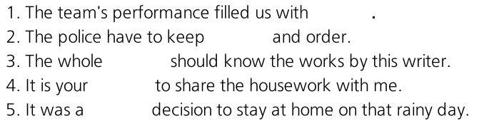

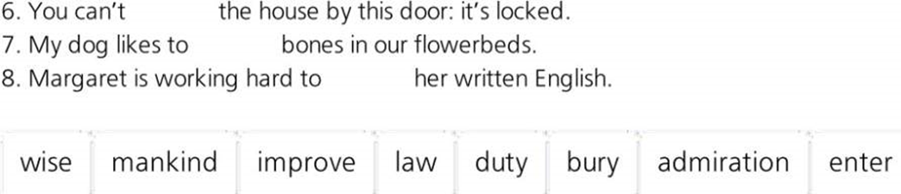

3.Впишите производные от слов из правой колонки в предложения.
