Учитель : Чобан Алёна Михайловна
МБОУ СОШ с.Завидово
Урок по английскому языку на тему «Описание родного села»
Класс: 6

Цель урока: собрать, систематизировать, отобрать и логически выстроить необходимую информацию по теме «Описание родного села» .
Планируемые результаты
Предметные | - создавать разные виды монологических высказываний;  - вести диалог, составлять монологическое высказывание по теме;  - активизировать самостоятельную деятельность;  -кратко излагать результаты выполненной проектной работы (объём – 7–8 фраз);  -владеть компенсаторными умениями: использовать при чтении и аудировании языковую догадку, в том числе контекстуальную, игнорировать информацию, не являющуюся необходимой для понимания основного содержания, прочитанного (прослушанного) текста или для нахождения в тексте запрашиваемой информации;
Личностные | - понимание роли различных социальных институтов в жизни человека;  -овладение языковой и читательской культурой как средством познания мира;  -формирование ответственного отношения к учению, готовности к саморазвитию и самообразованию;  -владение языковой и читательской культурой как средством познания мира;  -формирование коммуникативной компетентности в общении и сотрудничестве со сверстниками;
Метапредметные | -выявлять и характеризовать существенные признаки объектов (явлений);  -выбирать, анализировать, систематизировать и интерпретировать информацию различных видов и форм представления;  -эффективно запоминать и систематизировать информацию.  Коммуникативные:  -выражать себя (свою точку зрения) в устных и письменных текстах;  -воспринимать и формулировать суждения, выражать эмоции в соответствии с целями и условиями общения;  -понимать намерения других, проявлять уважительное отношение к собеседнику и в корректной форме формулировать свои возражения;  -составлять план действий (план реализации намеченного алгоритма решения), корректировать предложенный алгоритм с учётом получения новых знаний об изучаемом объекте;  -проводить выбор и брать ответственность за решение.
Используемая технология: Технология развития критического мышления.
Приемы: стратегия « статья» ,« Общее уникальное».

ХОД УРОКА.
Этапы урока | Учитель | Учащиеся | Время
1. Стадия Вызова  Воспроизведение имеющихся знаний по теме  Постановка вопросов | Listen to this conversation and tell me what is it about? Where do you live?  (послушайте монолог и назовите, что о чем идет речь)(А где вы живете?)  -is there a problem. Yes it is not easy translating al the words. Есть проблема? В чем?  - I have prepared a model, What is missing here? What is placed on our street?  (Я подготовила схематический макет, чего здесь не хватает?(информации)  -do you know something about village Zavidovo?  (Вам что-то известно о с.Завидово?)  -How do you think, what shall we do today?  -It’s a guidebook of Zavidovo | Учащиеся слушают и отвечают на вопрос (речь идет о селе, но не все предложения возможно перевести, речь пойдет об описании села))  Мы Будем говорить о селе/возможно отсутствуют здания, информация о них  Цель рассказать о селе. Возможно о значимых местах Завидово. | 3 мин.
2. Стадия Осмысления  Работа с новым материалом | Класс делится на 5 групп  (на доске конверты с заданием с текстами о зданиях)  1 группа :where do we study? Where we read books?.  2 группа: If you are feeling sick get to this building quick  3 группа:It is a place where we pray to God  4 группа:It is a place where we dance and act in the theatre  5 группа: It’s a place where we sentd letters to our relatives  Приложение 1  -You’ve received parcels with the tasks. You will work with this materials.  Your task is, to choose the most important information, cut out the sentences, pictures and represent it to in 7 sentences. And can use the internet , if it is necessary.  Your plan is  To study…….the information  To analyze…….texts  To choose……in journal page format  To systematize……works  To represent works.  (дети должны продолжить фразы)  (-Каждая группе дан конверт с заданиями. Это тот материал с которым вы будете работать. Ваша задача выбрать основную информацию и представить ее нашим гостям. Приложение 2) | Учащиеся отгадывают здания своего села  A school  A clinic  A church  A post office  A leisure center | 3 мин.  3 мин  15мин
 | -Are you ready? Lets represent your works.  (Сейчас каждая группа представит свою статью . ) | Ребята выступают со своим материалом | 15 мин.
3.Стадия Рефлексии  Размышление. Систематизация знаний | -And now , fill on your tables.  -Заполните таблицу  Приложение 3  – Your hometask is:  – make a crossword about these places  - choose one of the building and write about it additional information in 7 sentences  –Thank you for the work.  Goodbye. | Ребята заполняют таблицу в группах.  Ребята выбирают домашнее задание  Goodbye | 5мин.  1 мин.
Приложение 1
1 группа :where do we study? Where we read books?.
2 группа: If you are feeling sick get to this building quick
3 группа:It is a place where we pray to God
4 группа:It is a place where we dance and act in the theatre
5 группа: It’s a place where we sand letters to our relatives

Приложение 2
School
Many people look back on school years with sadness and some nostalgia; others, on the contrary, with hatred and boredom. The building of our school is very big and made of red brick. It’s neither old nor new, but it is well-equipped and modern inside.
Our school has 3 floors. The classrooms are spacious and light. Many of them are equipped with a teacher’s computer, a TV-set and an electronic board. There are 2 computer classes, a library with a reading-room, an assembly-hall, a dining hall, a gymnasium and a swimming-pool in our school. There are also 2 football fields and a sports ground outside the building.
The bell for the first lesson rings at half past 8 and we usually finish at about 2 or 3 p.m. As a rule we have 6 or 7 lessons a day and we study 6 days a week.
There is a long 20-minute break after the 3rd lesson to have lunch or just a snack.
I love and respect our principal and most of our teaching stuff. Although some of them are quite strict and old-fashioned, they give very interesting lessons and proper knowledge. The atmosphere in our class is always friendly and busy. Fortunately we haven’t had any bullying or rude behavior among our classmates. I made best friends with some of them. We often take part in school activities together. There are musical performances, intellectual games, concerts, school and inter-school sports competitions and class parties in our school. I'm sure I will miss my school life after I finish the 11th form.
Also it is important to wear a school uniform. Many think that it is not comfortable, but I think it is good .
Leisure center
Organization of youth leisure activities Cultural and leisure centers Currently, the activities of a cultural and leisure institution should primarily address social problems in the region by offering new lifestyle models. The leisure sector today is becoming a concentration of such social problems that society cannot solve in other spheres of life (drug addiction, alcoholism, crime, prostitution, etc.). Of course, this does not mean that leisure activities are fully capable of fulfilling this social order, but the club sphere is obliged to offer alternative, socially significant leisure programs. The activities of leisure facilities should be aimed at creating the most favorable, optimal conditions for recreation, for the development of spiritual and creative abilities of a young person.
Creative teams constantly take part in regional and district screenings, competitions and festivals. Field concerts and events are held in neighboring rural settlements. The works of the students of the applied art studio have repeatedly participated in the exposition of exhibitions of folk art in the Konakovsky district. The folk song ensembles "Harmonics" and "Sudarushka" annually become laureates of the Konakovsky Lights Festival. A permanent exhibition of handicrafts from the settlement has been organized in the exhibition hall of the Leisure Center. Free Internet access (Wi-Fi) is provided in the premises of the Leisure Center. There is a playground and table tennis tables on the territory of the Leisure Center. The surrounding area is planted with lawn grass, flowerbeds are laid out. There is a street lighting at the territory and sports grounds.
A youth club, a veterans club, and a Triumph sports club have been established. A cooperation agreement has been signed with the Tver Region Football Federation and the Russian Federation Freestyle Wrestling Federation. The Leisure Center has an art studio, an applied arts studio, a vocal and instrumental class, a choreography class, a theater studio, a sports hall for freestyle wrestling, a library (book collection of 3,000 and 2,000 books), a gym, an auditorium (200 and 250 seats), a football field. The municipal budget institution "Leisure Center" began its activity in 2012, after the construction of a new building. There are 8 club formations in the village of Zavidovo, in which not only children but also adults are engaged.
Clinic
All people have been in the hands of doctors at least once. And this is the norm of life, because in the modern world, we simply cannot live without them and hospitals. Of course, a doctor should love people, his job is to improve their health. He must be brave, because it is he who is the first to go to the call of the patient to a place where a devastating epidemic is raging.
He must fully devote himself to his work, be ready to treat, without fear of catching a deadly disease.
Our hospital is equipped with modern equipment.
The laboratory is fully operational.
A general practitioner monitors and issues referrals to patients. The children’s doctor is treating the children.
There is A dentist . Nobody of our village cannot imagine life without him.
The reconstruction of Zavidovskaya Hospital took place in 2023.
The building was completely renovated. There were allocated Parking spaces.

Trinity Church
The temple complex of the Dormition of the Holy Virgin Mary stands in the center of the ancient village of Zavidovo, a little east of the Moscow highway (112 km) - St. Petersburg (522 km). The ensemble currently includes two churches: the Dormition and the Holy Trinity, and also boasts a five-stories bell tower. The largest belfry of the Tver diocese features an impressive number of bells, reaching a total mass of 12.5 tons. Blagovest, the biggest one, weighs 1 ton alone.
Visit the museums
Learn about the history of Zavidovo village and the church complex, at the museum located in a former chapel and icon depository. Continue your tour at the Museum of Folk Crafts of Russia in the Sunday School, and marvel at birch artifacts, wooden toys and matryoshka dolls, as well as everyday life items like faience and clothes. Interactive programs are organized during school vacations. A third museums tells the story of the construction of the ‘Gosudarev road'.
Rare witnesses of the past
The earliest building of the complex is the Assumption Church. It was first mentioned in 1623 in the scribal book of the Klin district of the Moscow principality. The reconstruction of the end of the 18th – mid-19th century changed the original appearance of the church; nevertheless, its style and some architectural details belong to the 17th century. The Dormition Church is probably one of the earliest stone buildings erected after the Time of Troubles, that ended in 1613 with the establishment of the Romanov dynasty. Most likely, the church was built in the second half of the 1610s - early 1620s. In the first decades following the riots, very few stone churches were built in Russia, and even less are still visible. Standing next to the Church of the Dormition, the Trinity Church was built in 1781, replacing the wooden church of St. Michael the Archangel, destroyed in the 16th century.
Post office
If you need to send a parcel or get the parcel, buy stamps and subscribe to a newspaper or a magazine, you need to go to the post-office. You can send not only a telegram, but also a money transfer. Amicable postal workers will always help you do it. They will always tell you how to fill out the form correctly in order to avoid errors.
In some buildings of post-offices there are also special windows. You can pay there for various services such as phone, gas bills and electricity bills and so on. These opportunities make life of an ordinary citizen easier. Now you shouldn’t waste time on trying to find the right office or bank. Everything is within reach.
The term "post office" usually refers to government postal facilities providing customer service. "General Post Office" is sometimes used for the national headquarters of a postal service, even if the building does not provide customer service. A postal facility that is used exclusively for processing mail is instead known as a sorting office or delivery office, which may have a large central area known as a sorting or postal hall. Integrated facilities combining mail processing with railway stations or airports are known as mail exchanges.
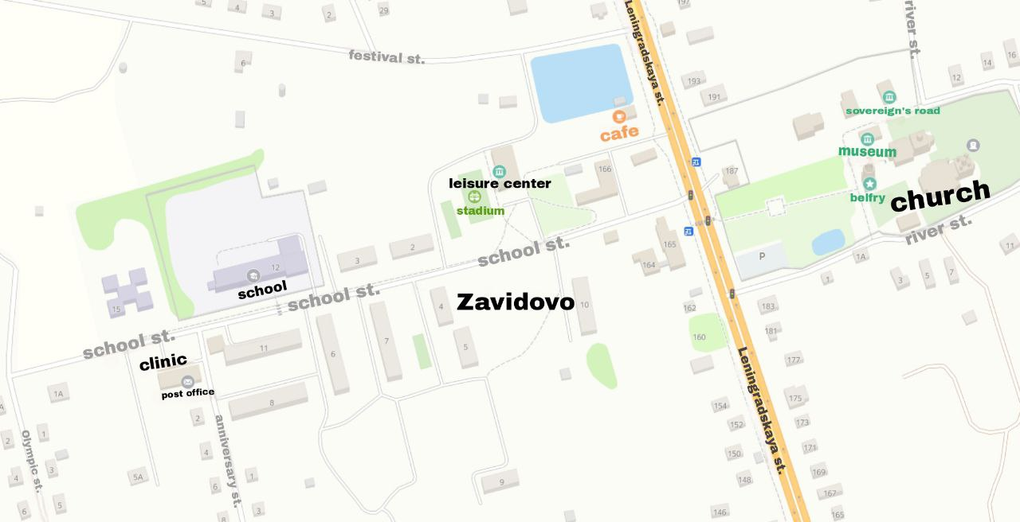

Приложение 3
Method “strategy frame or article”

 | The most important information  (перечисляются наиболее ценные факты) | White spots  (указываются каких сведений было не достаточно, что не было указано) | Rubbish  (факты которые по вашему мнению не нужно было указывать)
School
Clinic
Church
Leisure center
Post office

