[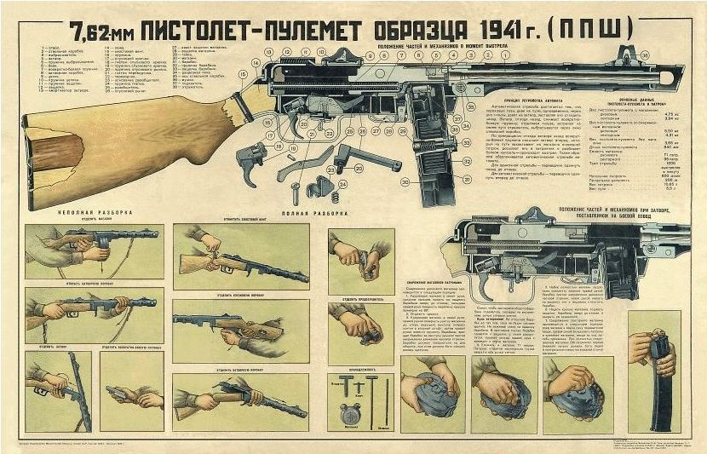](https://militaryarms.ru/wp-content/uploads/2019/08/plakat-s-ppsh.jpg)

