Министерство образования и науки Российской Федерации
Федеральное государственное бюджетное образовательное учреждение высшего профессионального образования
«Тамбовский государственный технический университет»

Н.А. ГУНИНА, Е.В. ДВОРЕЦКАЯ, Л.Ю. КОРОЛЕВА, И.В. ШЕЛЕНКОВА

КРАТКИЙ КУРС ДЕЛОВОГО АНГЛИЙСКОГО

Утверждено Учёным советом университета в качестве учебного пособия
для магистрантов всех специальностей и направлений



Тамбов
Издательство ФГБОУ ВПО «ТГТУ» 2012
1

УДК 811.111(075.8)
ББК Ш13(Ан)-923 К786

Р е ц е н з е н т ы :
Кандидат педагогических наук, доцент кафедры
«Международная профессиональная и научная коммуникация» ФГБОУ ВПО «ТГТУ»
Н.Л. Никульшина

Кандидат филологических наук, доцент кафедры ЛОБП ФГБОУ ВПО «ТГУ им. Г.Р. Державина»
В.М. Романова

К786 Краткий курс делового английского : учебное пособие /
Н.А. Гунина, Е.В. Дворецкая, Л.Ю. Королева, И.В. Шеленкова. –
Тамбов : Изд-во ФГБОУ ВПО «ТГТУ», 2012. – 80 с. – 150 экз.
ISBN 978-5-8265-1089-6

Включает в себя четыре учебных блока, посвящённых различным темам делового английского языка. Каждый блок содержит две подтемы, которые более подробно раскрывают материал. Подбор практических заданий, входя- щих в содержание каждого учебного блока, позволяет закрепить не только грамматический, лексический материал, но и развить умение вести деловое общение на английском языке.
Предназначено для магистрантов, специализирующихся в области изуче- ния делового английского языка.
УДК 811.111(075.8)
ББК Ш13(Ан)-923

ISBN 978-5-8265-1089-6 © Федеральное государственное бюджетное
образовательное учреждение
высшего профессионального образования
«Тамбовский государственный технический университет» (ФГБОУ ВПО «ТГТУ»), 2012
2

ВВЕДЕНИЕ

Данное учебное пособие предназначено для магистрантов всех спе- циальностей и направлений технических вузов, изучающих английский язык на уровне Intermediate, для практического использования в профес- сиональной деятельности, прежде всего в сфере делового общения, свя- занной с поездками за границу и продвижением товара на рынке мировых услуг.
Цели пособия:
- формирование у студентов навыков межкультурной коммуника- ции, принимая во внимание стереотипы мышления и поведения в культу- ре изучаемого языка;
- обучение культуре иноязычного устного и письменного общения;
- развитие общей, лингвистической, прагматической и межкультур- ной компетенций.
Выбранные темы пособия имеют непосредственное отношение к по- вседневным отношениям в современном деловом мире. Пособие направ- лено на решение следующих задач:
- расширить активный и пассивный лексический запас студентов по изучаемым темам;
- обеспечить закрепление и активизацию грамматического материа- ла, представленного в соответствующих разделах;
- развить умения и навыки ознакомительного, просмотрового, поис- кового и аналитического чтения;
- развить умения и навыки говорения;
- закрепить навыки понимания иноязычной речи на слух.
Данные цели и задачи определяют структуру пособия, которое со- стоит из четырех частей и восьми юнитов. Каждая часть включает в себя следующие секции: Starting up, Reading, Vocabulary, Language Focus, Listening, Speaking, Writing, Case study.
Starting up направлен на подготовку студентов к первоначальному обсуждению представленной темы, уже обращая внимание на некоторые новые слова и фразы, и таким образом представляя новую тему.
В секции Language Focus предлагается краткий теоретический мате- риал по грамматике, непосредственно связанной с изучаемой темой, и даются упражнения для его закрепления.
Раздел Speaking содержит задания для развития навыков подготов- ленной и неподготовленной монологической и диалогической речи на аудиторных занятиях.
Идея и разработка данного пособия принадлежит И.В. Шеленковой (Part I), Н.А. Гуниной (Part II), Е.В. Дворецкой (Part III), Л.Ю. Королевой (Part IV).

PART I PEOPLE AND CAREERS

STARTING UP

  - Study what you should say when you meet people:

Introductions and Conversation Openings
A person performing an introduction in a formal situation says, for example Mrs. Johnson, may I introduce Mr. Bentley? Mr. Bentley – Mrs. Johnson. Less formal alternatives to May I introduce...? are (in order of de- creasing formality):

Let me introduce... I'd like you to meet...
This is...

Meet...

The two people who have been introduced both say: How do you do? – in formal and semi-formal situations; Hallo – in informal and semi-formal situations.

Pleased/Glad to meet you.
Two phrases often used before introducing someone are:

Have you met...?
eg Have you met my sister? I don't think you've met...
eg I don't think you've met my sister.
If you have to introduce yourself, you may say, for example:
May I introduce myself? My name's Victor Petrov. I'm your guide.

Let me introduce myself.
When two people have been introduced, one of them usually has to start a conversation. One way to do this is to ask a question such as:

Is this your first visit to...?
Have you been here/to... before? Have you visited/seen...?

How do you like/find (our)...? (How) are you enjoying...?
Are you finding... interesting/useful? What do you think of...?

Are you interested in...?

Greetings and Inquiries About Health
When you already know someone, the following formal greetings should be used:
Good morning – until lunch-time (12 – 2 p.m.)
Good afternoon – until 5–6 p.m.
Good evening – until 10–11 p.m.

Morning/Afternoon/Evening – semi-formal. Used, for example, to neighbours, colleagues and other people whom one sees regularly but does not know well.
Hallo – semi-formal, informal
Hi – informal, used mainly in America. The name of the person greeted is often added.
Greetings are often followed by an inquiry about the other person's health:
How are you? – formal
How are you getting on? – semi-formal, informal
How's life? – informal
How are things (with you)? – semi-formal, informal The answer may be:
(I'm) very/fairly/quite well, thank you. – formal, semi-formal
Fine, thanks. – semi-formal, informal
Not too/so bad (thank you/thanks). – semi-formal, informal
All right, thank you/thanks. – semi-formal, informal
OK, thanks – informal, familiar
A bit tired, otherwise all right. – semi-formal, informal

Leavetaking
When you want to take your leave of someone it is often necessary to use some introductory sentence such as:

(Well,) I must go (now).
I'm afraid I must be going (now). It's time I was going/off.

I must be off now.
When you actually leave, you may say:
Good-bye. – formal, semi-formal
(Good-) bye for now. – semi-formal, informal
Bye (then). – semi-formal, informal Bye-bye. – semi-formal, informal Cheerio. – semi-formal, informal See you. – very colloquial.

See you later/tonight/tomorrow/on Saturday/next week, etc,
See you at the theatre/concert/party, etc.
When leaving someone we sometimes want to be remembered to some member(s) of his family or a mutual friend or acquaintance. The following phrases are used for this purpose:

(Please) give my (kind) regards to...– formal
(Please) remember me to...– formal, semi-formal
Give my love to...– informal, for close friends and relations

  - Make up sentences using one item from each column. Make sure that all the items in one sentence are of the same degree of formality.

Mr. Taylor | Let me introduce | our visiting lecturer, Dr. Miller
Mrs. Bond | I'd like to introduce | my sister Janet
Professor Reed | I'd like you to meet | my English teacher, Miss Sullivan
Peter | This is | a friend of mine, Alan Binns
Helen | Meet | my cousin Margaret
Father |  | some of my colleagues
  - Match each question with the best reply.
- What do you think of Tokyo? 1. Yes, extremely interesting.
- How often do you travel abroad 2. Thank you.
- Are you going to be here long 3. At the Sheraton.
- Is this your first trip to Japan 4. Yes, very well.
- Do you know Harvey Phillips in sales 5. It's a very interesting place.
- Where are you staying 6. No, I was here last year.
- It's an interesting conference, isn't it 7. Just five days.
- Can I get you a refill 8. Once or twice a year.

With a partner, think of some more questions and responses you can use when you meet someone for the first time. Write them down, and try them with other students in the class.
  - What would you say:
- to Professor Marsden, who is leaving for home after a short stay in your town?
- to your parents, when leaving your flat in the morning?
- to a secretary who has just given you some information, before leaving the office?
- when leaving a group of fellow-students after classes?
- to a friend whom you are seeing off to Moscow?

  - Here are two conversations where people are meeting one another. Put them in the correct order. Which conversation is more formal?
- Good. I've come to take you to your hotel. You'll be staying at the Hilton.
- Just a couple of days. I have to get back as soon as the conference is

over.

- Karl Striebel. How do you do? Thank you for coming to meet me.
- Thank you very much. Is it far?
- Fine thanks. How long are you here for?
- It's a pleasure. Did you have a good flight?
- She's the new head of European Sales, isn't she?
- Hello, Josef. How are you?
- No. It only takes about half an hour.
- Hello. I'm Mark Jensen from Ciba Geigy. How do you do?

- That's a shame. By the way, there's someone I'd like you to meet Caroline Eustace.
- Hi there, Sarah. Nice to see you again.
- Yes, it was fine thanks. No delays.
- That's right. Come on over and I'll introduce you. Conversation 1 Conversation 2
Mark J Josef l

Karl Mark
Sarah Josef

Karl Sarah Mark Josef Karl Sarah Mark Josef

  - Peter Berger is a consultant with Prodata, a computer consultancy firm. He is normally based in Geneva but he's working in Bradford at the moment, setting up a new quality control system. On his first day there, he meets Jenny Carlson over lunch.
Put these questions into the correct spaces to complete their conversation.
- And what exactly are you doing?
- What's your job?
- Anyway, how long do you think you'll stay in Bradford?
- I don't think we've met, have we?
- When did you start?
- So you're not from Bradford then?
- And how long have you worked here?
Jenny: Hello. I'm Jenny Carlson. (1) ?
Peter: No. Pleased to meet you. I'm Peter Berger from Prodata.
Jenny: (2) ?
Peter: No, I'm from Geneva. I'm just working here temporarily. Jenny: Really? (3) ? Peter: This morning. Today is my first day.
Jenny: (4) ? Peter: I'm setting up a new quality control programme. Jenny: That's interesting.
Peter: What about you? (5) ?
Jenny: I work in Sales.
Peter: (6) ?
Jenny: For eight years. I started as a sales representative and now I'm a regional manager. (7) ?
Peter: Just three or four months. It depends how long the new system takes to set up.

Jenny: I see. Well, I'm sure you'll enjoy it. It's a very friendly place.


  - Listen to some people meeting one another and make notes in the chart below.

Conversation 1 | Conversation 2 | Conversation 3
Is this the first time they have met?
Where do you think they are?
What nationalities do you think
they are?
  - With a partner, practice meeting someone for the first time at a business reception. Use real or imaginary information about yourself. Try to continue the conversation for as long as possible, using the table below as a guide.
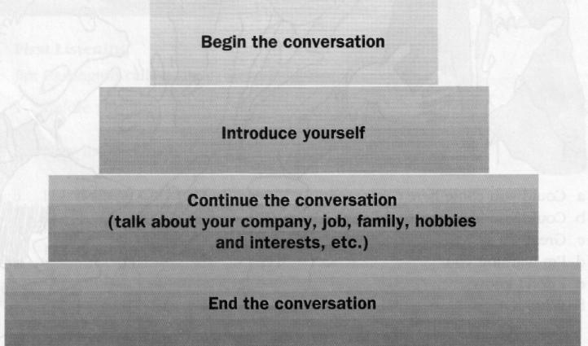

UNIT 1. JOBS AND RESPONSIBILITIES VOCABULARY
- Match the words from the box with the corresponding heading:
- What do you do?
- General responsibilities
- Working hours
- Pay and conditions
- Jobs
- Living the company

work for/in | sacked | meet clients | dismissed
salary | carpenter | nine-to-five job | get sick pay
run | self-employed | resigned | be employed by
surgeon | do shiftwork | paid holiday | full-time job
in charge of | attend meetings | retire | work overtime
mechanic | pay income tax | pay rise | do flexitime
part-time job | handle | attend meetings | architect
responsible for | personnel manager | minimum wage | deal with

- Match the verbs on the left with the nouns on the right. Use each verb once only.
  - earn a) overtime
  - work b) meetings
  - deal with c) a shop
  - attend d) complaints
  - run e) £2,000 a month

- Rewrite these sentences starting with the words given. The meaning must stay the same.
Example I'm a banker. I work in banking.
  - What do you do?
What's .......................................................
  - I'm employed by the government.
I work........................................................
3. I earn $50,000. My.......................................................
- I get £20,000 from my teaching job and another £10,000 from writing.
My total....................................................
- In my job I look after all the computers in the building.
My job involves …………………. ......................
6. I'm responsible for one of the departments. I'm in ……………………..

- This is part of a conversation with a teacher about her job. Write the missing questions.
A: …………………….? B: I start at nine and finish at four.
A: …………………….? B: Yes, a bit. On certain courses I work until 5.30. A: …………………….? B: 12 weeks. That's one of the good things.
A: …………………….? B: Yes, we do, but we have to have a doctor's note.

- Write down one job that would probably be impossible for these people.

  - Someone who didn't go to university doctor
  - Someone with very bad eyesight (= cannot see very well)
  - Someone who is always seasick on a boat
  - Someone who understands nothing about cars
  - Someone who will not work in the evening or at weekends
  - Someone who is afraid of dogs
  - Someone who is afraid of heights and high places
  - Someone who is terrible at numbers and maths
  - Someone who doesn't like to see blood (= the red liquid in your body)
  - Someone who is a pacifist (= is anti-war)

- You have just bought a piece of land and you are planning to build a house on it. Write down at least six people from the opposite page that you may need to help you. What would you need their help for?
Example A bricklayer to build the walls.

- Find the logical answer on the right for each of the questions on the left.
- Why did they sack her? a) Because she was 60.
- Why did they promote her? b) Because she was late for work every day.
- Why did she apply for the job? c) Because she needed more training.
- Why did she retire? d) Because she was out of work.
- Why did she resign? e) Because she was the best person in the
department.
- Why did she go on the course? f) Because she didn't like her boss.

- Complete the table. Use a dictionary to help you.
verb general noun person
manage ....management .... ............................
promote .............................
employ /
resign .............................
retire .............................
train /


READING

- Have you ever heard of Richard Branson? Read this article about the way he works. Is there anything unusual about his management style? Do you think you would like to work for him?

- Work with a partner. Look at the facts about Branson and ask and answer questions about how he works. Use these question forms to help you.
What...? | How...? | How many...?
Where ...? | Does he ...? | How much ...?
When...? | Has he...? | What sort of ...?
Why ...? | How often ...?

Richard Branson's

10 SECRETS OF SUCCESS

Richard Branson became famous as a 'hippy' businessman in the 1960s when he set up a record company. Today he runs the successful Virgin airline and he's still breaking many of the traditional rules of management So how does he do it?
- He regularly works an eleven-hour day, starting around eight and finishing around seven at night.
- He spends a lot of time talking to people on the telephone but he never sends memos.
- He rarely holds board meetings. He makes decisions on the phone or on the tennis court.
- He has a good memory and he writes people's names on his hand so he doesn't forget them.
- He invites every single one of his 10,000 employees to a party at his home in Oxfordshire every year. The last party cost around £100,000.
- He continually questions his employees about every aspect of the business and he tries to pick holes in their arguments to find out whether their ideas will work.
- If he becomes annoyed in meetings, he leaves the room. He hardly ever loses his temper.
- He employs people he likes personally. This is more important to him than qualifications.
- He has had several business failures in the past and nearly went bankrupt several times but he has always survived. He puts his success down to good ideas, good people, and good luck.
- He didn't go into business to make money. He went into business because he wanted a challenge.

- The text is about the different styles that men and women have in the workplace.
- Look at the cartoons and say which figures you think represent men and which represent women?

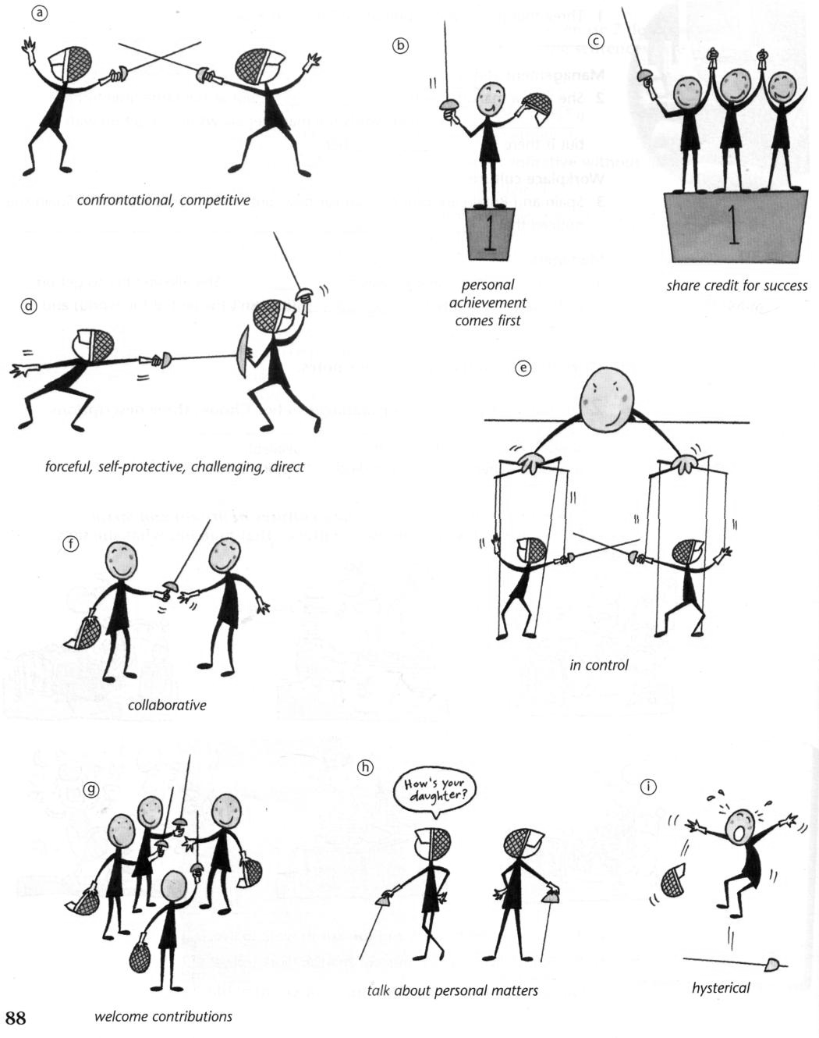

- Read the text and see if the writer's ideas are the same as yours.

- The text has eight main sub-sections. Match the cartoons to the sections.

MEN and women do things differently. There are, of course, exceptions to every generalisation, including this one.
Cristina Stuart is a managing director of Speakeasy Training, a consultancy that runs courses for men and women working together. Here she describes a few key differences between the sexes in the workplace.
- Working together
The male approach to business is competitive, direct and confrontational. The end justifies the means.* Personal status and a focus on the individual are important.
The female method is collaborative. Collective action and responsibility are more important than personal achievement. Lateral thinking*, as well as goodwill and the well-being of the individual, are also of great importance.
- Tackling problems
The male approach is to go to the heart of the problem, without taking into account secondary considerations. The female preference is to look at various options.
- Body language
Male body language tends to be challenging. Female body language tends towards self-protection. A stereotypical female pose is sitting cross-legged; the male sits with legs apart to give an impression that he is in control.
Male behaviour can include forceful gestures for example banging a fist on the desk for effect. The female style does not usually include aggressive gestures.
- Language
The male way of speaking does not encourage discussion. Women tend to welcome others' opinions and contributions more.
- Conversation
Men like to talk about their personal experiences and achievements or discuss 'masculine' topics such as cars or sport. Women tend to talk about staff problems and personal matters.
- Meetings
If a woman does not copy the male confrontational style, she is often ignored.
- Self-promotion
Men find it easy to tell others about their successes. Women tend to share or pass on the credit for a success.
- Humour
Men's humour can be cruel – a man's joke usually has a victim. Female humour is less hurtful. A woman often jokes against herself
CAVEAT Many men have a female style of working. Equally many women have a male approach. As Ms Stuart says many of the current management theorems – flatter organisations*, empowerment, managing by consensus* – have a female style to them.

  - the end justifies the means: it doesn't matter what methods you use; suc- cess is the only important thing
  - lateral thinking: thinking in a creative way, making unusual connections
  - flatter organisations: organisations in which there are fewer managers and people have equal status
  - managing by consensus: managing by getting everyone to agree

- According to the text, which of these phrases are typically used by men and which by women?
Example:
'It's very simple. The point is ...'
Men because 'the male approach is to go to the heart of the matter'.
- 'But we need to take account of...'
- 'You look worried. What do you think about the new plan?'
- 'That's rubbish!'
- 'I built the department from nothing.'
- 'Thanks for your kind words, but this really was a team effort.'
- 'It was so funny. He looked ridiculous!'

- Work in groups and discuss the questions.
  - What is the style of male and female managers in companies in your country? Are they similar to the ones outlined in the text?
  - Do you think there is a difference in style between men and women or is any difference usually because of personality?
  - Do you know any men who have a 'female' style of working? or women who have a 'male' style of working?
  - Do you find it easier to work with men or women? Why?

LISTENING

- A. Work in pairs. Discuss what you think the job of a tour representative is like.

B. Listen and complete the gaps.

Name:
Lisa Crawford
Job title:
Tour representative
Company she works for:
Perks:
Ratio of men to women:

C. Listen again and complete the gaps.
- It involves
- I'm responsible for
- I have to deal with
- It also involves

- A. Listen to five people talking about their jobs. Match each speaker to a job.
nurse politician model journalist firefighter lawyer professional footballer teacher shop assistant police officer TV presenter personal assistant sales manager

B. What are the key words which tell you the jobs?
1. shifts, patients,...

C. Listen again. What aspects of their jobs does each person say they like/dislike?

- A. Listen to five people talking about working from home. What is each person's job?

B. Listen again. How long has each person been working from home? Do they like it? What reasons do they give?


SPEAKING

- What about working conditions in your country?
- What are normal working hours for most office jobs in your country?
- How much income tax do most people pay, e.g. 10% or 20% of what they earn?
- Do workers normally get paid holidays? If so, how many days do they usually get?
- Is there a minimum wage decided by the government? If so, how much
is it?
- What jobs often involve shiftwork in your country? (Give at least two
examples.)
- Have you got a job in a company? If so, answer these questions as quickly as you can. If possible, ask another person the same questions.
- Are you responsible for anything or anyone?
- Have you had much training from the company?
- Have you been on any training courses?
- Have you been promoted from the time you started your job?
- Do you normally get a good pay rise at the end of each year?
- What do you think about your future prospects in the company?

UNIT 2. RECRUITMENT

VOCABULARY
  - Match the verbs 1 to 6 to the nouns a – f to make word partnerships.
- to train a) a vacancy/post
- to shortlist b) an interview panel
- to advertise c) the candidates
- to assemble d) references
- to make e) new staff
- to check f) a job offer
  - Now decide on a possible order for the events above from the employer's point of view.
For example: 1. to advertise a vacancy

 C. Listen to a consultant talking about the recruitment process to check your answers.
D. Complete the text using the following words or phrases:

curriculum vitae (CV) / resume probationary period interview covering letter
application form psychometric test

These days many applicants submit their ......................... ¹ speculatively to companies they would like to work for. In other words, they do not apply for an advertised job but hope the employer will be interested enough to keep their CV on file and contact them when they have a vacancy. When replying to an advertisement, candidates often fill in a / an ² and write a / an
................. ³. The employer will then invite the best candidates to attend a / an …………….⁴. Sometimes candidates will take a / an ⁵ before
the interview to assess their mental ability and reasoning skills. These days it is normal for successful candidates to have to work a / an ………………. ⁶ in a company. This is usually three or six months; after that they are offered a permanent post.

E. Complete the sentences with a suitable word or word combination.
applicant a vacancy, interview
a covering letter financial package
a headhunter a reference a probationary period resume
a shortlist

- The starting salary of the successful .....applicant... will be decided on the basis of qualifications and experience.
- The usual American English word for 'CV' is ' '.
- Our company has for a graduate in economics.
- Applicants will be called for ………………… between 10 and 16 April.
- We ask all our new employees to work of between
one and three months.
- The interview panel will draw up …………………. of only five candidates.
- Please send together with your CV.
- It is usual to ask your previous employer for when
you apply for a job.
- For high performers, a good is not all that matters. They
need a challenge as well.
- They hired ……………… to attract some executives from a rival company.

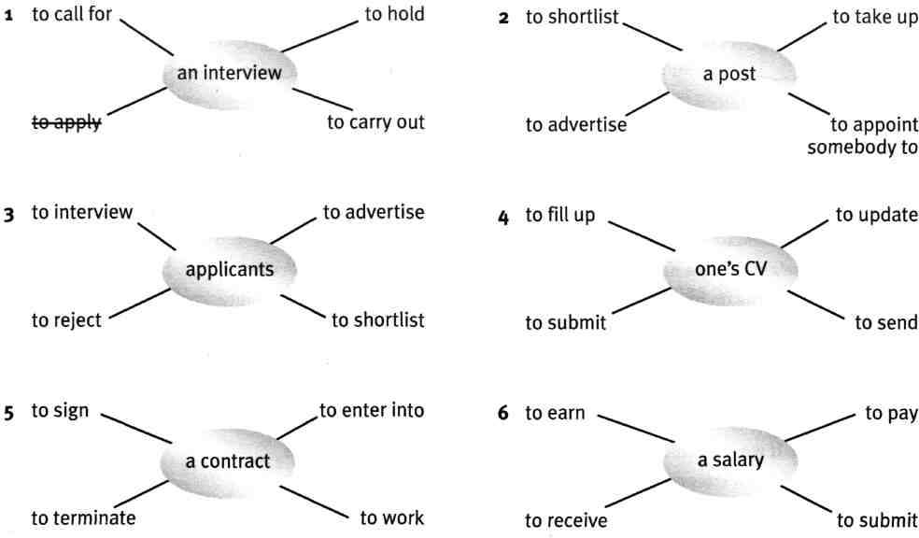
- Cross out the item which does not normally go with the key word.

READING
  - A) Read a leaflet from a recruitment agency giving advice about interviews. Choose the most suitable headings for paragraphs A – E. There are three extra headings.
    - contact details 5. survey results
    - shock tactics 6. hypothetical questions
    - attitude 7. one person's experience
    - appearance 8. advice

A
When it comes to interview questions, it pays to expect the unexpected. This is a true story of one candidate's experience. This is how his interviewers greeted him: 'We've been interviewing candidates all morning and we're getting bored. Do something to impress us’. Then the interviewers got out their newspapers and started reading them.
The candidate said, 'Well, I've been waiting in this office for more than two hours because you've been running late. Actually I'm not impressed by your organisation and not sure I want to work for you. Goodbye.'
The interviewee walked out, was invited back the next day and was offered the job.

B
How would you act in a situation like this?
That interview was rather extreme, but a lot of employers have turned to using 'killer questions' or 'shock tactics', such as these:
‘Tell me something about yourself that you have never told anyone’. 'Which three famous people would you invite to a dinner party and why?' 'We have employed people from your university, and they haven't been
good. Can you tell us why you think you'd do better?'
Killer questions often come early in the interview and are aimed at throwing the candidate off guard. By surprising the candidate with an original or difficult question, interviewers can get an honest reaction and an unplanned response. They also want to see candidates think through their responses calmly.

C
Interviewers also ask candidates other kinds of difficult questions to see how they react under pressure. For example, they may ask a hypothetical question related to work, such as: 'Imagine you are an employee in customer services. What would you do if an important customer was very rude to you?'
However, some experts think that hypothetical questions are not useful because they only generate hypothetical answers. They prefer candidates to talk about their past experience.

D
So, what should you do in these circumstances? Imagine: an interviewer has asked you a 'killer question' and you just don't know how to answer it – your mind is blank. Remember, the interviewer isn't interested in your response as much as the way you respond. So, stay calm, take a few deep breaths and buy some time, e.g. 'Actually, that's interesting. I haven't thought about it, but maybe I'd …’ It’s a good idea to practice asking and answering some of these questions with friends. You can find some typical 'killer questions' on the front of this factsheet.

E
J0BS4U have prepared three other leaflets, full of hints and tips about interviews. We can be reached in the following ways: Telephone 01865 701813
Email info@jobs4u.com

B. Read the leaflet again. Which of the following ideas are mentioned?
- Your answers to killer questions are extremely important.
- An interviewee left the interview before it was meant to finish.
- The way candidates look and dress was one area which bosses thought could have improved.
- Difficult questions often come at the end of an interview.
- Some experts prefer candidates to talk about things they have done rather than answer hypothetical questions.
- You should not hesitate when answering killer questions.

C. Find words in the leaflet for someone who:
is applying for a job.
asks questions at an interview.
has other people working for him/her. is attending an interview.
is paid to work for an organisation or another person. has special knowledge of a subject.
  - Read this typical job interview questions and think about your answers. What are the most difficult questions to answer? Visit the following web page read and compare your answers with the best answers to these and other job interview questions: http://jobsearch.about.com/od/interviewquestionsanswers/a/interviewquest.htm

Interview Questions: Work History
- Name of company, position title and description, dates of employment.
- What were your expectations for the job and to what extent were they

met?

- What were your starting and final levels of compensation?
- What were your responsibilities?

  - What major challenges and problems did you face? How did you handle them?
  - What have you learned from your mistakes?
  - What did you like or dislike about your previous job?
  - What was the biggest accomplishment / failure in this position?
  - What was it like working for your supervisor?
  - What problems have you encountered at work?
  - Who was your best boss and who was the worst?
  - Why are you leaving your job?
  - Why were you fired?

Job Interview Questions About You
  - What is your greatest weakness?
  - How will your greatest strength help you perform?
  - Describe your work style.
  - How many hours do you normally work?
  - How do you handle stress and pressure?
  - What motivates you?
  - What are your salary expectations?
  - What do you find are the most difficult decisions to make?
  - What has been the greatest disappointment in your life?
  - What are you passionate about?
  - When was the last time you were angry? What happened?
  - If you could relive the last 10 years of your life, what would you do differently?
  - If the people who know you were asked why you should be hired, what would they say?
  - Do you prefer to work independently or on a team?
  - What type of work environment do you prefer?
  - How do you evaluate success?
  - If you know your boss is 100% wrong about something how would you handle it?
  - Describe a time when your workload was heavy and how you handled it.

Job Interview Questions About the New Job and the Company
  - Why do you want this job?
  - What applicable attributes / experience do you have?
  - Are you overqualified for this job?
  - Why should we hire you?
  - What do you know about this company?
  - What challenges are you looking for in a position?
  - What can you contribute to this company?

- Are you willing to travel?
- What is good customer service?
- How long do you expect to remain employed with this company?
- Is there anything I haven't told you about the job or company that you would like to know?

Interview Questions: The Future
- What are you looking for in your next job? What is important to you?
- What are your goals for the next five years / ten years?
- How do you plan to achieve those goals?
- Questions about your career goals.
- What will you do if you don't get this position?


LISTENING

- A. Read the job advert and CV below. Why do you think Sara applied for the job?
Multinational food packaging equipment manufacturer seeks International Sales Manager to call on Europe and Latin America. Base $80K and commission, full benefits and expenses. Prefers: fluency in one or more foreign languages. Send resume with cover letter indicating citizenship and salary requirements.

Date & place of birth
Sara Verkade
58, Stoppard Drive, London SW16 Tel: 353 865 344872
E-mail: sara.verkade@gmz.net 23.7.78, Maassluis, The Netherlands

Marital status Single

Nationality Dutch

Qualifications September 1996 – July 1999
BComm, Marketing Management, Haagse Hogeschool, The Hague

Employment history
June 2000 – present
Management Team Co-ordinator, Helena Rubinstein, L'Oreal
Organising meetings, events and conferences. Analysing sales figures and producing relevant reports and charts.
Customer relations and responding to complaints and que- ries

June 1999 – June 2000
SPC Professional, Sales Productivity Centre, IBM
Sales team support. Research, pricing and proposal- writing on million dollar bids.

Languages Dutch, English, German, Spanish

IT Skills Proficient user of Microsoft Office suite

- Sara was interviewed for the job. Listen to the interview. Do you think they employed her?

- Listen again and complete the phrases below.
- Now, this is just a preliminary interview to details.
- Do your present you are?
- What don't you position?
- Well, Sara, can I ask you a your CV?
- Do you, in fact, have any experience?
- ... an 'SPC professional'. What mean?
- Yes, we provided twenty salesmen from different sec- tors of the company.
- ... it was a position that required a lot of time and prioritising of tasks.
- I'd like more responsibility and to be able to and my languages.

- Do you think the interviewer was fair in the interview?

- You will hear David Smyth, the Personnel Manager of a major European insurance company, answering questions about the way he interviews and selects candidates.
- In the first extract he talks about the four points listed below. Listen and number them in the order in which he mentions them.
- the mistakes a candidate can make in an interview
- the qualities a candidate must have
- his advice to interviewees
- the kinds of things a candidate is expected to know

Listen again and make notes on each point.

- In the second extract, David Smyth talks about the stages of an interview. Listen to what he says and complete the following chart

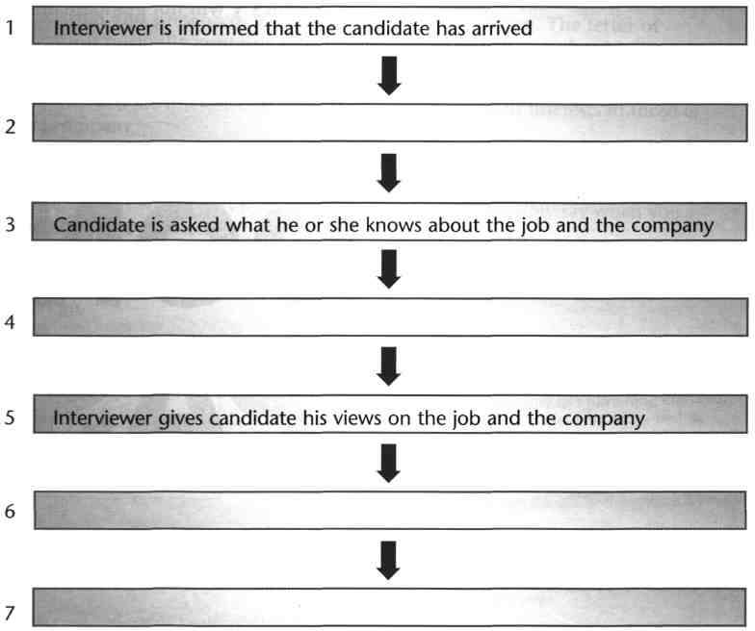

- Look at the questions that David Smyth uses during an interview. In which section of the interview would each question appear?
- Have you ever been in a situation in which you lost your temper?
- What sorts of projects did you work on during your time with them?
- What do you know about our recent acquisitions in Latin America? [3]
- Did you have any trouble finding our building?
- How do you deal with difficult people?
- Which of the options that you took at university was the most interesting?
- How ambitious are you?
- Are there any questions that you'd like to ask me?

SPEAKING
- Which of these words would you use to describe yourself in a work or study situation? Use a good dictionary to help you. Add any other useful words.
- motivated • confident • reliable • proud
- dedicated • loyal • determined • charismatic
- honest • adaptable • resourceful • meticulous

- In groups, discuss the following.
  - Do you think it is fair to ask killer questions?
  - Do you think hypothetical questions are useful?
  - How do you react under pressure?

- A. In pairs, look at the following job advertisements. You are going to interview a candidate for one of these vacancies. Swap your CVs and letters of application with another pair and prepare questions you would like to ask each of them.

B. When you have prepared the questions, interview one of the students whose CV you have read. After the interview, discuss the candidate with your partner. Would you employ him / her? Why? Why not?
- Marketing Executive
Jakarta, the country's leading sports shoe manufacturer, is looking for an ambitious marketing executive to join our busy marketing department. You will have experience of designing and coordinating large advertising campaigns. Candidates should be prepared to spend time at our overseas branches in Rome and Berlin. Fluency in a European language would be an advantage. This is a very exciting opportunity for the right candidate. Salary will depend on experience.

- Assistant to Finance Director
Foxtree is an IT company supplying software to the engineering sector. We are currently seeking an assistant to the finance director. The ideal candidate will be both flexible and ambitious. Candidates should have experience of preparing budgets, preferably in the IT industry. Although you will report to the Finance Director, you will also be responsible for assisting the Chief Executive when she travels abroad. There are excellent prospects for rapid career progress in the company for the right candidate.
Excellent Salary + Share Options

- Sales Manager
Excellent Benefits + Annual Bonus
Broadgate PLC is one of the largest suppliers of office equipment in the country. The successful candidate will be a dynamic person with excellent organisational skills. You will be responsible for leading and motivating a large sales team. You will also be expected to develop new market opportunities as part of Broadgate's continuing programme, of expansion. A knowledge of the office equipment market is desirable, but not essential. This is a challenging opportunity with one of the country's most respected employers.

- Chief Administrator
Frontline is a national charity that has been working with disadvantaged young people for over 50 years. The administrator will be based in our new London office. Duties will include providing support to the team and keeping our database up to date. The post will suit a self-confident and organised person who is used to working under pressure and alone. Although the hours are flexible, the post will involve some evening and weekend work. This is a very satisfying and rewarding job for the right person.


CASE STUDY
Background
SLIM GYMS owns and operates six health and leisure clubs in Manhattan. The clubs appeals mainly to people aged 20-40, All the clubs have a gymnasium, with the latest equipment, an aerobics studio, a swimming pool, sun decks, a cafe, bar and clubroom. Three of the clubs are located in areas where large numbers of Spanish, Chinese and Italians live.
In recent months, Slim Gyms' profits have fallen sharply. Many members have not renewed their memberships and the club has been unable to attract a sufficient number of new members. Slim Gyms recently advertised for a General Manager. His/Her main task is to boost sales at the clubs and increase profits.

Task
You are directors of Slim Gyms. Study the file cards on the four short- listed candidates on the opposite page. Hold a meeting to discuss the strengths and weaknesses of each person. Try to agree on who seems to be the best candidate for the job.

Then listen to the interview extracts with each of the candidates and come to a final decision on who should get the job:
Guido Passerelli, Martine Lemaire, David Chen, Gloria Daniels.

SLIM GYMS
General Manager

Required for our chain of Health and Leisure Clubs
- Salary negotiable
- Excellent benefits package 88 Harvey Place
11-C
New York
NY 10003 – 132

The job
  - Developing a customer-oriented culture in the organization of the clubs
  - Increasing the revenue and profits of the company of the six clubs in Manhattan
  - Exploiting new business opportunities
- Liaising with and motivating our team of managers and their staff
- Contributing to marketing plans and strategies

The person
- Dynamic, enthusiastic, flexible
- A strong interest in health and fitness
- A good track record in previous jobs
- The ability to work with people from different cultural backgrounds
- Outstanding communication skills
- A flair for new ideas and sound organizational skills
Name: Guido Passerelli
Age: 52
Marital status: Married, with three children
Education: Bronx High School
Experience: Former American football player. Ran a small business for several years finding locations for film companies. Recently organised stunts* for a major film company.
Outstanding achievement: 'I was 5th in the New York marathon when I was aged 34.'
Skills: Fluent Italian and Spanish. Speaks English fairly well, but with an Italian accent and is sometimes hesitant.
Personality/appearance: Tall, handsome, tanned. Very self- confident.Wore a designer jacket and expensive designer tie at the interview.
Comments: Many interesting ideas for improving Slim Gym's profits. For example, thinks members should get a 50% discount off their subscription fee if they introduce a friend. Wants Slim Gyms to aim at all age groups. Believes his organising ability is his best quality. Expressed his points of view forcefully, sometimes arguing heatedly with the interviewer.
* actions in a film that are dangerous. They are usually performed by a stunt man or woman instead of by an actor.
Name: Gloria Daniels
Age: 36
Marital status: Married, with two children
Education: Diploma in Sports Management (Massey University, New Zealand)
Experience: Worked for three years for a chain of fitness centres. Joined Johnson Associates, an organisation promoting top sports personalities. Has

travelled all over the world for the last ten years negotiating contracts with sportspeople.
Outstanding achievement: 'I negotiated a successful deal with Hank Robbins, the famous baseball player. We promote him exclusively.'
Skills: Has an elementary knowledge of Spanish and Italian. Was good at all sports when younger. Considered becoming a professional tennis player.
Personality/appearance: Wore a very expensive dress at the interview. Film star looks. Charismatic, over-confident (?) 'I like to win at everything I do, and usually I succeed. That's why I'm so good at my present job.'
Comments: Thinks Slim Gyms should raise more money by offering shares to wealthy individuals. In her opinion, Slim Gyms should immediately hire a firm of management consultants to review all its activities. In the interview, she seemed to be very competitive. Would she be a good team player?
Name: David Chen Age: 40
Marital status: Single
Education: Master's degree in Business Administration (Hong Kong University); Diploma in Physical Education (New University of Hawaii)
Experience: Several jobs in various companies before joining a large university as Sports Administrator. Has organised many sports events for the university.
Outstanding achievement: 'I have a black belt in karate.'
Skills: Numerate, extensive knowledge of computer programs. Fluent Chinese and English, some Italian.
Personality/appearance: Dressed in a formal dark suit but looked relaxed. Quiet, determined, polite and diplomatic. Asked many questions during the interview. Was rather shy if he didn't know the answer to a question. Comments: Believes Slim Gyms should increase its services, for example, offer classes in salsa dancing, open a small boutique at each club selling sports equipment, etc. It should immediately cut costs by 10% in all areas of its business. Thinks his honesty is his best asset. Has an interest in all
Eastern contact sports: judo, karate, aikido, etc.
Name: Martine Lemaire
Marital status: Divorced, with two children
Education: Degree in biology (Sorbonne, France); Master's degree in Dietetics (Yale University, US)
Experience: Worked for five years as a dietician in a hospital. Had a year off work when her health broke down because of stress. Joined a company selling health and skin-care products. For the last three years has been Assistant Sales Manager.
Outstanding achievement: 'I am proud of raising a family successfully while working full-time.'

Skills: Fluent French, good Spanish. Speaks and writes English fluently.
Personality/appearance: Well-dressed in fashionable clothes. Dynamic and ambitious. Sometimes assertive during the interview: 'Nothing will stop me achieving my goals.'
Comments: Her main idea for increasing profits: spend a lot of money on multi-media advertising and offer big discounts to new members. Believes her strongest quality is her creativity. In her leisure time, she runs a weekly aerobics class and also manages a local baseball team at the weekend.

PART II

COMPANIES AND ORGANIZATIONS

UNIT 1. TYPES OF COMPANIES AND ORGANIZATIONS STARTING UP
  - Discuss these questions:
    - Would you like to work for a big international company or a small local one? Explain why or why not.
    - How important are the following in showing a person’s status in an organization?
- a reserved parking space
- an office with a window
- a uniform
- a personal business card
- your own office
- a company car
- your name on your door
- having a secretary
- taking holidays when you like
- the size of your desk
- more than one seat in your office
- flying business class
- a company credit card
- having fixed working hours

  - Which of the words below can describe: A) good qualities of an organization; B) bad qualities of an organization.
bureaucratic | caring | centralized | conservative
decentralized | democratic | dynamic | hierarchical
impersonal | market-driven | professional | progressive

Can you add any others?
  - Study some useful phrases.
I work for a large, multinational company.
We manufacture components for our car production plants in Europe. The company has operation in over fifty countries.
We export to Eastern Europe and the Far East.
The domestic market accounts for about 40 per cent of our total production.
The company was founded in 1960. We have over sixty employees.
What’s your annual turnover? What does IABS stand for?

  - Read the dialogues and fill in the missing phrases.
Manufacture, headquarters, work for, operations, multinational company, areas of business, side of business

A manufacturing company
A: So, who do you ¹?
B: I work for a large ²called DAK Group. We have five

main
³ – construction, heavy industry, shipbuilding, motor

vehicles and telecommunications.

A: And which
⁴do you work in?

B: The motor vehicles division. I work in our Belgian factory. We
⁵ components for our car production plants in Europe.
A: Where are DAK ⁶?
B: In Seoul. But the company has ⁷in over fifty countries and thirty factories all over the world.

Diversify, design and assemble, accounts for, specialize

Products and markets
A: What does your company do exactly?
B: We ¹a wide range of electric generators for hospitals, hotels and small factories. We ² in medium-sized generators but we’re hoping to ³ into larger models next year.
A: And who do you sell to?
B: We export to Eastern Europe and the Far East. The domestic market
⁴about 40 per cent of our total sales.

Annual turnover, employ, technical people, workforce

Company size
A: How many people does your company ¹?

B: We have sixty employees. We have about forty factory workers and
²and the rest are admin and sales staff. We started off with only ten people so our ³ has grown a lot. What’s your ⁴?
B: It was just over two million euro last year.

A new factory, a small workshop, a German company

Company background
A: How long has the company been in business?
B: For over forty years. The original company – Davies Engineering – was founded in 1960 by Davies brothers in ¹near Manchester. They closed down the workshop in 1980 and opened up ²in Leeds.
A: When did it become IABS? B: In 1997 – when it was bought by ³. They set up two more businesses in the UK.
A: What does IABS stand for?
B: International Air Braking System.

  - Write down the questions from the dialogues for the following responses.
Example:
Who do you sell to?
We sell mainly to domestic packaging companies.

An electronics company called Eurotron.

We design jet engines.

We have over 1 000 employees worldwide.

I work for a small, three-owner software company.

We manufacture machined parts to the customers’ designs and specifications.

Just over two million dollars a year.

  - Complete the sentences with a proposition.
- We produce components the car industry.
- Exports account 70 per cent of total sales.
- We have factories all the world.
- We specialize top-of-the-range cars.
- We’re trying to diversify more expensive models.
- What does IBM stand ?

  - Match the products with the industries. Use a dictionary when necessary.

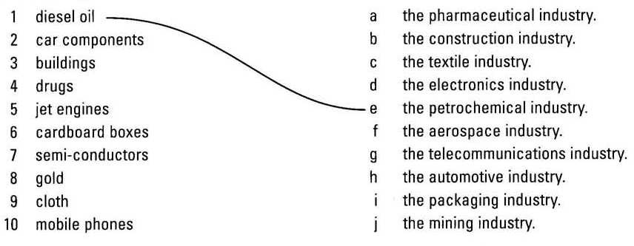LISTENING
- You are going to hear a manager from L`Oreal talking about her company. What do you know about L`Oreal’s business activities?
Listen to the description of the companies activities and complete the pie-chart and notes with the correct figures.
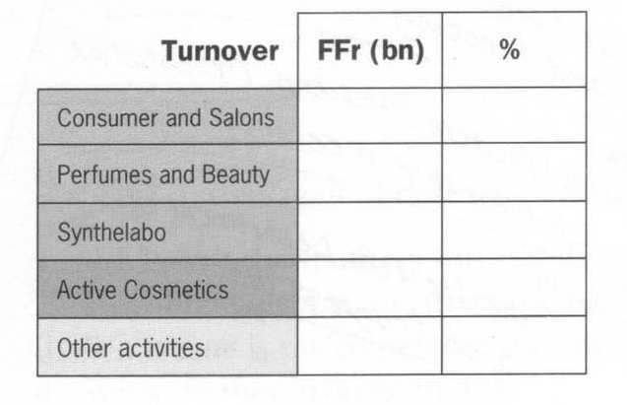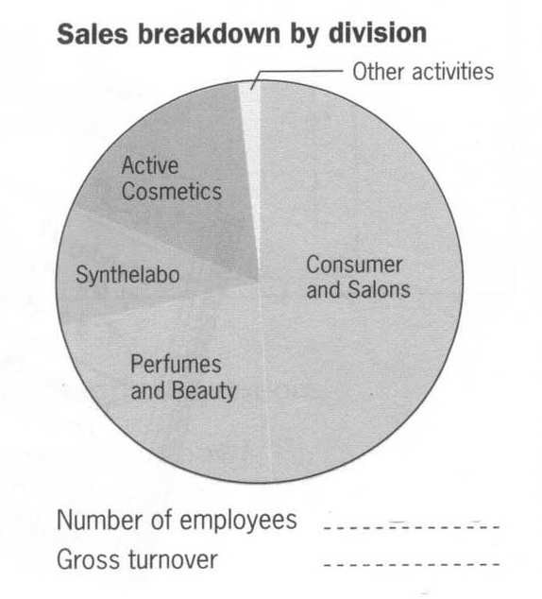

- Listen again and complete these extracts from the presentation.
  - We have production ,
in all five continents.

and

  - …the largest part of our comes form Consumer and Salons activities.
  - Here we have an exceptional of prestigious
which includes Lancome, Helena Rubinstein and Biotherm.
  - … this division has dual objectives: firstly to develop new, technically advanced cosmetics, and scondly to out close relationships with pharmacists – a key of .
  - Synthelabo is making in the treatment of central nervous system disorders at the moment, and it will become a world
in this in the future.
  - ….we a major in the Marie- Claire publishing group…

- What do these companies do? Talk about each company’s activities using word form A and B below.
Microsoft designs and sells IT software.


READING
General Electric
GE is a diversified technology, media and financial services company. The company mission statement is to create products that make life better: from aircraft engines to industrial machinery to insurance, medical technology, television news and plastics. GE operates in more than 100 countries and employs more than 300,000 people worldwide.
- Name two more industry sectors mentioned in the text: Technology …
- Name two more things that GE produces: Aircraft engines…
- How many people work for GE?
- Which word means that GE has many different business activities?

- Work in pairs. Task for Student A
Read the company profile and answer Student B’s questions.

Virgin is a leading international company based in London. It was founded in 1979 by Richard Branson, the present chairman. The group has seven main divisions: cinema, communication, financial services, hotels, investments, retail and travel. Its retail segment is led by Virgin Megastores. Virgin operates in 23 countries, including the United States, the United Kingdom, Continental Europe, Australia and Japan. In 2008 the combined sales of different Virgin holding companies exceeded $ 18 bn.

Now ask Student B questions about the company that he or she has read about, and complete the notes below.
Name of company Headquarters Chairman Business Activities
Main Markets Sales in 2008

- Task for Student B

Read the company profile and answer Student A’s questions.

Motorola maintains sales, services and manufacturing facilities throughout the world, conducting business on six continents. Its major business areas are: advances electronic systems, components and services, two-way radios, paging and data communications, automotive, defence and space electronics and computers. It has the largest portfolio in the world of cellular phones. The CEO is Christopher Galvin and the headquarters are situated in Chicago. Sales in 2008 were $ 31.1 bn.

Now ask Student A questions about the company that he or she has read about, and complete the notes below.
Name of company Headquarters Chairman Business Activities
Main Markets Sales in 2008

SPEAKING

Work with a partner. Think of a company in your country or town. What are its main activities? Does it specialize in one industry sector or is it diversified?

UNIT 2. COMPANY STRUCTURE VOCABULARY
- Here are three diagrams representing the structure of an organization. Look at diagram 1. Which group of people
- owns the company?
- sells to the company?
- formulates policy?
- buys from the company?
- works for the company?

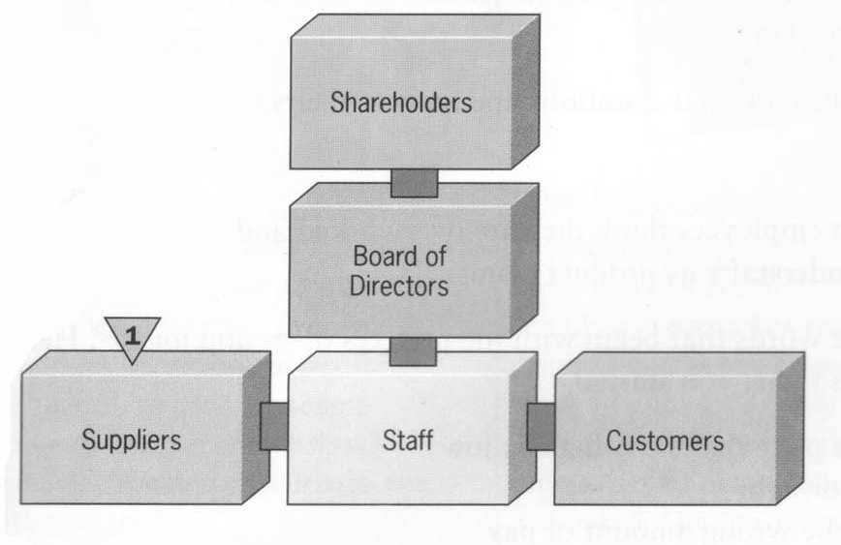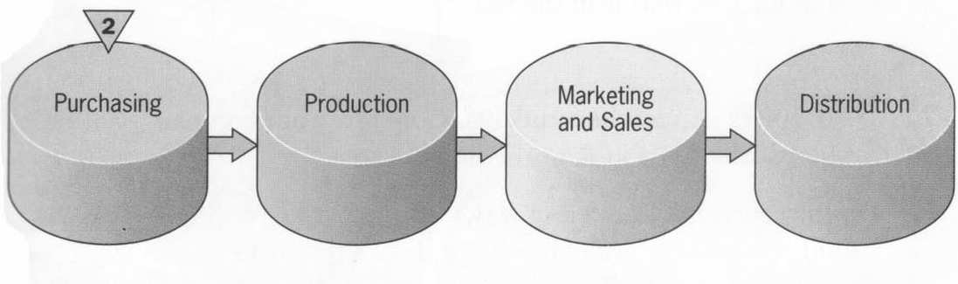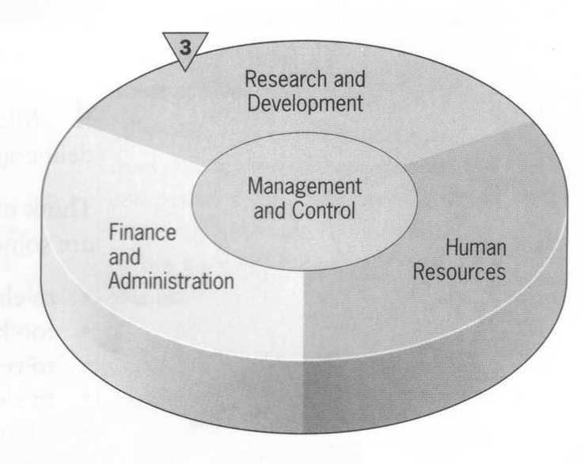
- Look at diagrams 2 and 3. Which part of the organization
- manufactures the products?
- sells the products?
- deals with personnel matters?
- creates new products?
- buys supplies?
- gets the products to the consumers?
- records transactions, collects cash, makes payments, and calculates costs?
- plans, schedules, monitors, measures, and gives direction?

LISTENING
  - Listen to seven people talking about their work and decide which department each one works for.
1. 2. 3. 4. 5. 6. 7.
  - List the verbs in the box in groups of similar meaning to complete the word network. Use the dictionary entries below if necessary.
oversee, monitor, boost, sort out, lead, improve, deal with, stimulate, increase, be in charge of, solve, clear up, keep an eye on, check, supervise, manage
to be in charge of – to be the person who controls or is responsible for a
group of people or an activity
to boost – to increase something such as production or sales
to check – to do something in order to find out whether something that you think is correct, true or safe
to clear up – to find the whole explanation for something that is strange or hard to explain
to deal with – to take the correct action for a piece of work
to improve – to make something better
to lead – to be in charge of an important activity or a group of people
to monitor – to carefully watch and check a situation in order to see how it changes or progresses
to oversee – to be in charge of a group of workers and check that a piece of work is done satisfactorily
to sort out – to deal with problems
to stimulate – to make something become stronger
to supervise – to be in charge of a group of workers or students and be responsible for making sure they do their work properly

performance | problems | profits | people

  - Study the description of a typical company. Complete the diagram.
Most companies are made up of three groups of people: the shareholders (who provide the capital), the management and the workforce. The management structure of a typical company is shown in this organization chart.
At the top of the company hierarchy is the Board of Directors, headed by the Chairperson or President. The Board is responsible for policy decisions and strategy. It will usually appoint a Managing Director or Chief Executive Officer, who has overall responsibility for the running of the business. Senior managers or company officers head the various departments or functions within the company which may include the following.
- Marketing & Finance
- Public Relations & Research and Development or R&D
- Production & Information Technology or IT
- Personnel or Human Resources
  - Shering is an international company engaged in agricultural and pharmaceutical activities. The French pharmaceutical subsidiary has recently changed its organizational structure. Listen to a manager describing the new structure to some colleagues from other parts of the organization and complete the organigram.
  - Listen again and answer these questions.
- Which person on the chart made the presentation?
- Who does he report to?
- What are the Unit Directors responsible for?
- What three advantages of the work group does he mention?
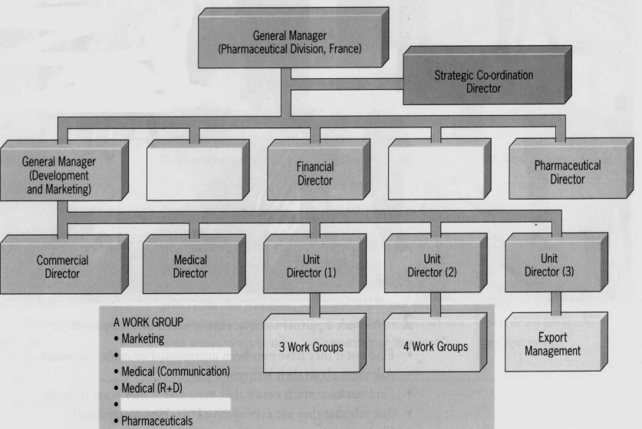

READING
  - You are going to read an article about the company Philips. Before reading the text about Philips, decide whether you think these statements are true (T) or false (F)?
    - It is the world’s second biggest electronics company.
    - It has produced over 100 million TV sets.
    - Its headquarters are in Amsterdam.
    - It was the first company to produce compact discs.
    - It is active in a small number of specialized businesses.
    - It provides the lights for famous landmarks such as London’s Tower Bridge.

Read the text and check your answers.

The Philips story

The foundations of the world’s biggest electronics company were laid in 1891 when Gerard Philips established a company in Eindhoven, the Nether- lands, to manufacture light bulbs and other electrical products. In the beginning it concentrated on making carbon filament lamps and by the turn of the century it was one of the largest producers in Europe. Developments in new lightning technologies fuelled a steady programme of expansion and, in 1914 it established a research laboratory to stimulate product innovation.
In the 1920s, Philips decided to protect its innovations in X-ray radiation and radio reception with patents. This marked the beginning of the diversification of its product range. Since then, Philips has continued to develop new and exciting product ideas like compact disc, which it launched in 1983. Other interesting landmarks include the production of Philip’s 100-millionth TV set in 1984 and 250-millionth Philishave electric shaver in 1989.

The Philips Company
Philips headquarters are still in Eindhoven. It employs 256,400 people all over the world, and has sales and service operations in 150 countries. Research laboratories are located in six countries, staffed by some 3,000 workers. It also has an impressive global network of some 400 designers spread over twenty- five locations. Its shares are listed on sixteen stock exchanges in nine countries and it is active in about 100 businesses, including lighting, monitors and shavers; each day its factories turn out a total of 50 million integrated circuits.

The Philips People
Royal Philips Electronics is managed by the Board of Management, which looks after the general direction and long-term strategy of the Philips group as a whole. The Supervisory Board monitors its general course of business of the

Philips group as well as advising the Board Management and supervising its policies. These policies are implemented by the Group Management Committee, which consists of the members of the Board of Management, chairmen of most product divisions and some key officers. The Group Management Committee also serves to ensure that business issues and practices are shared across the various activities in the group.
The company creed is “Let’s make things better”. It is committed to making better products and systems and contributing to improving the quality of people’s work and life. An on travels around the world, whether passing the Eiffel Tower in Paris, walking across London’s Tower Bridge, or witnessing the beauty of the ancient pyramids of Giza, you don’ have to wonder any more who lit these world famous landmarks, it was Philips.
  - Read “The Philips Story” again. Why are these dates important?
1891 1914 the 1920s 1983 1984

LANGUAGE FOCUS
Present Perfect and Past Simple
The Past Simple is used to talk about actions in the past that have finished.
It talks about 'then' and definitely excludes 'now'.
The Present Perfect Simple is used to look back on actions in the past from the present. It always includes 'now'.
These sentences are in the past with no connection to the present.
- I first got to know him 10 years ago.
- I started work here in 1989.
Now look at these same situations seen from the present.
- I've known him for 10 years.
- I've worked here since 1987.
We use time expressions like 'yesterday', 'ago', 'last year', 'in 1999' with the Past Simple.
- We made our last purchase from them over a year ago.
- She joined the company in 1999.
We use time expressions like 'ever', 'never', 'since' with the Present Per-

fect.

- I've never seen so many people here before.
- Have you ever been more surprised?
- I've done a lot since we last talked about it.

- Complete the following company profile with either the Present Perfect or Past Simple tense of the verb in brackets.
Procter & Gamble 1 has been (be) in the soap business since William Procter and James Gamble 2 (form) their partnership in

1837. In order to raise capital for expansion, the partners 3
(set up) a corporate structure in 1890, with an appointed pres- ident at the helm of the company.
It 4 (undergo) further restructuring in 1955, with the creation of individual operating divisions to better manage their growing lines of products. John E. Pepper 5 (lead) the company since 1995, when he was elected Procter & Gamble's ninth Chairman and Chief Executive Officer. The same year, the company 6 (move) from managing the business under two geographic areas, US and Inter- national, to four regions – North America, Latin America, Asia, and Eu- rope/Middle East/Africa. Ivory soap, which 7 (be- come) a common household name, 8 (come) onto the market in 1879. With the introduction and instant success of Tide laundry detergent in 1946, Procter & Gamble 9 (embark) on a strategy of rapid growth into new product lines as well as new markets around the world. The firm's commitment to innovation in technology 10
(help) Tide to remain their single brand over the years. Perhaps the product that 11 (have) the greatest impact, howev- er, is Pampers, the disposable nappy which they 12 (launch) in 1961.
As a result of their aggressive expansion policy, Procter & Gamble sales 13 (reach) $10 billion in 1980. Since then the company 14 (quadruple) the number of consumers it can serve with its brands – to about five billion people around the world. In 1998 sales 15
(rise) to $37.2 billion.

- Read the story about Procter & Gamble again and answer the questions:
How was the company formed? When?
Why did the partners set up a corporate structure? When did the company undergo further restructuring? What did the restructuring result in?
Who has led the company since 1995? How did the managing system change?
What are the main landmarks of the company development? What is the company policy?
What enabled the company to embark on a strategy of rapid growth? What product has had the greatest impact?
What did their aggressive expansion policy result in? How many consumers do they have worldwide?

LISTENING
What do you know about the LEGO toy manufacturing company?

A. Listen to 8 short extracts from a talk about the early history of the LEGO company. Match the extract with an event .
1.
2.
3.
4.
5.
6.
7.
8.
- Ole Kirk Christiansen founded the company
- The company adopted the famous LEGO name
- Fire destroyed the factory
- The LEGO company purchased equipment to produce plastic toys
- The company manufactured the first building brick
- The company launched their system of play
- The LEGO Group established the first foreign sales company in Germany managed by Axel Thomsen
- Ole Kirk died and his son Godtfred Kirk succeeded him

B. Listen again and answer these questions.
- What sales terms did LEGO offer retailers on their original building bricks?
- When Ole Kirk founded the company, what did it produce?
- How old was Godtfred when he started working for the company?
- What potential did Godfred see in the building bricks?
- Why was the factory fire such a disaster?
- Who was Alex Thomsen?
- Where did the name LEGO come from?
- What did the Danish toy trade magazine say about plastics?

READING

  - Read the description of shamrock organization.

The Irish management thinker, Charles Handy, believes that the traditional company is dying. In his book, The Age

of Unreason, he says that today more and more people are working in “shamrock organization”.
The first leaf of the shamrock represents the organization’s core workers. These employees are usually qualified professionals and managers. They work very long hours, and in return, receive high salaries and generous benefits.
Work that is not essential to the organization goes to people in the second leaf of the shamrock. These people are normally self-employed and are specialists in certain kinds of work. They often sell their services to more than one organization.
The third leaf of the shamrock is flexible workforce – temporary and part-time workers. The organization saves money because it only employs these people when it needs them.

  - Compare the shamrock organization with a traditional company. What are the advantages and disadvantages of a shamrock organization for the following?

 | advantage | disadvantage
For the company
For core workers
For self-employed people
For flexible labour force

SPEAKING

A company reorganization

A traditional company has decided to reorganize as a shamrock organization in order to cut costs. Work in small groups and discuss these points. In each case give your reasons.
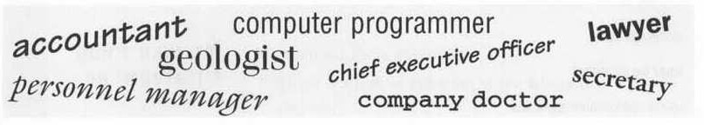
- Which of these jobs should you keep in the core?

What other jobs should be in the core?
- Is it better to use self-employed workers or a flexible labour force to do the non-core jobs?
- Which of these functions should you keep in the core?
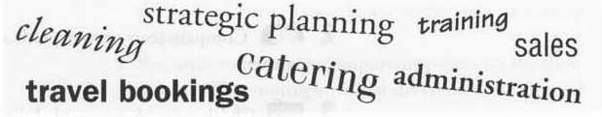

- Which non-core functions should be done by self-employed workers and which by a flexible force?
- In the business world which of the three groups do you think is growing most quickly? Give reasons for your opinion.

PART III TRAVEL AND CULTURE
STARTING UP
- What do you call someone who comes from each of these countries?
Australia Canada Holland India Norway Sweden

Brazil France Hungary New
Zealand
Saudi Arabia
the USA

Follow the model: If he comes from Italy he’s Italian.
If she comes from Ireland she’s an Irishwoman.
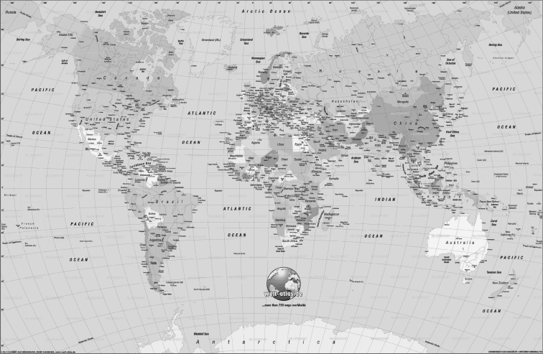

- Working in pairs, make a list of the following countries. Be careful about your spelling!
5 African countries

5 Asian countries

5 countries in the Middle East

5 Latin American countries

5 countries belonging to the European Union (EU)

5 countries which don’t belong to the EU

When you’re ready, join another pair. Ask them to tell you what they would call a person from each of the countries on your list.

UNIT 1. BUSINESS AND CULTURE READING
- Discuss these questions:
- If someone comes from another country, what differences do you ex- pect in their behaviour, manners, eating habits, etc.? Think of some examples.
- Which other nationalities do you think are most different from your own? Give your reasons.
- Read this article and choose one of these titles for it:
When in Rome … Problems that business people face
Travelling abroad Good manners, good business
Doing business in Europe I didn’t mean to be rude!
Nobody actually wants to cause offence but, as business becomes ever more international, it is increasingly easy to get it wrong. There may be a single European market but it does not mean that managers behave the same in Greece as they do in Denmark.

In many European countries handshaking is an automatic gesture. In France good manners require that on arriving at a business meeting a manager shakes hands with everyone present. This can be a demanding task and, in a crowded room, may require gymnastic ability if the farthest hand is to be reached.
Handshaking is almost as popular in other countries – including Germany, Belgium and Italy. But Northern Europeans, such as the British and Scandina- vians, are not quite so fond of physical demonstrations of friendliness.
In Europe the most common challenge is not the content of the food, but the way you behave as you eat. Some things are just not done. In France it is not good manners to raise tricky questions of business over the main course. Business has its place: after the cheese course. Unless you are prepared to eat in silence you have to talk about something – something, that is other than the business deal which you are continually chewing over in your head.
Italians give similar importance to the whole process of business enter- taining. In fact, in Italy the biggest fear, as course after course appears, is that you entirely forget you are there on business. If you have the energy, you can always do the polite thing when the meal finally ends, and offer to pay. Then, after a lively discussion, you must remember the next polite thing to do – let your host pick up the bill.
In Germany, as you walk sadly back to your hotel room, you may wonder why your apparently friendly hosts have not invited you out for the evening. Don’t worry, it is probably nothing personal. Germans do not entertain business people with quite the same enthusiasm as some of their European counterparts.
The Germans are also notable for the amount of formality they bring to business. As an outsider, it is often difficult to know whether colleagues have been working together for 30 years or have just met in the lift. If you are used to calling people by their first names this can be a little strange. To the Ger- mans, titles are important. Forgetting that someone should be called Herr Dok- tor or Frau Direktorin might cause serious offence. It is equally offensive to call them by a title they do not possess.
In Italy the question of title is further confused by the fact that everyone with a university degree can be called Dottore – and engineers, lawyers and architects may also expect to be called by their professional titles.
These cultural challenges exist side by side with the problems of doing business in a foreign language. Language, of course, is full of difficulties – dis- aster may be only a syllable away. But the more you know of the culture of the country you are dealing with, the less likely you are to get into difficulties. It is worth the effort. It might be rather hard to explain that the reason you lost the contract was not the product or the price, but the fact that you offended your hosts in a light-hearted comment over an aperitif. Good manners are admired: they can also make or break the deal.

- Decide if these statements are true (T) or false (F), according to the writer:
- +In France you are expected to shake hands with everyone you meet.
- People in Britain shake hands just as much as people in Germany.
- +In France people prefer talking about business during meals.
- It is not polite to insist on paying for a meal if you are in Italy.
- +Visitors to Germany never get taken out for meals.
- +German business people don’t like to be called by their surnames.
- Make sure you know what the titles of the German people you meet
are.
- +Italian professionals are usually addressed by their titles.
- A humorous remark always goes down well all over the world.

- Discuss these questions:
- Which of the ideas in the article do you disagree with?
- What would you tell a foreign visitor about ‘good manners’ in your country?
- How much do you think international business is improved by knowing about foreign people’s customs?

VOCABULARY
- Both in Britain and in the US people speak English, but not always in the same way. Which word in each pair below is American English?
Petrol – gasoline | Truck – lorry | Car park – parking lot
Holiday – vacation | Cab – taxi | Baggage – luggage
Return – round trip | Tube – subway | Flight attendant – steward
Motorway – freeway | Line – queue | Timetable – schedule
- Business people often have to talk about how they get around. Match the words and phrases in bold type (1-14) with the pictures (a-n).
  - I was lucky to get a seat in the carriage.
  - Fortunately there was plenty of room in the buffet car.
  - The high-speed train seemed to get us to the capital in no time.
  - The only hold-up was when the shuttle bus to the airport got stuck in heavy traffic.
  - The jam soon cleared.
  - The check-in was quick because I only had hand luggage.
  - I flew with my favourite airline as always.
  - On arrival, I went straight to the car hire desk to collect the hatchback
I’d booked.
  - It’s true I could have had a saloon this time since I had so little luggage.

  - As soon as they’d checked my driving license, I was away.
  - Soon I was cruising round the bypass.
  - There was a short queue at the toll station.
  - But it wasn’t long before I was inside the ring road heading for the centre.
  - 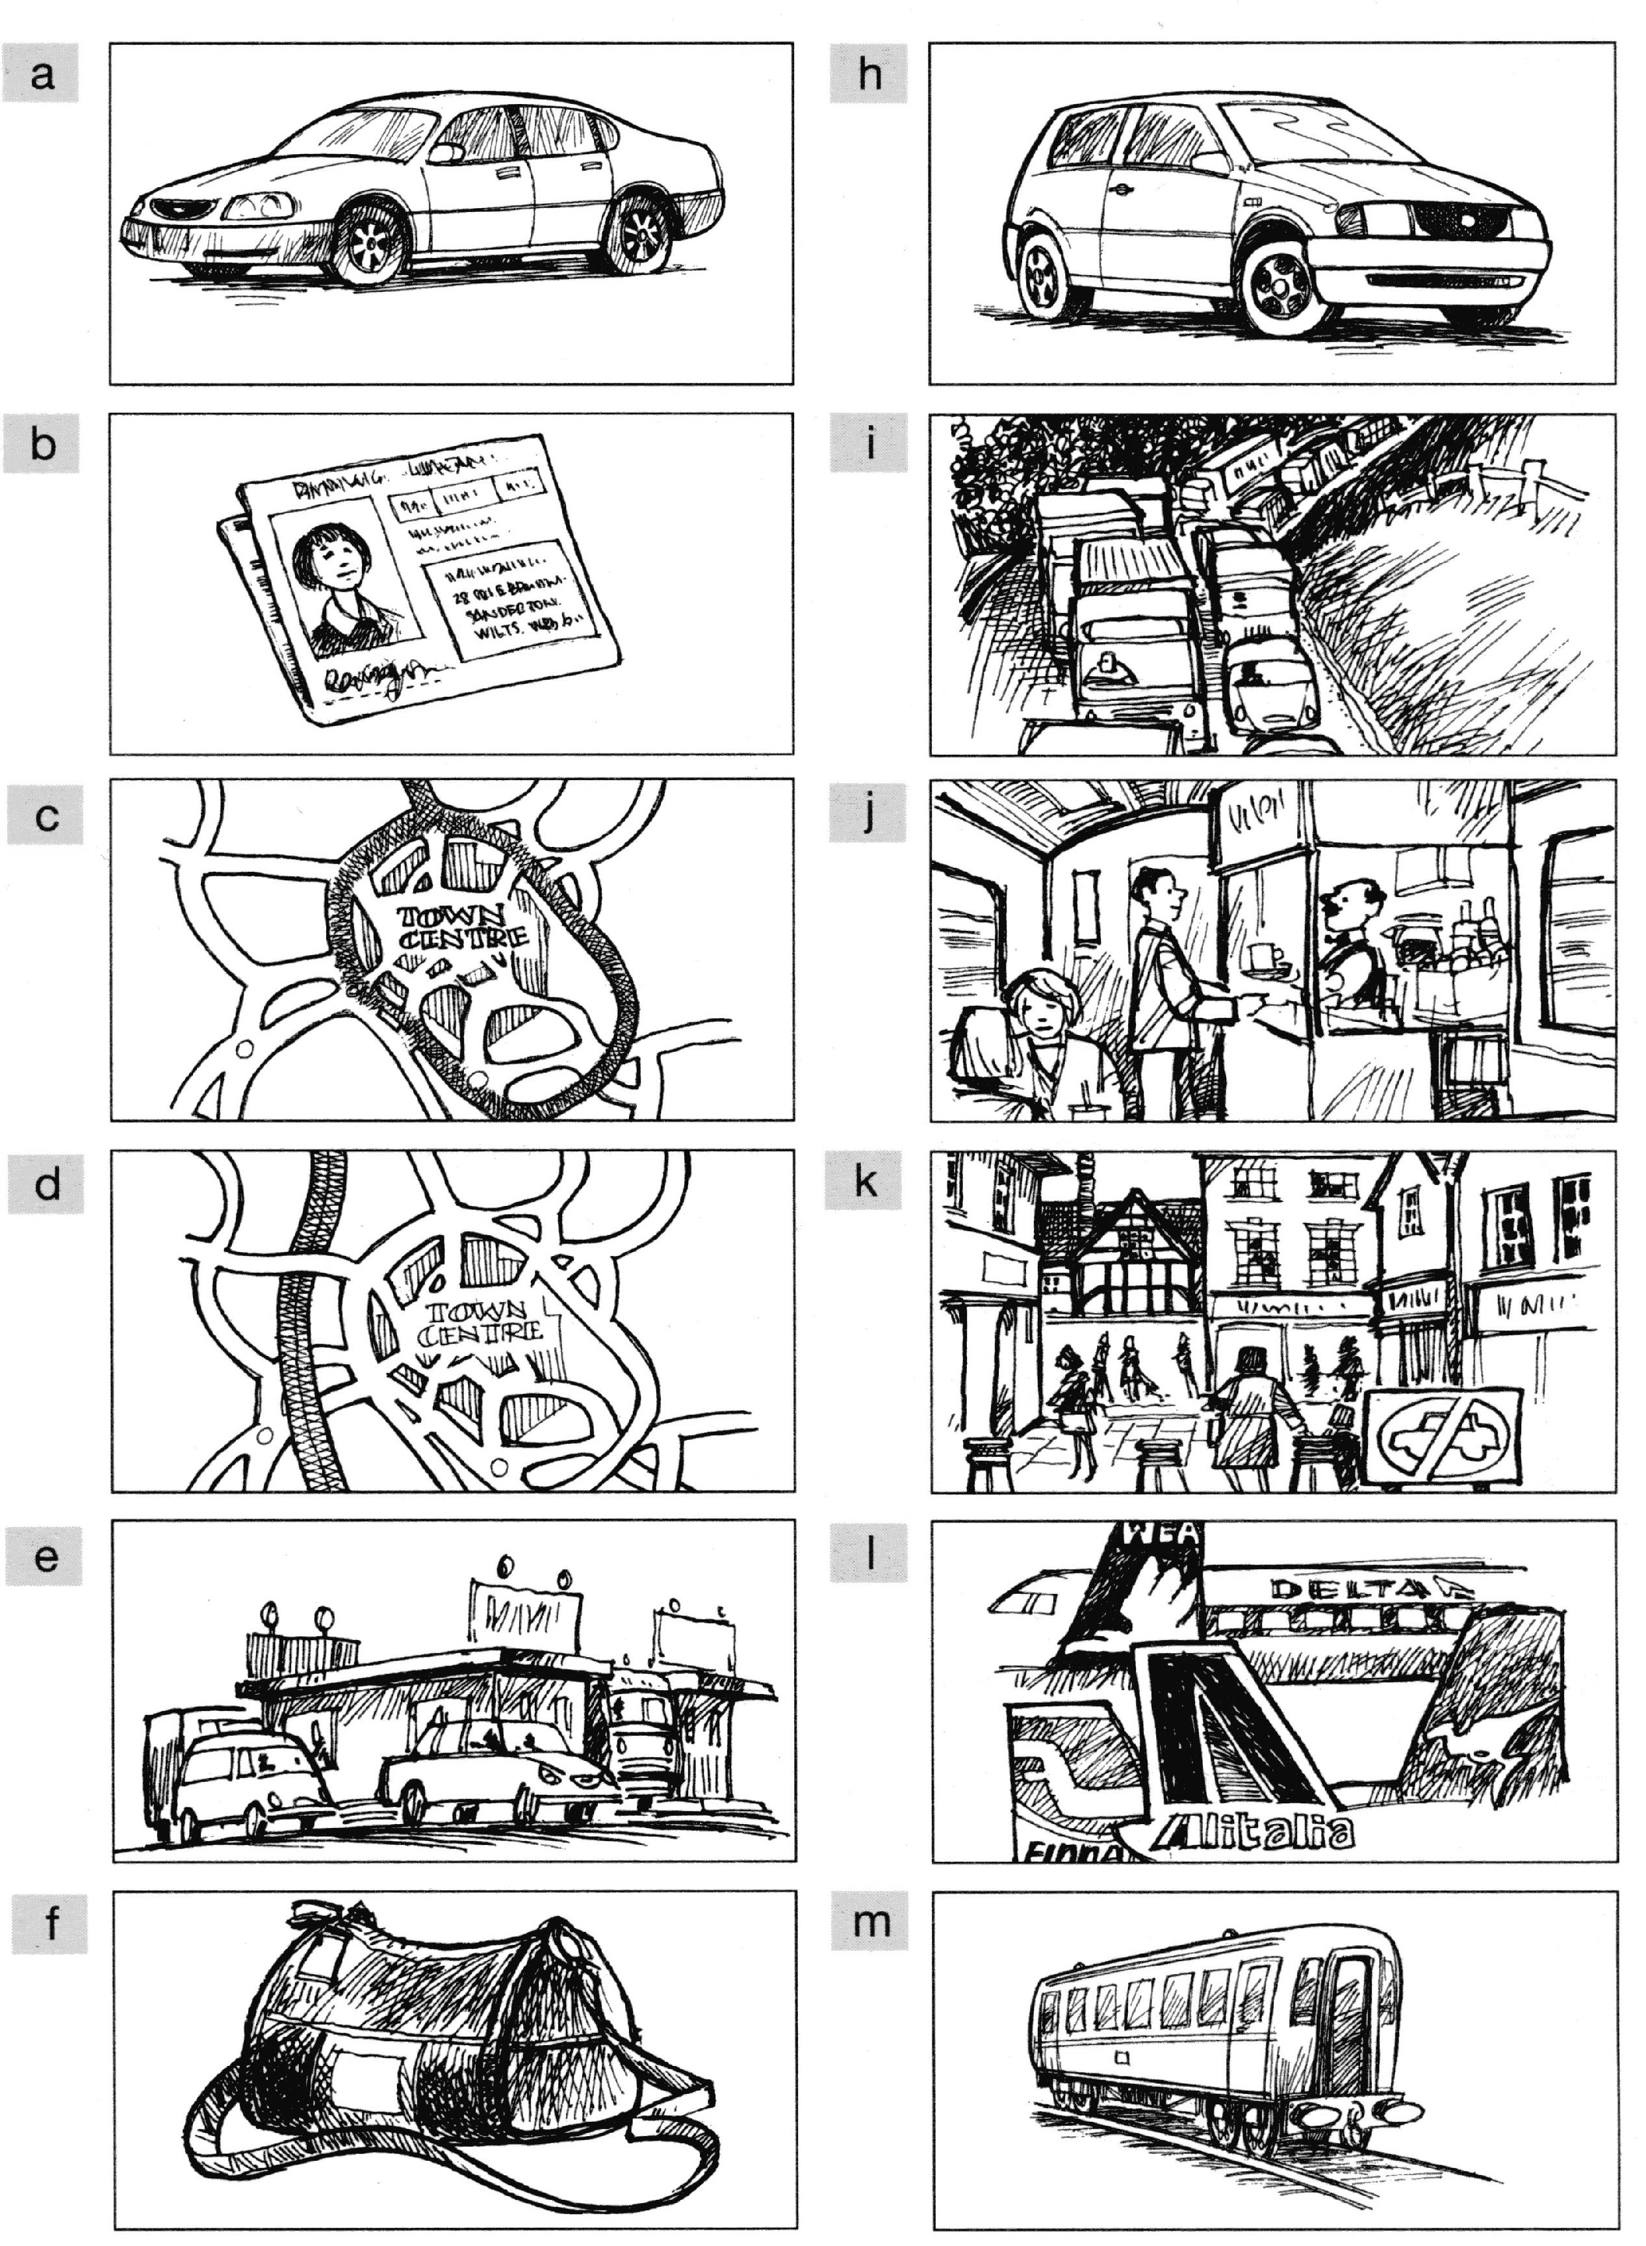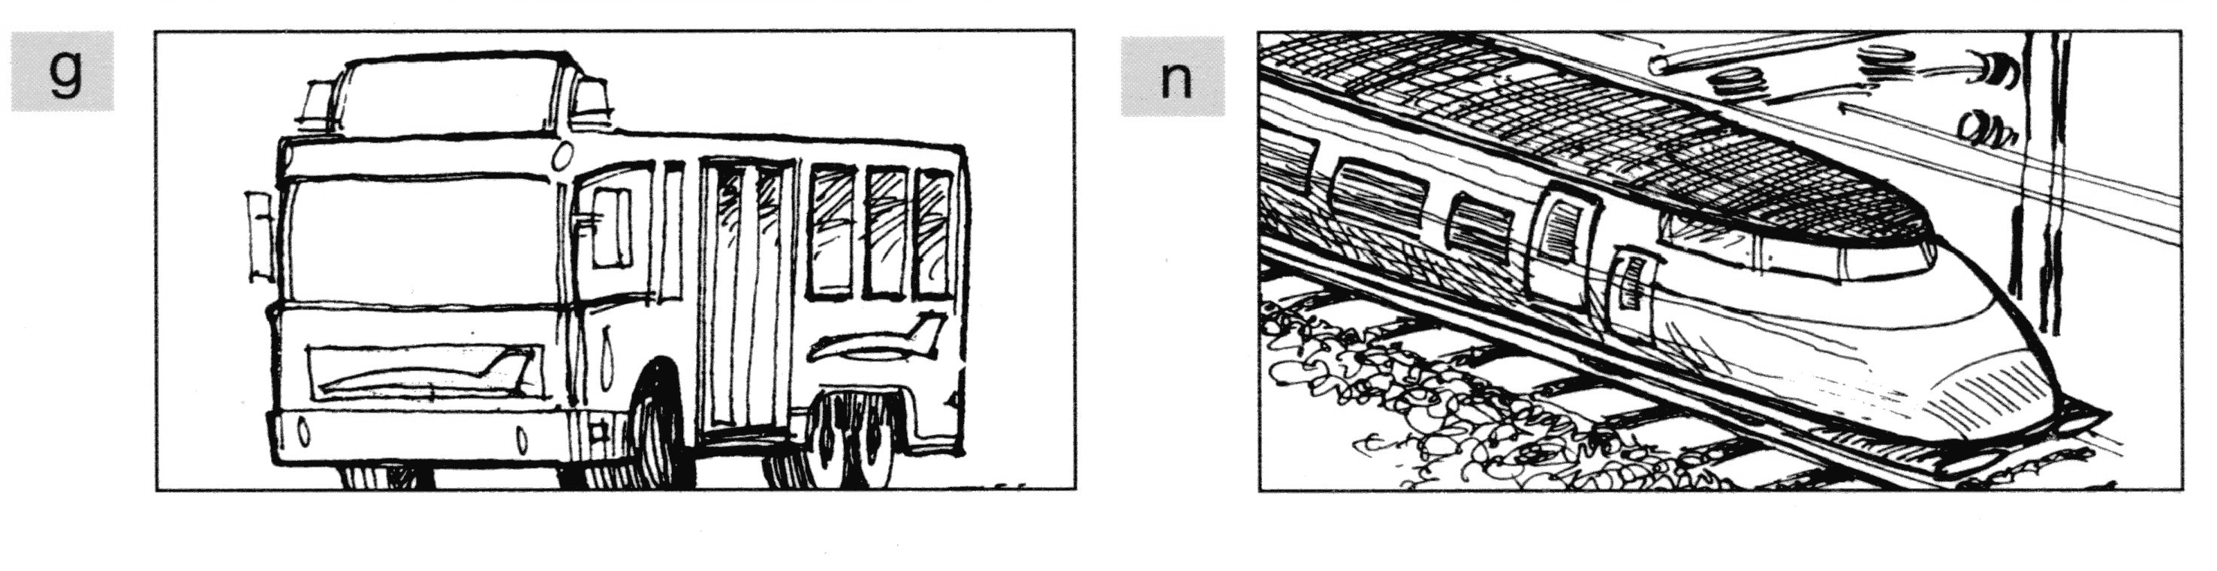The hotel was just on the edge of the city’s main pedestrianized area.

SPEAKING

SMALL TALK is what we call the non-serious conversation between people in social situations. The purpose of small talk is to get to know and develop confidence in the other person.

    - Are the following topics suitable as small talk at a business lunch or dinner? Mark the topics as safe, dangerous or very dangerous.

Topic | Safe | Dangerous | Very dangerous
Cars, traffic and transport
Children (your or your business partner’s
sons and daughters)
Clothes and fashion
Computers and new technology
Corruption in your business partner’s
national government
Films which you or your business partner
have seen
Food
Football (or any other sport)
Global warming, pollution and other
environmental topics
International politics
Marriage (your or your business partner’s
husband and wife)
Religion (your or your business partner’s
beliefs and religious practices)
The salary or wage you or your business
partner receive for working
The weather in your or your business
partner’s country
Travel and places you or your business
partner have visited
Wars between your country and your
business partner’s country
Your hobbies (e.g. gardening, dress-
making, shopping)
Your or your business partner’s political
beliefs or political party membership

    - The purpose of small talk is to make the other persons feel good about themselves and to show that you are interested in their lives. But your interest must never invade their privacy.

Part of the skill of small talk is to keep the conversation developing. Read what a business person says in italics and then choose the most suitable response from the visitor.
      - I’ve just bought a Toyota Classic 3900.
        - Really? I’ve heard that is a terrible car.
        - Really? How much did you pay for it?
        - Really? Will you buy one for me?
        - Really? Are you pleased with it?
      - My son has just gone to university.
        - Really? What is he studying?
        - You must be pleased to get rid of him.
        - I don’t believe you!
        - How can you afford to pay for him?
      - I enjoy collecting old books.
        - I prefer collecting old motorbikes.
        - I’m sure my old books are better than yours.
        - I think old books are boring.
        - That’s fascinating/ What kind of books do you like?
      - Our national team will be in the World Cup if we beat Bolivia on Friday.
        - Bolivia has a good team. I’m sure you will lose.
        - Bolivia has a good team. I’m sure it will be an interesting game.
        - Bolivia has a terrible team. Anyone can beat Bolivia!
        - Do you really want to be in the World Cup?
      - I’m afraid I have a bad cold.
        - I know someone who died from a bad cold.
        - Keep away from me! I don’t want to catch it.
        - That’s very bad luck. But thank you for coming to the meeting.
        - That’s nothing. I’ve got pneumonia!
      - I’m afraid it’s raining.
        - Yes, you really have a bad climate in this country.
        - Don’t worry, a little rain won’t hurt me.
        - I hope it won’t get any worse than this.
        - We usually have good weather in my country.

    - Compare your choices of the most suitable responses with another student. Look back at the responses you did not choose. Why were those responses not suitable?

UNIT 2. BUSINESS TRAVELLING

VOCABULARY
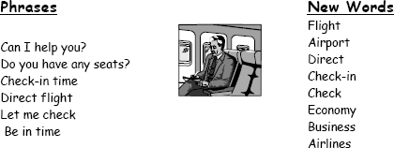
- Study the following words and phrases:

- Use the words from the box to fill in the blank spaces in the dialogue:
take (2), need, flight, see, time, help, have, airport, direct, check, seats, leave

Agent: Cathay Pacific Airways. Can I you?
Jake: Yes. I a from Tokyo to New York on Friday. Do you have any ?

Agent: Let me . Yes, I
Jake: Five thirty! What’s the check-in
on the 5:30 flight.
?

Agent: One hour economy. Thirty minutes business class. Will you
that?
Jake: No, I won’t get to the in time. When will the next flight
?
Agent: There won’t be another flight on Friday. There will be one on Saturday at the same time.
Jake: Fine, I’ll that.
Agent: Just let me . Oh, I’m sorry, that flight’s full.

READING
- Answer these questions.
- How often do you travel by air, rail, road or sea?
- What do you enjoy about travelling? What don’t you enjoy?
- Which is the best/worst airline you have flown? Why?

- Which of these things irritate you the most when flying? Rank them in order of most and least irritating.

Cancellations | Overbooking | Bad food
Jet lag | Not enough room | Long queues at check-in
Strikes | Lost or delayed luggage | No trolleys available

- Read the text and answer the questions below.

A Return to Spending and the Front Rows

BUSINESS travelers are back, and the airlines are eager to court them again.
Whether they are small-business owners, sales representatives or corpo- rate executives, business travelers these days are more often found at the front of the plane than at the back, where cuts in travel budgets confined them during the recession.
The restrictive company policies that banned business-class travel, limited accommodation to three-star hotels and replaced three-day sales conferences in Las Vegas with virtual meetings via conference calls have all but disappeared. The years of chasing costs have given way to a rebound in travel as the econo- my picks up.
The airlines have gleefully greeted the return of their premium travelers and are fighting more fiercely than ever for their loyalty with new business- class seats, refurbished business lounges and improved service on board.
Eric Shaver, who logs about 100,000 miles a year with United Airlines, said he had seen evidence of this trend this year. It has been harder to get up- graded to first class these days because so many frequent fliers are crowding the air.
“On a flight back from London last year, there were five rows of empty seats. A month ago, the flight was packed,” said Mr. Shaver, a managing direc- tor for a consulting and training firm called Kensei Partners. “Budgets had been cut to the bone. But you can’t keep your people on the bench forever.”
The rebound in business travel has proved a huge relief for airlines, hotels and car rental companies battered by the recession and the financial crisis. Thanks to growing demand, the airlines have been raising fares in recent months. Market research surveys show that in 2010 corporate travelers ac- counted for 36 percent of the domestic travel market in the US, which includes revenue from airlines, hotels, car rental agencies, trains and cruises, with spend- ing totaling $255 billion. That compares with spending of $233 billion in 2009.
Business travelers are often a good leading indicator for the economy. The airlines have embraced the return of their most valuable customers and are fighting for their loyalty more fiercely than ever. In that battle, the airlines have

upgraded their business cabins with plusher seats, flatter beds, tastier meals and better wines. And they are trotting out new services aimed at their business clients.
United Airlines is installing flat-bed seats in many of its planes flying in- ternational routes. Delta, for its part, is spending $2 billion to enhance its ser- vices, including upgrading its cabins with new business-class seats that recline fully. Even airports lounges where travelers can unwind or catch up on their e- mails are getting a makeover.
Business travelers, to be sure, still have to contend with the various has- sles of modern travel, from long airport security lines to delayed or canceled flights. But even there the airlines are eager to step in. Some are working on smartphone applications that would enable travelers to manage their own jour- ney. For instance, passengers will soon be able to rebook their tickets directly from their phones.
In a not-too-distant future, thanks to location services embedded in most smartphones, analysts foresee that airlines might also be able to track down passengers stuck in traffic on their way to the airport, or rushing to find a gate. They could offer, for instance, to automatically get them on the next flight or provide a map of the airport terminal.
American Airlines expanded an exclusive meet-and-greet personalized service, called Five Star, first opened for celebrities, because of increased de- mand from business travelers over the last two years. For $125, American helps speed its customers’ journey through the airport, from the curbside, through security and onto the plane.
The skies are getting crowded again. “Forget about finding a first-class seat, which is always sold out; I am having trouble finding an aisle or a window seat,” said Mr. Tenenbaum, a private investor and strategic consultant. “Planes are full.”

  - How did business travelers cut down their travel budgets during the recession?
  - What is characteristic of their economic behaviour now?
  - How do airlines react to the growing demand for business travel?
  - Which technologies will help travelers to manage their journey?


LANGUAGE FOCUS

- There is a number of countable and uncountable nouns in the text. Countable nouns can have a plural form; they can be used with a or an (an office, two offices). Uncountable nouns do not have a plural form.

Which of these nouns from the text are countable? Which are uncountable?
service | travel | airline
accommodation | location | security
research | flight | survey

- Correct the mistakes in the use of countable and uncountable nouns below.
Alpha Airlines flies to an extensive network of major destinations. We need information from you. Help us with our researches by completing two surveys and you will be entered into a prize draw for a trip for two people including seven nights’ luxury hotel accommodations in one of three exotic locations.

- Sonia Schmidt is phoning to book a hotel room. Complete the conversation by putting the words in brackets in the correct order.
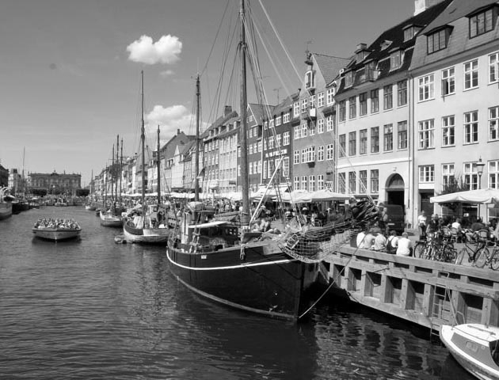

RECEPTIONIST: Good morning. Blakeney Hotel.
SONIA: Hello. My name’s Schmidt. I’d like to book a room please.
RECEPTIONIST: Certainly. (staying / how many nights / you / be / will?)
(1)
SONIA: Three. Starting next Thursday. RECEPTIONIST: Yes, we have rooms available. Double or single?
SONIA: Double please. (available / is / one / with a sea view?)
(2) RECEPTIONIST: Yes. By the way, (have / about / the special offer / we are
running / you / at the moment / heard?)
(3)

SONIA: No.
RECEPTIONIST: It’s four nights for the price of three. (don’t / take / it / advantage / you / why / of?)
(4) SONIA: (have / for it / what / I / to / do / to qualify / do?)
(5) RECEPTIONIST: Just confirm your reservation in writing and pay a ten per
cent deposit.
SONIA: (be / much / would / that / how?)
(6) RECEPTIONIST: £15.
SONIA: Yes. I think I’ll do that. (to / make / the cheque / who / I / should / payable?)
(7) RECEPTIONIST: The Blakeney Hotel.
SONIA: OK. I’ll post it today.
RECEPTIONIST: Thank you very much. We’ll look forward to seeing you. SONIA: Thank you. Goodbye.
RECEPTIONIST: Thank you.

LISTENING

David Creith, Customer Service Teaching Manager for an international airline, is talking about the problems he has to solve for business travellers.

  - Before you listen to the conversation, try to predict what the problems might be.

  - Now listen to it and answer these questions.
    - David Creith is the Customer Service Teaching Manager:
a) for which airline? b) at which terminal?
c) at which airport?
    - Some people want:

a) b)
c)
    - Why is it not possible to give everyone the seat they want?
    - Why do airlines have to oversell flights?

    - Who are Gold Card holders?
    - What do Gold Card holders often ask for?

 WRITING
Below are some details of a trip you are planning to make to meet a colleague, Jack Lott, in London. Write an informal e-mail message to Jack explaining your travel arrangements. Jack has offered to meet you at the airport, so make sure he knows your flight arrival details.
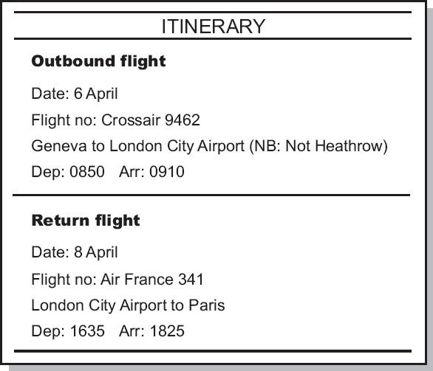

INFOQUEST – Visiting Barcelona

Your boss is going to Barcelona to meet an important customer. He wants to take the customer out to diner to try traditional Catalan food.


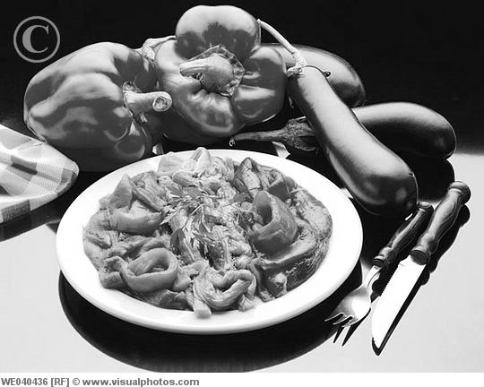

Task 1 – the research
This website will give you information about restaurants in Barcelona.

Barcelona tourism – http://www.barcelonaturisme.com

On the language bar select English. Click on ‘Where to eat in Barcelona’ in the middle of the page. In the restaurants search engine use the drop-down menu next to Category to select Catalan and then click on Search. In the list of search results, you can click on the Location button for each restaurant to see its position on a map of Barcelona. You can also click on the +information button to learn more about each restaurant. Scroll to the bottom of the list and click on Forward to see more restaurants. Fill in the table.

 | Address and | Average cost of meal per person |  | Your
Name of | interesting |  | Information | impression
restaurant | places in the |  | about the food | from the
 | area |  |  | photograph

Task 2 – giving options
Use the phrases in the box to help you give your boss the options for restaurant:
You have … options: First of all there’s … And then there’s … And finally there’s …
Giving options:
The restaurant is near (interesting place). They have good (type of food).
The restaurant is very traditional / modern / comfortable.

PART IV PRODUCTS AND SERVICES

UNIT 1. BRANDS AND ADVERTISING

STARTING UP
- Pick up some product you have with you (a mobile phone, a laptop, a watch, a jacket, a bag, etc.) and describe it using the following expressions without naming the object. Let your partners guess what it is.
It is made in … (country of origin) … It is sold … (distribution channel) … It is advertised … (media)…
It is in the … (€40 to €50) price range.
I bought it because … (your own reason) …

- Now give a fuller description of your object paying attention to its size, shape, materials, design, function, features, etc. You can use the following adjectives and nouns:
large, small, tiny, medium-sized, square, oval, round, plastic, silk, cotton, leather, well-designed, fashionable, luxurious, multifunctional

- Name some of your favourite brands. And answer these questions.
  - Are they international or national brands?
  - What qualities does each one have? Use the following words and phrases to help you.
value for money, timeless, well-made, durable, inexpensive, cool, reliable, stylish, sexy

  - Why do people buy brands?
  - Why do you think some people dislike brands?

- A recent survey named the brands below as the world’s top ten. Which do you think is number one? Rank the others in order.
Marlboro, Nokia, Mercedes, General Electric, Intel, IBM, Microsoft, Coca-Cola, McDonald’s, Disney

READING
- Answer the following questions.
  - What famous companies in the world producing clothes do you know?
  - Do you wear clothes made by these companies?

- Now read the text and answer the questions.
  - Who became President of the company mentioned in the text in 1985?
  - What European countries does the company have factories in?
  - Was this company always a success?
  - What did police find in 1993?
  - What do they hope for in the future?

THE LEVI’S STORY

The company that makes the most famous and popular trousers in the world. They are made of very strong cotton which originally came from Nimes in France.
Levi Strauss was a German immigrant who arrived in San Francisco in 1853. First, he made tents for gold prospectors. Then, he started to make trousers from the same material. In 1873 Levi’s dyed the trousers blue. Levi’s headquarters today is still in San Francisco and, in 1993, they sold 50 million pairs of their “501” blue jeans.
The company was not always successful. In the 1980s, they had problems but they changed management and in 1985 Bob Haas became President of the company. With large investment in marketing and advertising, Levi’s relaunched the original “501” jeans. The campaign was a huge success. In Great Britain the advertising was so successful that sales of “501” jeans rose by 800%.
Today, about 16,000,000 pairs of “501” jeans are sold in Western Europe and they are all made in factories in Scotland and France. More than half of Levi’s profits come from export.
The factory in France employs about 540 people who produce 18,000 pairs of jeans every day. With thirty-five factories in the US, the company is a major employer, particularly in the South. Unfortunately, because this is such a popular product there are many “private” copies made also. In 1993, for example, police throughout the world found 2,000,000 fake pairs of Levi’s jeans.
In the future, they hope that more companies will allow casual dress so that sales will rise as office employees start to wear jeans to work. Just what Levi Strauss designed more than one hundred years ago – working trousers!

- Which of these statements are true? Correct the false ones.
  - The text is about the company which makes the most fashionable bags in the world.
  - Levi Strauss made tents for those in search of gold to start with.
  - The company made huge profits all the time.
  - Now jeans are produced in all countries of the world.
  - Export plays an important part in the business of this company.
  - No other clothes can compete with Levi’s jeans.
  - Levi Strauss had a great idea – he designed trousers for workers.

- Discuss these questions in pairs.
  - Why do young people all over the world prefer to wear jeans?
  - Can you name products of other companies which compete with jeans?
  - Do you think advertising played a big role in making people believe that jeans were very comfortable?

VOCABULARY
- to arrive - прибывать
- headquarters – штаб-квартира
- to advertise – рекламировать
- advertising – работа, связанная с рекламой
- advertisement – реклама
- to launch – запустить, начать
- to relaunch – начать снова
- campaign – кампания
- to rise – подниматься
- profit – прибыль
- to employ – нанимать на работу
- employer – работодатель
- employee – служащий
- private – частный
- fake – подделка, поддельный
- to design – предназначать, проектировать
- to distribute – распространять

- Match the words (1 – 8) with their definitions (a – h).
- luxurious a) extremely small
- fashionable b) the place where a company or organization has its offices
- tiny c) a series of actions intended to produce political or social change
- leather d) very expensive and comfortable
- headquarters e) money that you make from your business

- profit f) made to look like something real
- campaign g) popular at a particular time
- fake h) a strong material made from animal skin

- Complete each sentence with an appropriate word form the Vocabulary list.
- Now we are going to our …… which are situated in the centre of the
city.
- The ….. is directed at the of our goods.
- When did you …… this product?
- We have more than 1000 working in our offices.
- Last year our rose by 15%.
- Is your bag made of ?
- These goods were found out by the police to be …… .
- If we ………. well we’ll make good next year.
- This is the most costume I’ve ever seen.
- Our …….. will at 6p.m tomorrow.

- Look at the words in the box below. Label each item 1 for advertising media, 2 for methods of advertising or 3 for verbs to do with advertising.
directories 1 run commercials exhibition point-of-sale target
press
persuade mailshots public transport billboards
posters endorsement Internet
publicize promote place launch
sponsorship cinema
free samples leaflets
word of mouth radio
research slogans
sponsor television

- Choose the most suitable word from the words in brackets to complete the sentences.
  - Viacom Outdoor is an advertising company that specializes in placing adverts on (billboards/public transport/television) such as buses.
  - Some perfume companies provide (leaflets/commercials/free samples) so that customers can try the perfume on their skin before they buy.
  - Advertising companies spend a lot of money on creating clever (slogans/directories/mailshots) that are short and memorable such as the message for the credit card Access: ‘Your flexible friend’.
  - Celebrity (exhibition/research/endorsement) is a technique that is very popular in advertising at the moment.
  - If news about a product comes to you by (word of mouth/press/ Internet) someone tells you about it rather than you seeing an advert.

  - If you have something to sell, you can (target/place/launch) an advertisement in the local newspaper
- The following words are often used to advertise a product. Match the words (1 – 6) to the words (a – f) to make collocations.
  - energy a) teasing
  - eye b) saving
  - thirst c) watering
  - money d) catching
  - mouth e) quenching
  - brain f) saving
- Which of these collocations would you use to describe these products?
- a soft drink
- a fruit bar
- a computer quiz game
- a low-power light bulb
- a range of smart clothing
- a range of supermarket own-brand products

LANGUAGE FOCUS
We make passive verb forms with the verb to be + past participle.
Today, about 16,000,000 pairs of “501” jeans are sold in Western Europe.
We often choose a passive structure when w are not interested in, or it is not necessary to know who performs an action.
Jeans are all made in factories in Scotland and France.
If we want to mention who performs an action, we can use by. Originally jeans were made by Levi Strauss.
We can use the passive to describe a process, system or procedure.
Finally the products are sold.
- Use this table to make passive sentences. For example, Diamonds are mined in South Africa. Then make similar sentences about products from your own country.

Diamonds Microchips | produce | Poland Kuwait
Semiconductors | manufacture | Japan
Electronic goods Coffee | make | The United States
Leather goods | refine | Finland Switzerland
Oil Rice Watches Coal | grow | Malaysia Russia
Copper Mobile phones | mine | Spain South Africa
 |  | Zambia China

- Change these active sentences into the passive so that they sound more natural.
  - Workers plant the gold variety of the kiwifruit worldwide.
  - Workers in France make these Renault cars.
  - Farmers grow this rice in India.
  - The employers asked the staff for their opinions.
  - A mechanic is repairing my car at the moment.
  - Somebody has found the missing file.
  - Somebody made this toy in Japan.

- This article describes how a healthcare company develops new products. Complete it with passive forms of the verbs in brackets.
The idea for how our company’s new products ….. (develop) is not new – it …. (model) on the well-known example of the Body Shop. When a new product ….. (plan), the first step is to send Product Development Agents to the region of the developing world chosen for their project. They start by finding materials that … (use) in the product. Then links ….. (arrange) with local suppliers. Wherever possible, products ….. (manufacture) locally as well, although the finished product ….. (export) for sale mostly in the developed world. Normally, products …. (ship) in large containers and …. (package) in their final form only when they reach their destination. The Product Development Agent identifies and establishes links with local material suppliers. After that he or she ensures that these links …. (maintain). The agent is also responsible for producing the goods safely so that human rights …. (respect) and local workers ….. (not exploit).

LISTENING
- Listen to a sales manager presenting a product to some buyers. Which of the adjectives below does she use? (Recording 1)
fashionable, stylish, elegant, user-friendly, high-quality, well-designed, reliable, flexible, popular, practical

- Listen again to the presentation. How does the sales manager describe the product? Fill in the missing words and phrases.
- As you can see, it’s attractive and ….. .
- The tower of wood.
- Let me its dimensions.
- It in three colours.
- Its s just under £25.
- It’s for storing CDs and CD-ROMs.

- It has several ………….. …………… which should appeal to our customers.
8 is that it’s easy to select the CD you want.
- The tower is well-designed. It’s …….., and user-friendly.
- It really does of music lovers.

- Jeremy Thorpe Woods, Head of Planning at Saatchi, a leading advertising agency based in London, talks about advertising campaigns. Listen to the first part of the interview and answer these questions. (Recording 2)
  - What does Jeremy say is the most important thing about advertising nowadays?
  - What are the key elements of a good advertising campaign, according to Jeremy?

- Listen to the second part of the interview and complete the information in the table. (Recording 3)

Planning and launch stages of an advertising campaign
Stage 1. Discussion with …..
Talk about their ……… ……. and ………. .
Develop a ………. .
Stage 2 Stage.
Observe the target audience, get to know them through
………. ……….. .
Stage 3. Develop a ……… ……… .
Talk to your creative partners about ……… ……… .
Discuss the communication idea with your ……….. .
Go back to your …….. ………. .
Stage 4. Make the ………. ……… .
Use to track how it is working.

SPEAKING
- What do you think about commercials? Do you think that the advertising practices described below are acceptable? Are any other types of advertisement offensive?
- Using children in advertisements.
- Using nudity in advertisements.
- Promoting alcohol on TV.
- Comparing your products to your competitors’ products.

- An image flashed onto a screen very quickly so that people are influences without noticing it?
- Exploiting people’s fears and worries.
- Which of the following statements do you agree with?
  - People remember advertisements not products.
  - Advertising raises prices.
  - Advertising has a bad influence on children.
- Work in small groups. Choose one of the products the information about which is given below. Prepare a short presentation about your product. Invent any additional information that you wish.

Product 1. OUTDOOR HEATER
Function: To heat the air outside a building.
- Gives out a lot of heat for 26 hours
- Powered by propane gas
- Easy to regulate the heat
- Light and easy to move
- Can be used in all weathers
- Easy to clean
- Attractive design Price: €299
Product 2. LEATHER ATTACHE CASE
Function: To carry business documents
- Expandable case with desktop facility
- Twin combination locks
- 3 compartments
- 2 extra pockets
- Pen and credit-card holders
- 2-year guarantee
- Dimensions: 40 cm (height) 49 cm (width) 15 cm (depth) Price: €70
Product 3. BABY MONITOR
Function: To check the health of a sleeping baby
- Works up to a 100-metre range
- Powered by mains or battery
- Low battery indicator
- Adjustable volume
- Has a belt clip and also a stand
- Easy to use and very light
- 3-year guarantee

Price: €48
Product 4. JUICE EXTRACTOR
Function: To extract juice from fruit and vegetables
  - Juices whole fruit and vegetables (hard and soft)
  - Powerful motor
  - Easy to pour juice
  - Safety locking lid
  - All parts easy to remove and can be washed in a dishwasher
  - Stainless steel filter
  - 10-year motor guarantee, 3-year parts and labour guarantee
  - Free recipe book Price: €68

- Now form groups and present your products to each other. Answer any questions that you are asked about them.

USEFUL LANGUAGE

Introducing the product
This is our new product
I’m going to tell you about our new product.

Describing the product
Let me tell you about its special features. It’s made of leather/wood/steel/aluminium. It weighs just 2.3 kilos.
It comes in a wide range of colours.

Stating the product’s uses
It’s ideal for travelling.
It’s designed to be used with any type of material.

Mentioning selling points
It has several special features.
A very useful feature is the energy-saving design. Another advantage is its very small size.

Inviting questions
Does anyone have any questions? Would anyone like to ask a question?

UNIT 2. QUALITY

STARTING UP
- Give examples of high-quality products or services.

- Which of the words and phrases below best express your idea of the quality of goods and services.
glamorous, luxurious, simple, functional, cool, beautiful, ordinary, comfort- able, reliable, fashionable, corresponding to high (low) standards, well- known, genuine, value for money, expensive, made in (country), long- lasting, hand-made, well-designed, traditional, modern, mass-produced

- Look at these sayings. What do they mean? Which of the ideas do you agree with?
  - ‘They don’t make them like they used to.’
  - ‘Quality not quantity.’
  - ‘You get what you pay for.’
  - ‘Don’t judge a book by its cover.’

- Discuss these questions.
  - What do you understand under the term the quality of goods?
  - Can you say the same about the quality of services?
  - How do you react if you are dissatisfied with a product or service?
  - Which of the following do you prefer to do?
- To make a complaint and claim a refund
- To pretend that everything is all right and go away
- To discuss with your friends or relatives your bad experience

READING

- Read the dialogue below and decide whether these statements are true or false.
  - Dmitry Vasilyev is dissatisfied with the service of the company which John Cartwright represents.
  - The main problem is the short-delivery of the ordered equipment.
  - It took the company one week to deliver equipment.
  - Mr. Vasilyev also complains of the inappropriate packaging which led to the damage of the equipment in one of the containers.
  - The parties have to go through arbitration procedures.
- In pairs discuss these questions.
  - Is it necessary for Mr. Vasilyev to go through arbitration procedures if the parties don’t solve the problems themselves?
  - What other steps would you recommend?
  - Do you think such problems often take place nowadays?
  - What should be done to avoid them?

WORSE THINGS HAPPEN

Dmitry Vasilyev and John Cartwright are discussing by phone some prob- lems which have arisen in connection with the delivery of equipment.
J. Cartwright: Hello. Mr. Cartwright speaking.
D. Vasilyev: Hello, John. This is Dmitry Vasilyev from Russia.
J. Cartwright: Hello, Dmitry. Any problems?
D. Vasilyev: Yes. Did you receive our fax yesterday?
J. Cartwright: Yes, we did.
D. Vasilyev: I’d like to know your reaction on it.
J. Cartwright: We’ve carefully studied your complaints, Dmitry. You are perfectly correct as to the short-delivery. Items 2.5 and 2.6 lacked in the consignment of equipment we sent you. It was overlooked by our controller. We apologize for the oversight. It won’t happen again.
D. Vasilyev: When will you send us these parts?
J. Cartwright: This week. By air. We’ll also send you some documents to facilitate customs clearance at your end.
D. Vasilyev: Fine. But what about the packaging? The cover of one of the containers was badly damaged. The equipment in this container was damaged a little too.
J. Cartwright: It wasn’t our fault, Dmitry. The equipment was packed in the required way. You should take this up with the captain of the ship.
D. Vasilyev: We’ve already done it, John. He believed that your packaging is to blame.
J. Cartwright: I must disagree totally with him. Perhaps you should have been firmer in dealing with him.
D. Vasilyev: Let’s go back to this matter in a couple of days, John. I’ll try to discuss it with the shipowners. But there is one more problem: a three-week delay in delivery of the equipment. We suffered some losses through this delay. I’d like to remind you that according to the sanctions clause of our contract we have the right to claim a penalty.
J. Cartwright: I’m afraid you haven’t that right, Dmitry. This delay was caused by a strike in the Brighton port. We consider this strike to be a force majeure circumstance that had a direct effect on the execution of our liabilities. We did our best to meet the deadline.
D. Vasilyev: I don’t agree, John. English ports are often hit by strikes. You were able to foresee this complication. Moreover, to meet the deadline you could have delivered the equipment to other port.
J. Cartwright: We couldn’t have done it owing to circumstances outside our control.
D. Vasilyev: If we don’t reach mutual understanding, our company will have to go through arbitration procedures.

J. Cartwright: There’s no need to get aggressive, Dmitry. There will be a meeting of our top executives at 11 o’clock where your claim will be on the agenda. I’ll try to settle it and ring you back after the meeting.
D. Vasilyev: All right. I’m waiting for your call, John.
J. Cartwright: Bye, Dmitry.

VOCABULARY
- complaint – жалоба, претензия
- to complain of – жаловаться на что-либо
- to make a complaint – подавать жалобу
- short-delivery – недопоставка
short-shipment
- consignment – партия
- to overlook – 1) не заметить, упустить из виду;
2) возвышаться
- oversight – недосмотр, оплошность
- to facilitate – обеспечивать
- customs clearance – растаможивание
- to be damaged – быть поврежденным
- fault – вина
- in the required way – должным образом
- to deal with – иметь дело с
- delay – задержка
- to suffer losses – нести потери, убытки
- to claim a penalty – требовать компенсацию
- to be caused by – быть вызванным чем-либо
- strike – забастовка
- execution – исполнение
- liability – обязательство
- to do one’s best – делать все возможное
- to meet the deadline – уложиться в срок
- to foresee – предвидеть
- force majeure
circumstance – форс-мажорное обстоятельство
- to go through
arbitration procedures – обратиться в суд
- top executives – руководители
- claim – претензия
- to be on the agenda – быть на повестке дня
- to settle – улаживать

- Match the words (1 – 5) to their definitions (a – e).
- complaint a) a time or date by which you have to do something
- consignment b) a situation in which something happens later or more slowly than you expected
- penalty c) something that someone complains about
- deadline d) a punishment for breaking a rule or law
- delay e) an amount of goods delivered

- Complete each sentence with an appropriate word from the Vocabulary list.
  - Our partners have got used to making ….. every time they are dissatisfied with something.
  - I don’t know how our controller ….. such a defect and I admit that you are right to ….. a penalty.
  - Due to the ….. at the airport last week this company didn’t receive these goods in time and now …. losses.
  - It isn’t our ….. that this container is damaged.
  - We will do ….. to come to some agreement and solve this problem as soon as possible.
  - I’m sure this short-delivery ….. by ….. circumstances.
  - If our ….. meet today they will certainly …. the problem.
  - Do you think we’ll have to go through ….. if we don’t pay the penalty?
  - According to the latest news our company will ….. with Canadian partners in the near future.
  - Do you know what will be on …… today?

С. Use the words in the box to complete the sentences.
identified, modified, failed, relaunched, durability, recalled, reliability, tested, launched

A defective product

We launched the product two years ago. We have a policy of zero defects so we were surprised when, shortly after the launch, we received complaints about the …. and …. of this product. Because of market feedback, we … the product so that any faults could be investigated. At the same time, we withdrew it from sale. After extensive tests, our engineers… a fault. As a result they were able to correct the fault and we … the product. We … the product under controlled conditions. Finally, we … the redesigned product in the market. Unfortunately, it … due to the lack of consumer confidence caused by bad publicity.

D. Complete the sentences below with words and phrases from the box. Use a dictionary if necessary.
Consumer satisfaction questionnaire, compensation, monitoring, routine checks, minimum standards, guarantee, inspection, after-sales service, faults

Quality control
- Quality control involves checking for … before selling goods.
- We always … the quality of our products.
- The quality control department found several faults during one of their
… .
- We use a number of … to measure quality.
- During the … a number of serious production flaws were found.

Customer service
- We measure how happy our customers are with an annual … .
- We ensure that the machines are well-maintained by offering …
- We provide our customers with a … lasting 10 years.
- If there is a faulty product, we usually offer customers … .

LANGUAGE FOCUS

We sometimes use one verb after another verb. Often the second verb is in the infinitive form.
We can’t afford to lower our standards. Should we refuse to pay them because the quality is so poor?
The verbs below are often followed by the infinitive: intend, mean, want, seem, claim, attempt, try, pretend, fail, guarantee, promise, arrange, hope, wish, plan, offer, forget, expect.

But sometimes the second verb must be in the gerund form. This depends on the first verb.
The decision involves reducing our heavy losses.
The following verbs are usually followed by the gerund:
admit, give up, enjoy, mean, can’t stand, resent, risk, suggest, look forward to, appreciate, involve, consider, mind, don’t mind, detest, delay, avoid, contemplate, deny, carry on, justify, remember, recommend, miss, put off.

Some verbs can be followed by the gerund or the infinitive form without a big change in the meaning.
She started loading the software. / She started to load the software.

With other verbs, however, the meaning changes.
We stopped to check the machinery. (We stopped what we were doing in order to check the machinery.)
We stopped checking the machinery. (We stopped our habit of checking the machinery.)

- In these sentences two of the verbs are possible and one is incorrect. Tick the two correct verbs.
- He …. to review our quality procedures.
  - promised b) delayed c) wanted
- I … improving reliability.
  - undertook b) suggested c) recommended
- I … to meet the Quality Director.
  - decided b) didn’t mind c) arranged
- She … to check the large order.
  - refused b) put off c) delayed
- We … to invest in new machinery.
  - consider b) hope c) plan

- Match these sentence halves.
- The board recommends a) to make mistakes with this big or-
der
- The factory can’t afford b) to turn around the company’s repu-
tation in the coming year
- The Research and Development c) producing the faulty products de-
partment should consider
- The new Chief Executive promised d) outsourcing some of the company’s
functions
- The factory stopped e) to accept our apology for the fault
- The customer refused f) changing its policy on product test- ing

- Choose the most appropriate form of the verb from the brackets to complete these sentences.
  - He stopped (to work / working) on the project after three months because of ill-health.
  - She was driving in a hurry but she stopped (to answer / answering) her mobile phone.
  - Did you remember (to call /calling) the customer yesterday?
  - The sales assistant forgot (to give / giving) the customer a discount.
  - I can’t remember (to offer / offering) you a replacement.
  - The customer forgot (to complete / completing) the guarantee form.

LISTENING

Quality management
    - Mike Ashton is Senior Vice President of Hilton Hotels International. The hotel employs 75,000 people in 65 countries. Listen to the first part of the interview. Complete the definition of quality. (Recording 1)
I believe the best way to define quality is to look very closely at customers’ ……………….. and then to look at the of business
to …………….. or those expectations, consistently.

    - Listen to the second part of the interview. Which of the following does the hotel use to measure quality improvements? (Recording 2)
a) contacting guests b) inspecting rooms daily c) contacting team members d) studying operational standards e) comparing check out times f) making unexpected visits.

    - Listen to the third part of the interview. According to Mike Ashton, why is investment in quality important? (Recording 3)

Telephone complaints

- Listen to a customer making a complaint. Answer these questions. (Recording 4)
  - What is the customer’s complaint?
  - What solution does the customer service representative suggest?
  - What solution does the customer want?
  - How does the call end?

- Listen again and complete the extracts from the dialogue.
Customer services: I’m sorry to hear that. What ……. to be the
………….?
Customer services: Could you give me ,
please?
Customer services: Can you bring it in? Then we can ………… ……….
the matter.
Customer services: I’m afraid it’s to
replace items.
Customer: Well, that’s not really ……….. …………… .
Customer services: All right then. Bring the machine in and we’ll see what for you.

SPEAKING
- One of you is the Production Manager for a powerful tools manufacturer. The other is a supplier of components. Role play the following telephone call.
Production Manager Supplier
Ring your supplier to Deal tactfully with the complaint complain about some electric Show understanding.
motors (order No. 1234) Get the facts. which have a number of defects Promise action. (don’t fit, not up to usual
standard, etc.).

- Think of a product or service which you have complained about. Tell the partner what the problem was and weather it was solved.

- Write down one of the most common complaints customers have, in your opinion (one sentence is enough). In pairs exchange your sentences and try to solve these problems.

USEFUL LANGUAGE
Complaining

Making the complaint
I’m ringing to complain about…
I’m sorry, but I’m not satisfied with… Unfortunately, there is a problem with… Explaining the problem
The CD player doesn’t work
There seems to be a problem with… We haven’t received the… Insisting
It really isn’t good enough. I’d like to know why… Threatening
If you don’t replace the product, I’ll complain to the manager.
If you can’t deliver on time, we’ll have to contact other suppliers
Dealing with complaints Showing understanding Oh, dear! Sorry to hear that. Mmm, I see what you mean.
I’m sorry about the problem / delay.

Getting the facts
Could you give me some details, please?

What happened exactly? What’s the problem exactly?

Making excuses / denying responsibility
It’s not our policy to replace items. It’s not our fault that it hasn’t arrived. I’m afraid that’s not quite right.

Promising action
OK, I’ll look into it right away.
I’ll check the details and get back to you.

PRACTICE FILE

  - Read the text and translate it into Russian.

Worry for retailers as web shopping clicks into place by Elizabeth Rigby
For traditional stores, online shopping has become a cause for concern in a difficult retail environment. The Internet is accounting for more spending than ever. In addition, it also makes it easier for consumers to compare prices across a far bigger selection of items than a trip to the high street.
‘The way the Internet encourages people to shop about is having a big im- pact on the market’, says Nick Gladding of Verdict Research, a consultancy. Internet retailers have been able to offer cut-throat prices because they do not have to bear the cost of running a physical shop.
Price-comparison website such as Kelkoo, where a shopper can compare prices on any product from DVDs to Prada perfume to get the best deal, make the market more competitive. ‘It is a lot more competitive online just because you are always just one click away from a rival’, says a CEO.
Retailers selling electrical goods have been particularly hit by the Internet, as items such as televisions and DVD players become more common purchas- es. This creates a dilemma for retailers who sell products both online and in shops.
Some bricks-and-mortar retailers are adopting a model of dual pricing in order to keep their position online while maintaining margins in their shops. Mr Gladding says dual pricing will become harder to practice as consumers be- come better at surfing the Internet. ‘In the long run, prices must come together’, he says.
To be successful in operating in the online and offline world, retailers should probably try to integrate the two as much as possible. Some businesses, for example, have set up their operation to allow customers to shop online, over the telephone or in stores.

FINANCIAL TIMES

  - Read the text and translate it into Russian.

Customer service

by Rod Newing
The main factor for the success of Toyota, the number-one company for customer service, is not only its customer focus, but also its products. Toyota provides the products that customers want to buy, and designs models that meet people’s changing priorities. In particular, it has responded to the industry trend by providing smaller, more environmentally friendly cars, such as the Prius, a hybrid car with both petrol and electric engines.
However, Toyota’s after-sales service too is very much appreciated. ‘They do everything to make clients satisfied,’ says one respondent.
Toyota’s reward for its world-beating customer service is not just to be the world’s most profitable carmaker. It is on course to become the world’s biggest producer.
Three very different computer companies fill the second, third and fourth slots – Dell, IBM and Microsoft. IBM and Dell are nominated for being cus- tomer-focused, while Microsoft scored more highly on products.

FINANCIAL TIMES

  - Read the text and translate it into Russian.

Commitment to communities by Alison Maitland
Microsoft scores most highly in the eyes of chief executives for demon- strating commitment to, and investment in, communities.
Among the reasons they give are the work of the Bill and Melinda Gates Foundation, the company’s ‘respect for local community needs’ and the large sum it spends on sponsorship.
‘Bill Gates’ contributions to charity have dramatically changed the image of Microsoft,’ says one CEO.
Toyota, in second place, has ‘a commitment to train local suppliers and employees,’ says another respondent. Another says the autos company contri- butes to the protection of the environment.
Third is Coca-Cola, which ‘provides a lot of employment’ and ‘adapts to the culture of every country’. BP and McDonald’s take fourth and fifth place, and GE comes sixth.

The next generation of respected companies, says one CEO, will be those that develop environmental technology and medical treatments for global use and that contribute to world peace and safety.

FINANCIAL TIMES

  - Read the text and translate it into Russian.

Ferrari attraction

by Bernard Simon
The Penske-Wynn car dealership in Las Vegas had a problem when it opened. About 1,500 people a day were trooping in to admire the Ferrari and Miserati sports cars parked on the showroom floor. Staff spent as much time on crowd control as selling cars.
The dealership began charging a $10 entrance fee to anyone not intending to buy a car or not bringing one in for service.
With about one-fifth of the daily visitors claiming to be prospective buy- ers, the dealership could bring in close to $100,000 a month in admission fees – as well as selling 20-30 cars a month, of which a little more than half are used models. Prices for the cars range from $170,045 for a Ferrari F430 coupe to
$254,150 for a 612 Scaglietti.
An analyst observed that it was interesting that people were paying to en- ter a car showroom, while General Motors almost had to pay people to come to its dealerships.

FINANCIAL TIMES

  - Read the text and translate it into Russian.

Million Dollar Homepage

by Kate Mackenzie
Twenty-one-year-old Alex Tew was looking for ways to raise money for his university studies. In August 2005, he had what he called ‘the perfect idea’: ‘simple, catchy and cheap’. He opened a one-page website, divided it into a million pixels (or dots), and sold the space as advertising. He sold his pixels for one dollar each, the minimum purchase being 100 pixels.
Tew spent the money generated by the first sale on promoting his website, the ‘Million Dollar Homepage.’ After a couple of months of intense media cov- erage, he had sold about $400,000 worth of pixels.

Because of its high traffic and low prices, his site was in great demand among companies that needed advertising space, including ‘The Times’ news- paper and Yahoo. In late January 2006, the last pixels were sold, and Tew be- came a millionaire.
Tew knows that this idea will only work once, but he says he has learnt a lot about business, and he is already working on his next venture.

FINANCIAL TIMES

  - Read the text and translate it into Russian.

What will the future bring? (Part I)

New Media
With wifi connectivity everywhere in the next decade, people will be di- vided into three categories: the constantly wired, the selectively wired and the disconnected. Freedom will depend on the ability to select which group you belong to. Relationships between these groups will define society. As most transactions ant interactions (economic, electoral, health, education, travel, rela- tionships, and so on) will occur electronically, your personal identity will have to be protected by both you and the government.

Society
Mental health and quality of life will be worse, s population growth eats up green space. More people will be leaving the UK for better living environ- ments (France, Spain). Globalization will leave us time-stressed and denatured. Britain’s cities will be denser, and more claustrophobic. Terrorism, drug abuse and drinking will be more widespread. “Natural” (man-made) disasters will be on the rise. Hybrid green cars using more combination of electricity, hydrogen, biodiesel and petrol, will be common on the roads. GM foods will have spread worldwide – though not quite to the UK. Offices will house dormitory capsules to maintain round-the-clock productivity.

Science
We will be living in a hotter, stormier country struggling to balance its energy needs with its obligations to decrease carbon-dioxide emissions. A na- tional campaign to build new nuclear plants will become the main focus. Oppo- nents will stress the dangers, and will insist on using wind plants to provide carbon-free electricity. On a more positive note, research on human stem cells will allow to have widespread clinical use, giving hope to patients with di- abetes, Parkinson’s and Alzheimer’s.

What will the future bring? (Part II)
Global change
Many of the big changes that have affected our lives over the past couple of decades haven’t been predicted by anyone – such as the coming of the inter- net, the disappearance of communism in eastern Europe almost overnight in 1989-1990, the war in ex-Yugoslavia, the anti-globalization movement. 11 Sep- tember 2001, and the invasion of Iraq. Almost certainly, something else as yet unforeseen will come out of the side-field over the next few years to influence our everyday lives and politics. So I will say what I’d like to see rather than offer empty predictions. I hope (and believe) that Great Britain will become a more social-democratic country. I hope (but doubt) the US will change its atti- tudes to energy dependence and the ecological crisis. I hope (and believe it to be a real possibility) the aim of ending absolute poverty in the world can be solved.

Fashion
Fashion will polarize: it will either be about being incredibly well-dressed or incredibly casual, with almost nothing in between. The area right under the bust – the midribs – will continue to be exposed. To be able to show this you’ll have to stay in really good shape. For men, it’s about suits with cling and high- er heels.

Music
The war against piracy and illegal downloading will continue. CD sales on- line and in supermarkets will be good for industry profits, but will probably lead to a wider gulf between “successful” and “unsuccessful” artists. In the past dec- ade eclecticism has prevailed. Rock and hip-hop will work together – finally. Country music will surprise its critics and continue to get hipper, and don’t bet against (in fact, never bet against) the popularity of Christian Surf Goth Rock.

ЗАКЛЮЧЕНИЕ
Деловой иностранный язык является неотъемлемой частью жизни современного человека, которому постоянно приходится общаться с ог- ромным количеством людей, вести переговоры, принимать важные реше- ния, выезжать в зарубежные страны, следить за производством товаров на собственных предприятиях и грамотно продвигать продукцию на миро- вом рынке. В данном пособии авторы попытались охватить основные принципы, на которых строится бизнес в современном мире, и соотнести изучение английского языка с ними.
В результате изучения материалов данного пособия у магистрантов сформируются навыки межкультурной коммуникации, культура устного и письменного общения.
Темы пособия подобраны так, что в результате их освоения студенты
- расширят активный и пассивный лексический запас по той или иной ситуации;
- закрепят грамматический материал, представленный в соответст- вующих разделах;
- у них сформируются умения и навыки ознакомительного, просмот- рового, поискового и аналитического чтения; говорения и понимания иноязычной речи на слух.

СПИСОК ЛИТЕРАТУРЫ
    - Богацкий, И.С. Бизнес-курс английского языка: Словарь- справочник / И.С. Богацкий, Н.М. Дюканова. – Киев: Логос; М.: Рольф: Айрис – пресс, 2003. – 352 с.
    - Cotton, D. Market Leader. New Edition: Pre-intermediate business English coursebook / D. Cotton, D. Falvey, K. Simon. – Pearson Education Limited, 2007. – 164 p.
    - Cotton, D. Market Leader. New Edition: Intermediate business English coursebook / D. Cotton, D. Falvey, K. Simon. – Pearson Education Limited, 2007. – 172 p.
    - Emmerson, P. Five-minute activities for business English / P. Emmer- son, N. Hamilton. – Cambridge University Press, 2010. – 114 p.
    - Сlarke, S. In Company Pre-intermediate / S. Clarke. – Macmillan, 2003.
    - Phillip, A. Business Opportunities / A. Phillip, T. Phillips. – Oxford University Press, 1997.
    - Redman, S. English vocabulary in use Pre-intermediate and Intermediate / S. Redman. – Cambridge, 2003.
    - Robbins, S. First insights into business / S. Robbins. – Longman, 2000.
    - Tullis, G. New insights into business / G. Tullis, T. Trappe. – Longman, 2000.

CONTENTS
80
ВВЕДЕНИЕ 3
PART I PEOPLE AND CAREERS 4
UNIT 1. JOBS AND RESPONSIBILITIES 8
UNIT 2. RECRUITMENT 16
PART II COMPANIES AND ORGANIZATIONS 28
UNIT 1. TYPES OF COMPANIES AND ORGANIZATIONS 28
UNIT 2. COMPANY STRUCTURE 34
PART III TRAVEL AND CULTURE 43
UNIT 1. BUSINESS AND CULTURE 44
UNIT 2. BUSINESS TRAVELLING 50
PART IV PRODUCTS AND SERVICES 57
UNIT 1. BRANDS AND ADVERTISING 57
UNIT 2. QUALITY 65
PRACTICE FILE 74
ЗАКЛЮЧЕНИЕ 79
СПИСОК ЛИТЕРАТУРЫ 79

Учебное издание

ГУНИНА Наталия Александровна, ДВОРЕЦКАЯ Екатерина Валерьевна, КОРОЛЕВА Людмила Юрьевна, ШЕЛЕНКОВА Ирина Владимировна

КРАТКИЙ КУРС ДЕЛОВОГО АНГЛИЙСКОГО
Учебное пособие

Редактор И.В. К а л и с т р а т о в а
Инженер по компьютерному макетированию М.А. Ф и л а т о в а

Подписано в печать 03.04.2012
Формат 60 × 84/16. 4,65 усл. печ. л. Тираж 150 экз. Заказ № 140

Издательско-полиграфический центр ФГБОУ ВПО «ТГТУ» 392000, г. Тамбов, ул. Советская, д. 106, к. 14

