Технологическая карта учебного занятия №
по общеобразовательной дисциплине Иностранный язык
Специальность:
Группа:

Преподаватель: Храпова Людмила Васильевна
Вид занятия:
Тема занятия: Любимое занятие
Межпредметные связи:

Цель урока: развитие коммуникативной компетенции учащихся на основе изученных лексических единиц, речевых и грамматических структур по теме «Хобби».
Задачи урока:
Познавательный аспект:
- Развитие культуры устных выступлений, ознакомление учащихся с возможностью самостоятельного изучения английского языка средствами чтения аутентичной литературы.
Развивающий аспект:
- Развитие мышления, памяти, творческих способностей учащихся, мотивации к изучению иностранного языка на основе реального контекста, исходя из интересов студентов, в условиях педагоги сотрудничества, с позиции личностно-ориентированного общения. Формирование потребности пользоваться иностранным языком как средством общения и самореализации, познания и социальной адаптации.
Воспитательный аспект:
- Воспитание толерантного отношения к иным взглядам своих одногруппников. Формирование ценностных ориентаций.

Учебный аспект:
- повторение лексического материала по теме «Хобби» и отработка его употребления в речи;
- совершенствование коммуникативных навыков по теме посредством интеграции учебной и внеучебной деятельности, межпредметных связей;
- совершенствование навыков чтения и говорения с различной стратегией.
Личностно-ориентированный аспект:
- развитие умения сопоставлять факты, развивать исследовательские и творческие навыки;
- создание условий для развития навыков общения и совместной деятельности.
Тип урока: урок обобщения знаний
Формы и виды работы: индивидуальная, фронтальная, групповая.
Оборудование урока: компьютер), , раздаточный материал с текстом, карточки со словами.
ХОД УРОКА
I.Организационный момент/ Warming-up
Good morning, dear students! Take your seats, please, and get ready for the lesson. Well, if you are ready, let’s start it.
II. Формулировка темы и задач урока / Announcement of the topic and the goals of the lesson
Look at the blackboard and read these words. What unites all these words in the web?
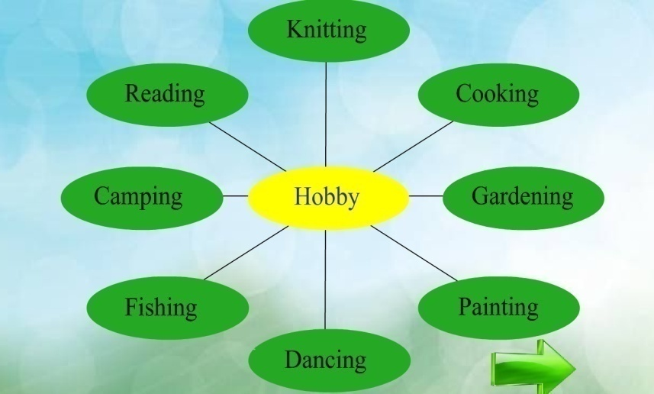
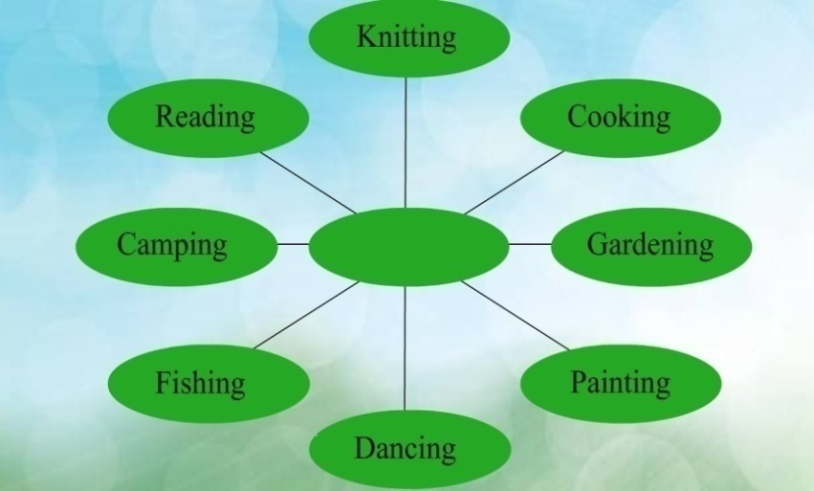

I think you have already guessed the theme of our lessons. What is it?
III. Актуализация личного опыта/ Actualization of personal experience
Teacher: So, the theme of our lesson is “Hobby”. But what is a hobby? Can you give the definition of the word “hobby”?
Students: A hobby is that you enjoy or like to do in your spare time.
Teacher: Look at the pictures and say what kind of hobby you would prefer. Explain your choice using the word combinations.
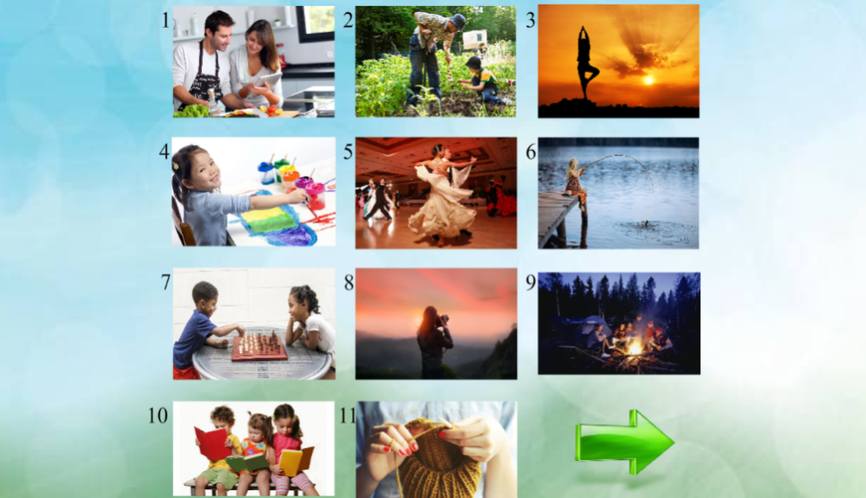
Students: I prefer reading books because it’s the way to relax and I can learn something new about different things.
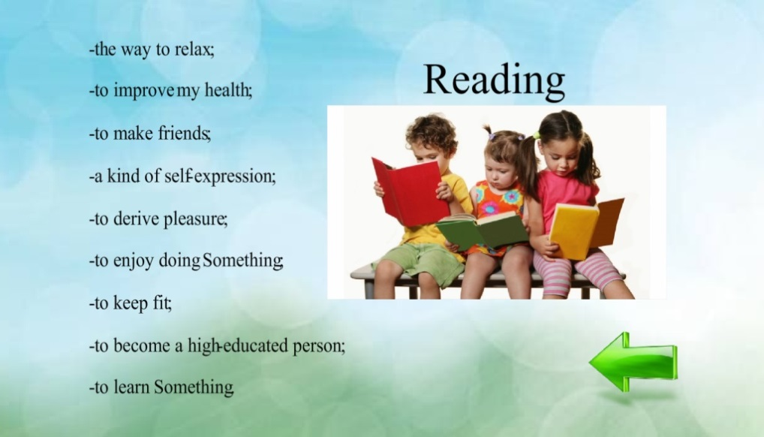

IV. Отработка лексических единиц / Vocabulary practice
P. Let’s practice these words. Pronounce the words after me correctly! All together

Teacher: Hobbies can be subdivided into four large classes: doing things, making things, collecting things and learning things. Let’s drag these words into the table.
What do hobbyists prefer doing whose hobby is doing things?
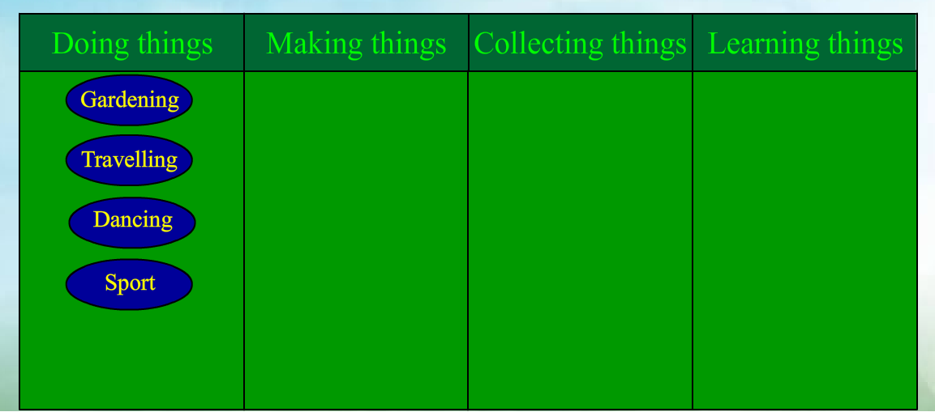

What do hobbyists prefer doing whose hobby is making things?
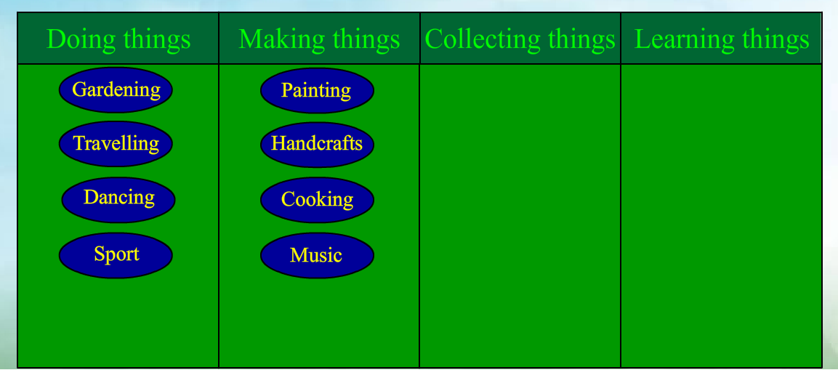
What do hobbyists prefer doing whose hobby is collecting things?
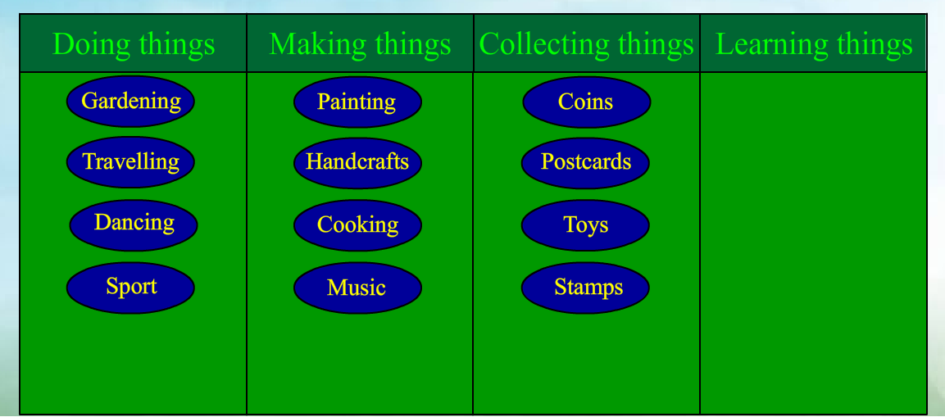
What do hobbyists prefer doing whose hobby is learning things?
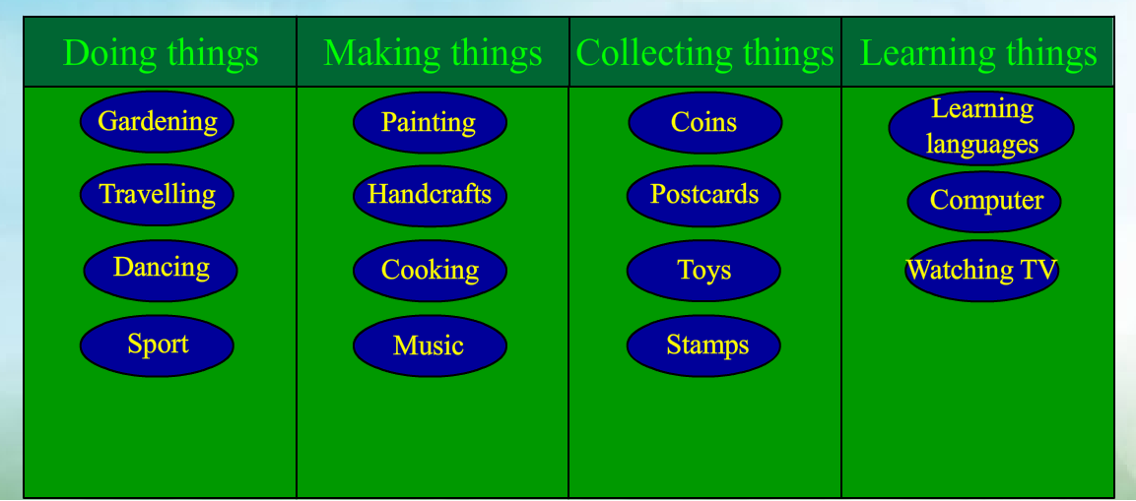
!

Match these words with their Russian equivalents. Work in your groups.
2. Let’s play the game “What hobby is it?” Each group has to prepare three riddles.
Group 1: You can do it alone or with friends. People do it out of doors. People need some animals. People need some special equipment. This pastime is expensive.
Group 2:Is it horse riding?
Group 1: Yes, it is.
V.Чтение/ Reading
a) Pre-reading
Teacher:Do you want to know more about different kinds of hobbies? I suggest reading the text. Take the cards, please. Look at the title of the text: “Caught in the Game”. What do you think this text is about? Why is it called so?
Students: About a computer game addiction. It is called so because these addicts can’t live without playing computer games, they are dependent on them.
Teacher: Read this text in groups. One by one and translate it. Correct the mistakes in pronunciation.
b)Reading
Caught in the Game.
Playing computer games is one of the most popular hobbies today. Computer games are constantly becoming more life like and complex, which is the main reason why many people can play for hours. But is it really a good idea to spend so much time with only a computer for company?
In my opinion, computer games have a lot of disadvantages. Firstly, their developers have been accused of the depiction of graphic violence, sexual themes, consumption of drugs, alcohol or tobacco, bad language, propaganda, and profanity. Secondly, many games encourage violent behaviour, blur the difference between right and wrong and cause addiction. Moreover, computer games make children and teenagers unsociable and passive.
However, some people say that computer games give them а chance to forget about their everyday problems and to plunge into exciting adventures. Besides, computer games are meant not only for entertainment. They can improve gamers' visual skills and dexterity and help them to develop coordination.
But I still believe that playing computer games is not the best way to spend your free time. Spending much time in front of the screen leads to decreased physical activity and social interaction with others. We should not forget that reading, exercising and spending time with our friends are much more worthwhile things.
To conclude, playing computer games may be fun, but we should be aware of the time we spend. Ardent gamers tend to enjoy virtual reality more than anything else, which сап cause them numerous problems. I think that those who are fond of computer games should make sure that they leave plenty of time in their lives for other interesting and useful activities.
c)After-reading
You have read about pros and cons of playing computer games - now it’s the best time to speak about them! The first group should make the list of pros, and the second group - the list of cons. Then give your own opinion about computer games.
VI.Обобщение / Summing up
In conclusion I’d like to say that it’s very interesting to have a hobby. I think you don’t waste time. Hobbies help us to learn more about our planet and different things, make us more intelligent and well-educated. We should all have a hobby and our life will be more interesting. Did you like our lesson?
VII.Домашнее задание и выставление отметок за урок / Hometask and lesson assessment
At home you’ll make up a short composition. Write down and choose any topic:
- My hobby.
- As many people as many hobbies.
- Strange hobbies.
The lesson is over. Thank you for your work.

Список используемой литературы и электронных ресурсов:

  - Пассов Е. И. Урок иностранного языка в средней школе. - М.: Просвещение, 1988. - с. 96
  - www.bbc.co.uk/learningenglish
  - http://www.esl-galaxy.com/
  - http://www.english-kids.com/

