Методическая разработка урока по английскому языку
«Фильм на английском языке "Сквозь снег", создание, актёрский состав и содержание»
Учитель английского языка
МБОУ "СШ № 16" г. Смоленска
Отделякин И.В.
Методические рекомендации
Данный урок по английскому языку можно проводить в обычной общеобразовательной школе, лучше всего для учащихся 11 классов, потому что, как правило, эти дети, интересуются этим предметом, понимая его актуальность и необходимость в современном обществе. Именно старшеклассники добиваются неплохих результатов в изучении языка. Содержание данного урока может быть также полезно в клубах английского языка для старшеклассников, как бы они не назывались, в особенности в клубах с такими названиями как «Клуб любителей фильмов на английском языке», «Клуб увлечённых англоязычной культурой» и т.д. Этот урок можно также провести в 11 классе школ, где существуют группы углублённого изучения английского языка, в филологических, гуманитарных или гимназических классах, где на английский язык отводится больше времени. Этот урок можно использовать в ходе реализации технологии проектной деятельности.
Цель: познакомить обучающихся 11 класса с содержанием, историей создания фильма на английском языке “Snowpiercer”, обратив особое внимание на актёрский состав; ввести новые лексические единицы, связанные со съемками фильмов, их обсуждениями.
Развивать у обучающихся способность к проектной деятельности, к аудированию на английском языке, умение вести дискуссию, готовить презентации и выступать с ними; продолжить формирование различных УУД всех четырёх блоков: личностных, регулятивных, познавательных, коммуникативных.
Воспитывать у обучающихся 11 класса толерантное отношение к иноязычной культуре.
План урока
- Орг. момент.
- Этап целеполагания. (Введение. Вступительное слово учителя).
- Этап объяснения нового материала. (общее знакомство с фильмом. Презентации участников проекта).
- Этап закрепления нового материала. (повторение лексики, трудных слова и выражений, терминов).
- Подготовка к проверочной работе (знакомство с вопросами тестирования).
- Проверка знаний (тестирование).
- Домашнее задание.
- Подведение итогов урока.
Ход урока
Вступительное слово ведущего.
Today we have gathered in this classroom to discuss the film which received a lot of different rewards. The title of the film is “Snowpiercer”. You watched the film some time ago. It was made in 2013 by the director from South Korea - Bong Joon-ho.
Общее знакомство с фильмом. Презентации участников проекта.
Первая презентация.
Во время этой презентации на экран выводятся только постеры, фотографии кадров фильма. Тексты не выводятся на экран, их лучше заучить учащимся, которые готовили данный проект или в крайнем случае их можно читать с листа.
1 слайд.Look at the poster of the film. Here we can see four main characters - Curtis Everett (Chris Evans played this role), his mentor Gilliam whom John Hurt played, Wilford who is the head of the train (Ed Harris played him), where they all go across the globe.
Poster of the film
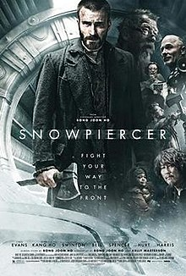
2 слайд.
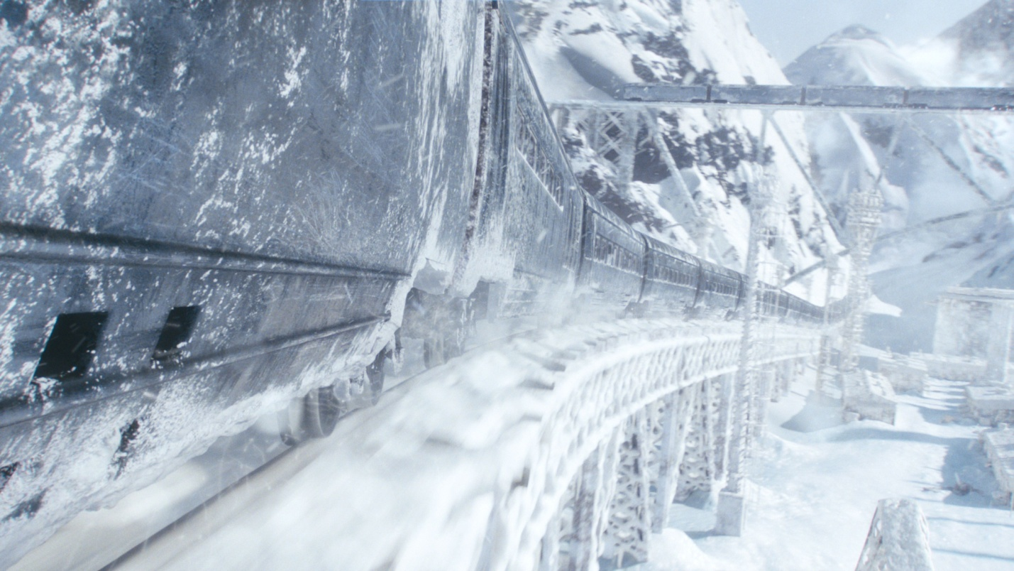
The plot of the film is the following.
In 2014, an attempt to counteract global warming through climate engineering backfires catastrophically, causing an ice age and extinguishing nearly all life; only animals that can adapt to sub-zero temperatures and the inhabitants of Snowpiercer remain. Snowpiercer is a massive train, powered by a perpetual motion engine, traveling on a circumnavigational track created by the transportation magnate and inventor, Wilford. By 2031, elites inhabit the extravagant front cars while the "scum" inhabit the tail in squalid and brutal conditions. Under watch by Wilford's guards, they are brought only gelatinous protein bars to eat.
3 слайд

Conspiring with his mentor Gilliam (John Hurt) and second-in-command Edgar (Jamie Bell), Curtis Everett (Chris Evans) plans to lead the tail passengers in a revolt that will take them all the way up to the engine.
4 слайд
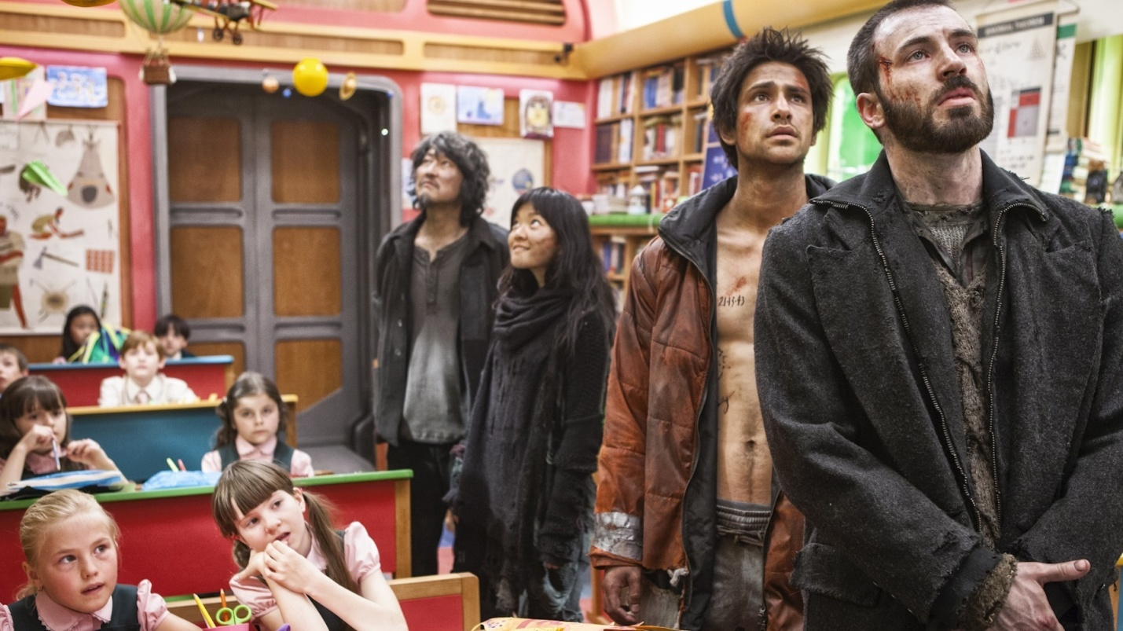
They travel through several luxurious cars and arrive at a classroom, where the teacher (Alison Pill) expounds to the children and the rebels on the greatness of Wilford and the "sacred engine".
Вторая презентация о режиссёре и актёрах фильма.
Лучше всего, если эту презентацию будут делать двое из участников проекта по очереди. На экран выводятся только фотографии актёров и режиссёра. Текст участникам лучше заучить наизусть.
1 слайд
The director of the film Bong Joon-ho was born on September 14, 1969 in Daegu. He decided to become a filmmaker while he was in middle school. His father, Bong Sang Gyun, is a graphic designer. In the early 1990s, he completed a two-year program at the Korean Academy of Film Arts. After graduating, he spent the next five years contributing in various capacities to works by other directors.

2 слайд
Christopher Robert Evans was born in Boston, Massachusetts on June 13, 1981. His mother, Lisa, is an artistic director at the Concord Youth Theater, and his father, G. Robert Evans, is a dentist. Evans graduated from Lincoln-Sudbury Regional High School. He moved to New York City and took classes at the Lee Strasberg Theatre and Film Institute.
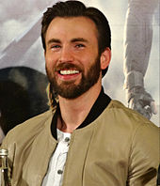
3 слайд
John Vincent Hurt was born on 22 January 1940 in Chesterfield, Derbyshire, England. His screen and stage career spanned more than 50 years. Hurt came to prominence for his role as Richard Rich in the film A Man for All Seasons (1966) and gained BAFTA Award nominations for his portrayals of Timothy Evans in 10 Rillington Place (1971).
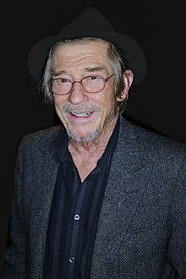
4 слайд.
Andrew James Matfin Bell was born on 14 March 1986 in Billingham, England. He rose to prominence for his debut role in Billy Elliot (2000), for which he won the BAFTA Award for Best Actor in a Leading Role.

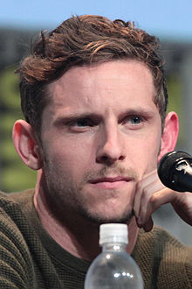
5 слайд.
Katherine Matilda Swinton was born on 5 November 1960 in London, England. She is an actress and performance artist who identifies as Scottish. She is known for her roles in both independent arthouse films to blockbusters. She won the Academy Award for Best Supporting Actress and the BAFTA Award for Best Actress in a Supporting Role for her performance as Karen Crowder in the 2007 film Michael Clayton.
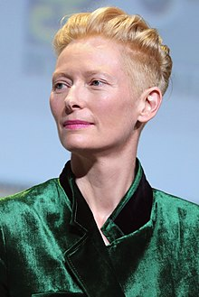
6 слайд.
Edward Allen Harris was born on November 28, 1950 in Englewood, New Jersey, U.S. He is an American actor, producer, director, and screenwriter. Harris began his career on the stage. In 1976, he played an FBI agent in the world premiere of Thomas Rickman's play. Harris' first film role came in 1978 with a minor part in the suspense film Coma, starring Michael Douglas. His first major role in a film came two years later with Borderline (1980), in which he starred alongside Charles Bronson.
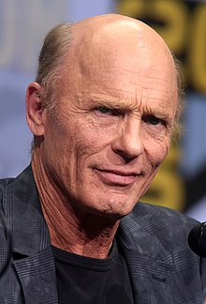
Знакомство с вопросами тестов и тестирование.
Перед просмотром фильмы всем присутствующим в аудитории раздаются задания теста к фильму в двух вариантах. Задания выполняются в течение всего фильма. Данный этап, то есть просмотр фильмы, можно осуществить заранее на других уроках английского языка для этого класса.
Test № 1for students of the 11-th grade
v-1
1. What scene does the film begin with?
a) with the passengers in the head of the train, b) with people who work in the supply section of the train, c) with the passengers on the tail of the train standing in front of the solders, d) with Wilford in the head of the train

2) What happened with the violinist who said these words - Excuse me, sir, my wife and I played the violin in the Boston symphony orchestra?

a) he was taken to the head of the train to play the violin there, b) he was beaten by guards, c) he was killed by guards, d) guards broke his glasses

3) How was Andy's father Andrew punished after his attempts to fight back guards ?

a) he was shot by solders, b) he was thrown away from the train, c) he was beheaded by the guards of the minister Mason, d) he was being forced to put his arm into the extreme cold outside the train

4) Why does Curtis release security expert Namgoong and his daughter Yona from the prison car?
a) because he can disable the locks between cars, b) because he knew Wilford very well and could negotiate with him, c) because he knew minister Mason very well and could negotiate with her, d) because he wanted to use him as a hostage

5) How many years have Curtis lived in the train?

a) 7, b) 17, c) 20, d) 22

6) Who is extra in the list of those people who together with minister Mason as a hostage go to negotiations with Wilford to the head car of the train - Curtis, Namgoong, Yona, Tanya, Andrew, Gilliam, Grey?

a) Gilliam, b) Tanya, c) Andrew, d) Grey

7) Who asks the minister Mason a question - Have you seen these kids?

a) Andrew, b) Curtis, c) Tanya, d) Gilliam

8) In what car of the train was Andrew killed?

a) in the water supply section, b) in the car where they are eating sandwiches with sushi, c) in the tail of the train, d) in the car-classroom of the train

9) Who executed Gilliam?

a) Grey, b) Curtis, c) Tanya, d) Franco

10) Who killed the minister Mason?
a) Namgoong, b) Curtis, c) Tanya, d) Franco

Test № 2 for students of the 11-th grade
v-2
1. Who is saying these words in the beginning of the film - everybody, sit down, one two three four five?
a) Wilford, b) a guard, c) Andy's father Andrew , d) Andy
2) What happened with the violinist's wife?
a) she was taken to the head of the train to play the violin there, b) she was beaten by guards, c) she was killed by guards, d) solders allow her to go with her husband to Wilford
3) Who is saying these words - Minister Mason, please, deliver a massage to Mr. Wilford..., he and I need to talk?
a) Curtis Everett, b) Gilliam, c) Andrew d) Timmy's mother
4) How many years did Curtis live outside the train?
a) 7, b) 17, c) 20, d) 22
5) Whom does Curtis sacrifice to win the fight for the water supply car?
a) Gilliam, b) Andrew, c)Tanya, d) Edgar
6) Who is saying these words - Survivors, wash yourself in the water supply section?
a) Curtis, b) Gilliam, c) Andrew, d) minister Mason
7) Who is saying - Now, Grey, you must go with Curtis?
a) Andrew, b) Curtis, c) Tanya, d) Gilliam
8) Who killed the teacher?
a) Grey, b) Curtis, c) Tanya, d) Franco
9) Who killed Grey?
a) Namgoong, b) Curtis, c) Tanya, d) Franco
10) What did Curtis promise Tanya before her death?
a) to kill Wilford, b) to find Timmy, c) to revenge for her, d) to bury her
Использованные интернет-ресурсы
https://en.wikipedia.org/wiki/Snowpiercer
https://en.wikipedia.org/wiki/Bong_Joon-ho
https://en.wikipedia.org/wiki/Chris_Evans_(actor)
https://en.wikipedia.org/wiki/Tilda_Swinton
https://en.wikipedia.org/wiki/Jamie_Bell
https://en.wikipedia.org/wiki/John_Hurt
https://en.wikipedia.org/wiki/Ed_Harris
http://pickfilm.ru/film/skvoz-sneg.html
https://www.imdb.com/title/tt1706620/
https://w6.zona.plus/movies/skvoz-sneg

