МБУ ДО «ЦДОД «ЮНИТЭР» РМР

Занятие на английском языке с использованием игровых технологий

Провела: педагог Костычева М.М.

1. Прочитай рассказ и ответь на вопросы.

Rabbit.


It is a blue rabbit. Its name is Bunny. It likes its name. It lives in forest. It is five. Bunny is not big but it is strong and brave. Bunny is nice and funny. It can run and jump. It can’t swim and skate.

Словарь:
to live in the forest - жить в лесу
big-большой
strong - сильный
brave – смелый
nice- хороший
funny – смешной
run- бегать
jump – прыгать
skate - кататься на коньках
swim - плавать

1. Is Bunny a rabbit?
2. Is Bunny a black cat?
3. Is it seven?
4. Is it strong and brave?
5. Can Bunny swim?
2. Прочитай рассказ и выполни задания
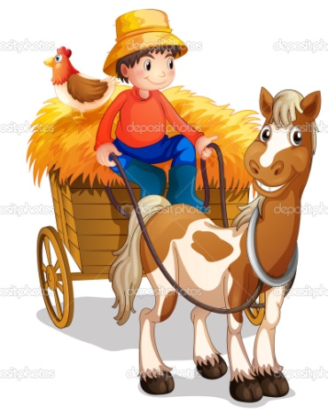
On the farm.
Tim is a farmer. He has six pets. He has five black dogs and one grey horse. His horse lives on the farm. It is very strong. It is nice too. It can run and jump well. Tim’s dogs are not big. They are not strong but they are very brave. They like to go to the forest with Tim.
Словарь:
a farmer – фермер
He has- у него есть
pet- домашнее животное
grey- cерый
horse - лошадка
to live on the farm – жить на ферме
strong- сильная
nice- хорошая
brave – храбрый
to go to the forest – ходить в лес
Задания:
1. Заполни пропуски словами из рассказа.
Tim is ____________.
He has ____ dogs and ______ horse.
His horse is very ________.
It can run and _______.
Tim’s dogs are not big and strong but they _________.
2. Прочитай предложения и исправь, если это необходимо.
Tim is a doctor.
He has three white dogs and one gray elephant.
His horse lives in the house.
Tim has big cats.
His cats like to go to the park.

3. Прочитай текст и выполни задания.

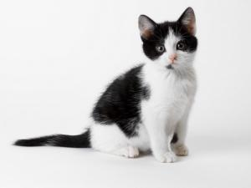

Nick’s cat.

Nick has got a cat. Nick’s cat’s name is Pippy. Nick’s cat is big and nice. It is black and white. It eats meat and fish. Nick’s cat drinks milk. Pippy can run and jump. Nick teaches Pippy to swim but it can’t swim. Nick teaches Pippy to sing but it can’t sing.
Словарь:
Name-имя
Big-большой
nice – красивый
eat - кушать
meat – мясо
fish- рыба
drink - пить
teach – учить
sing- петь
Задания:
1. Сопоставь вопрос и ответ.
Has Nick got a cat? Yes, he has
Has Nick got a dog? Yes, it is
Is Pippy a cat? No, he hasn’t
Can Pippy run? No, it can’t
Can Pippy swim? Yes, it can
2. Переведите слова и словосочетания, используя текст.
Кот,
большой и красивый,
пить молоко,
кушать мясо,
учить плавать,
учить петь,
умный.
3. Ответь на вопрос.
Have you got a cat?

.

Farm animals
This is a dog. The dog is small. The dog is black. It says, «Woof-woof».
This is a cat. The cat is small. It is red. The cat says, «Mew-mew».
This is a pig. The pig is big. It is pink. The pig says, «Oink-oink».
This is a hen. The hen is small The hen is red. It says, «Cluck-cluck».
This is a cow. The cow is big. It is brown. The cow says, «Moo-moo».
This is a duck. The duck is small. It says, «Quack-quack».
This is a sheep. The sheep is white. It is big. It says, «Bah-bah».
Словарик:
This is -это
Small- маленький
Big-большой
Say- сказать
Brown-коричневый
White-белый
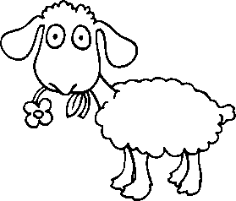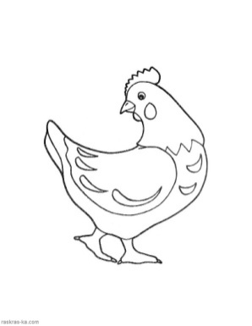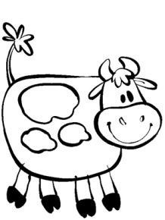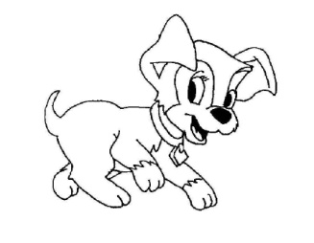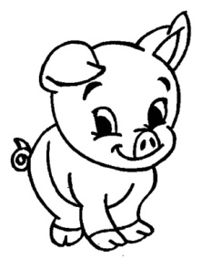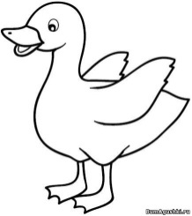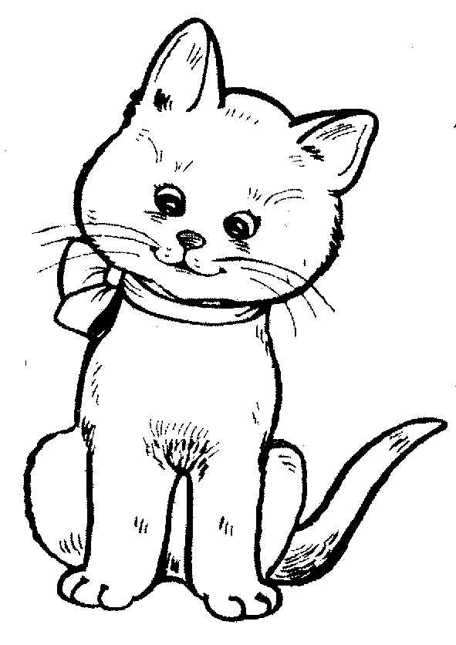
Ex.1. Подчеркни слова, которые есть в тексте. 
The dog, the cat, the pig, the hen, the cow, the duck, the wolf, a farmer
Ex.2. Впиши буквы.
C_w, h_n, d_g, p_g, c_t.
Ex.3. Дополни предложения, подбирая слова big или small
The pig and the cow are ______.
The cat and the dog are _______.
The hen and the duck are _______.
Ex.4. Переведи на английский.
Ферма — _______,
Розовый — _______,
Белый — _______,
Маленький —
Ex.5. Oтгадай загадки.
It is big. It is brown. It says “Moo-moo”. This is a _________.
It is little. It is yellow. It can swim. This is a _________.
It is big. It is pink. It says “Oink-oink”. This is a _________.

