My pet.

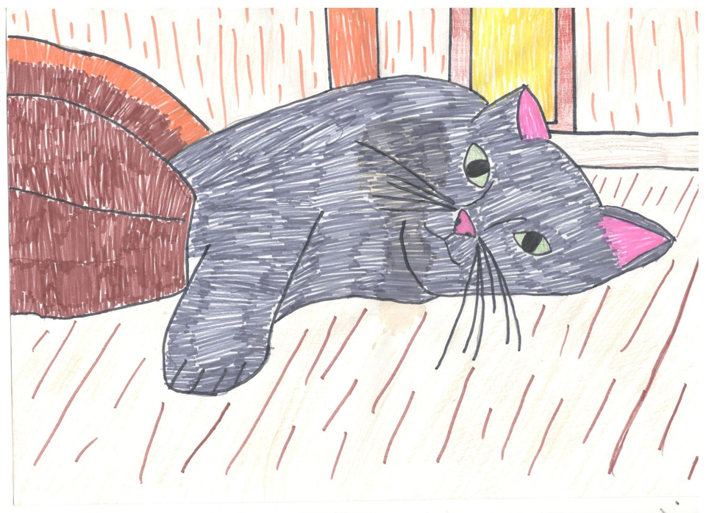

I have got a pet.

It is a cat.

It`s name is Pushok.

It is grey.

Pushok is funny.

It can jump.

My pet likes milk, meat and fish.

I like Pushok.