Проект выполнил: Чолахсавов Алексей, 10 лет

МБУДО «ЦРТД и Ю» ДДТ поселок Чульман

Т/о «Диалог культур»

Педагог: Ланкина Наталья Львовна

My Family

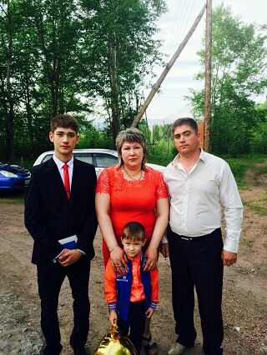My name is Aleksey Cholakhsavov, but please, call me Lersha. I’m ten. I’m from Russia. My home town is Chulman. It is very far from Moscow. Well, my family isn’t really big. My parents have got two of us: my brother and me. Our dad Valeriy is forty-six. He is an entrepreneur. Our mum’s name is Elena. She’s a housewife. My mum a very kind person. She is the heart and the soul of our family. My brother’s name is Konstantin. He is twenty-two. So, I’m the youngest in the family. We’ve got a cat in the house. I’m proud of my Greek roots. Everything about Greece is very unusual: the clothes, the food, the traditions. So, my father’s parts of the family are in Greece and Armenia. My grandmother’s name is Anait. The second grandmother’s name is Svetlana. I love my family with all my heart.