Проект: Я люблю мою семью.

Выполнила: Герасимова Марина, 11 лет.

МБУДО «ЦРТД и Ю» ДДТ поселок Чульман,

т/о «Диалог культур»

Педагог: Ланкина Наталья Львовна

**I love my family.**

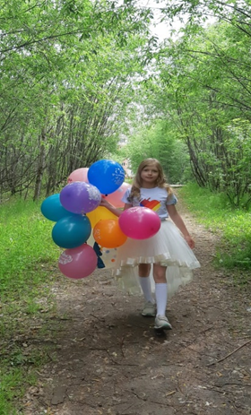Hi! My name is Marina, but you may call me Marine. You see, I like sea. I live in Yakutia, in a small town Chulman. I am eleven. I am a good-looking girl; my parents think I am very smart for my age. I am good at English, Literature and PE.

I like music, dancing and computer games. I have got a lot of friends.

My family is not very big. We are four in the family: my mother, my father, my brother and me. Our dad’s name is Alexzander. He is forty, he is an engineer at the airport Nerungri. My father is the head of our family. He loves all of us very much.

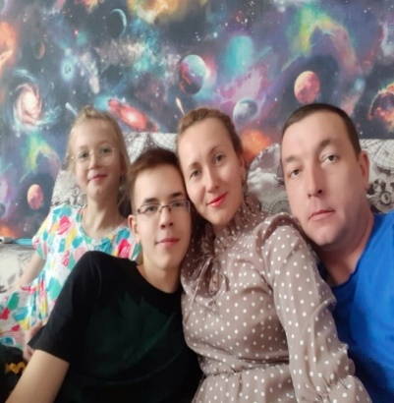My mum’s name is Elena; she is a nurse at our town’s hospital. She is a very kind person. We all think she is the heart and soul of our family. But sometimes she is strict. My mum is younger than my father and she looks very nice.

My brother’s name is Dima. Dima has got a lot of friends. He loves computers best of all. He is going to be an engineer too. Dima is much older than I but we are friends. He always helps me with my school problems.

It’s a pity but I have got no grandfathers. My grandmothers are my best friends. They are very kind. My grannies always give me nice presents. I like to spend summer holidays with them. I have got three aunts and three uncles and six cousins. I want to see them more often.

I am very proud of my family.