Задание 1
- Read the letter (прочитай письмо):
Dear Joy,
How are you? It`s my birthday next Saturday and I`m having a party at my house. Why don`t you come? We always have a great time!
I usually decorate my house with a lot of colorful balloons and we all play some great party games. Then there is the food. My mother is a great cook and she makes a lot of delicious food. We usually have pizza with ham, bacon, mushrooms and peppers, ham and cheese or tuna sandwiches and different kinds if salads. There is always a lot of coke, orange and apple juice to drink, and my birthday cake of course. I like chocolate so it`s always a chocolate cake.
So, I really hope you can make it! The party starts at six. Don`t be late!
Love,
Helen
b) What is this email about? Choose the right answer. (О чем это электронное письмо? Выбери правильный ответ):
__a. New Year party
__b. School party
__c. Birthday party
__d. Halloween party
c) Mark the statements as T (true) or F (false). (Отметьте утверждения как верные (Т) или неверные (F))
1) Joy`s birthday is next Saturday.___
2) Helen decorates the house with balloons.___
3) Helen`s father cooks the food.___
4) There is only one salad.___
5) Helen doesn`t like chocolate.___

Задание 2:
- Choose the odd word (выбери лишнее слово):
  - Five, first, fifth, fiftieth
  - Spring, winter, summer, cloud
  - Sunday, Friday, August, Saturday
  - a nose, a leg, an ear, a cheek
  - a table, a sofa, a fridge, a chair

- Choose an adjective (выбери прилагательное):
    - Larissa is a __________ girl.
a) pretty b) prettier c) prettiest

    - Vera is the __________ student in the class.
a) good b) better c) best
    - Alex is____________ than Danya.
a) loud b) louder c) loudest
c) Choose a right verb (выбери правильную форму глагола)
1. His uncle__________ in Samara last year.
a) live b) lives c) lived
2. My aunt __________ in Vladivostok.
a) live b) lives c) lived
3. The children__________ a museum two days ago.
a) visit b) visits c) visited
4. Seva and Taras ________bored at the last lesson.
a) are b) was c) were
5. My mother _________ a doctor. She works in a hospital.
a) is b) was c) were
6. Hello! We _______ happy to see you. You look good.
a) are b) was c) were

d)Write when are the birthdays. (напиши, когда дни рождения у ребят)
Alina`s birthday/ May 5
Alina`s birthday is on the fifth of May._________________________________________________

Polina`s birthday/ July 1

Roma`s birthday/April 22

Marina`s birthday/September 12

Задание 3: Прослушай и обведи.
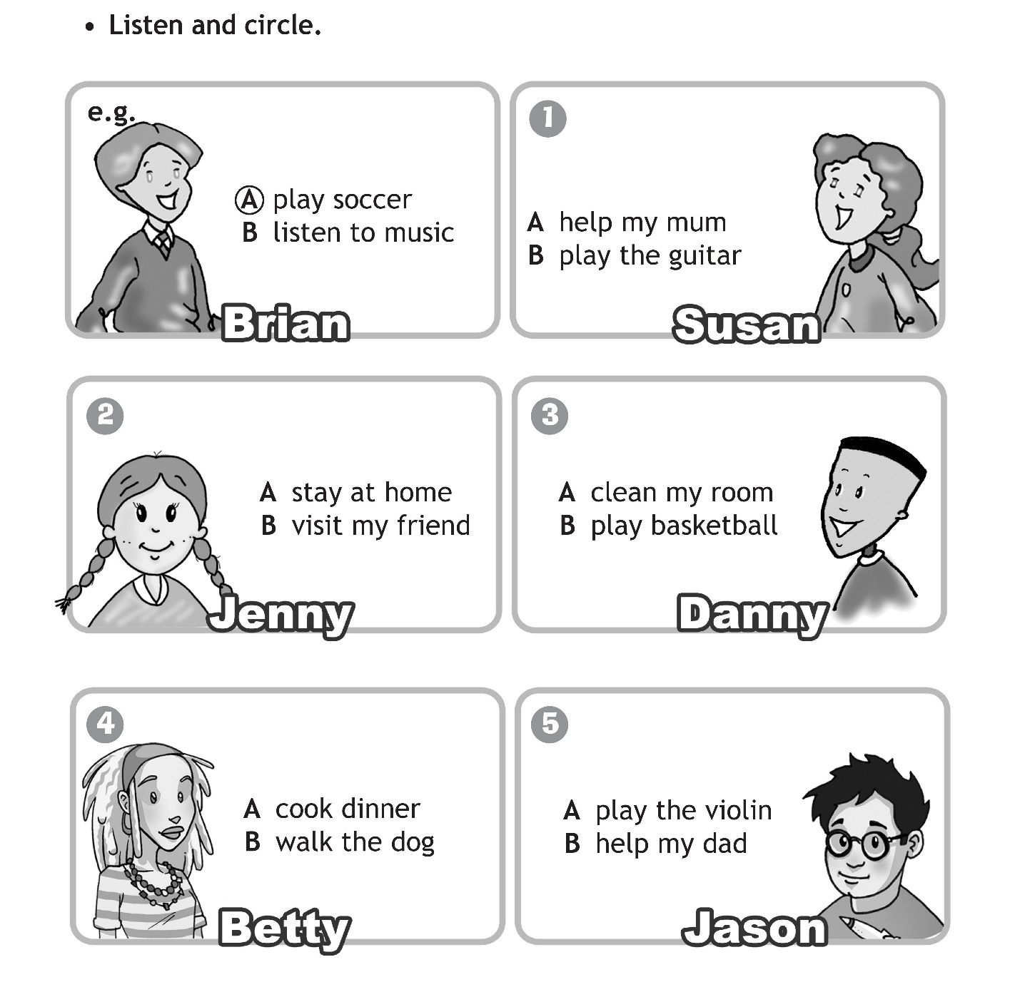

Задание 4: Write a letter to you friend. (Представь, что получил письмо от зарубежного друга, где он рассказывает об увлечениях своей семьи. Напиши ему ответ. Используй его письмо в качестве образца.)

Manchester, UK
3 October

Dear____________________,
Thank you for your letter.
We like doing a lot of things in our family. My dad likes diving. He goes diving three times a week. My mum likes dancing. She has dancing lessons twice a week and she always dances when we have a party. My granny likes cooking. She always makes yummy biscuits and cakes on Sundays.
My little sister likes painting. She has painting lessons once a week and she sometimes paints very nice pictures. I like playing the guitar and listening to music. I have guitar lessons on Saturdays.
And what about your family?
Write back soon.
Love,
Chris

________________________, Russia
_______________________________
Dear Chris,

Write back soon.
Love,
______________________

