- Организация начала урока.
- Приветствие (Good morning now – Слайд 1)
- How are you?
2. Речевая зарядка.
-What date is it today? What day of a week? What season is it now? Thank you.
I hope you are in a good mood and you are ready to work as usual
3. Фонетическая зарядка. Слайд 2 (What rhymes with these words do you know)
all – small, tall, call, ball
o+ m, n, v, th - some, Monday, mother, London
ea - tea, sea, mean, eat, season
4.Девиз урока «Proverb Business before pleasure»
Please try to translate. Why did I take it? Слайд 3
Some tasks will help you
What letter is missing
- h_king, s_nbathing, s_iling, r_fting
- sh_rpeher, r-ler, d_ctionary, p_ncil
What’s ‘common between the words in the first line? In the second line?
“Summer fun” “School”
Look at proverb again (мнения детей).
5.Введение в тему. Our theme is Holidays. Today we are going to practice our skills in reading, listening, grammar.
6.Словарная работа. Vocabulary. What summer activities do you know? Look at the card.
Activity holiday
Cruise
Tiring
Safari
Sightseeing tour
Beach holiday
Match.
Jet…surfing
Sight..climbing
Wind..biking
Mountain…skiing
Rock…seeing

7. Слайд 3 Everyday English.
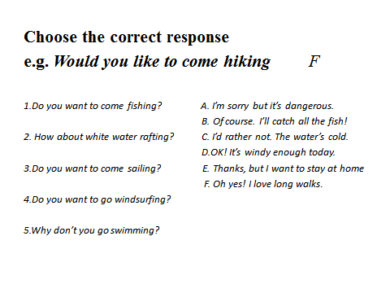
8. Слайд 4 Grammar
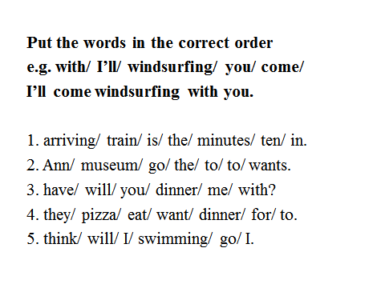
9. Let’s listen the song about holidays ( ex.1 p.SS3). How many different sorts of holidays can you find in the song?
-What type of holiday do you like? How do you like travelling? Where do usually spend your holidays?
10. Физминутка.
We go by car and we go by train
We go by boat and we go by plane
We go by land and sea and air
We go, go, go from here to there
11. Open your books. Ex.8 p.117 (Listen to two people talking on the phone and fill in the missing information)
12. Describe the picture. 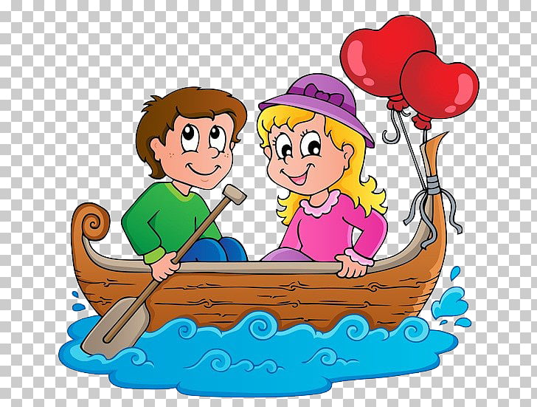  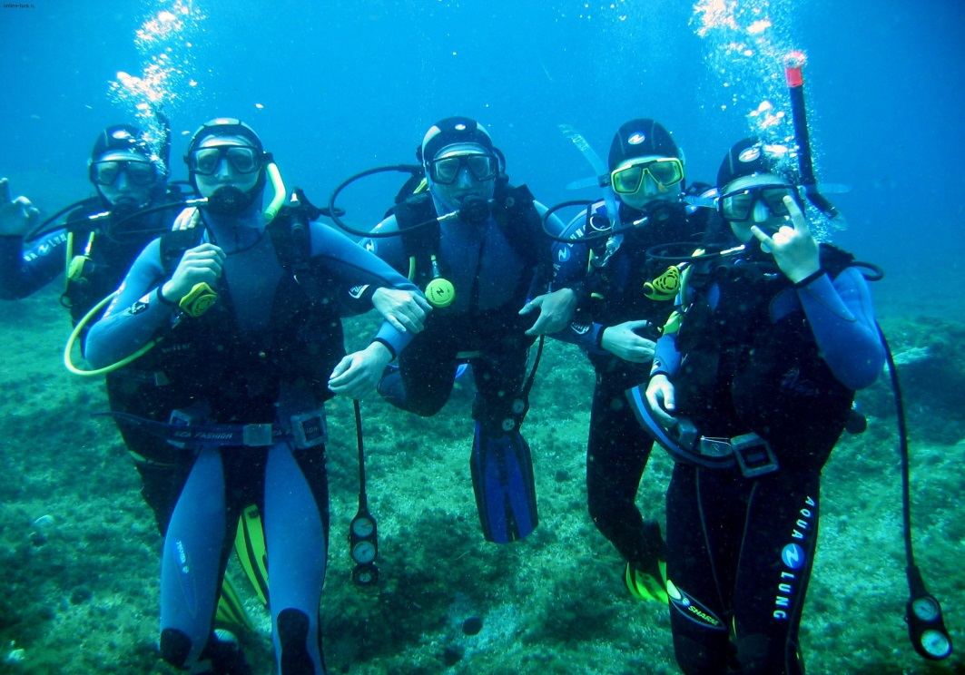 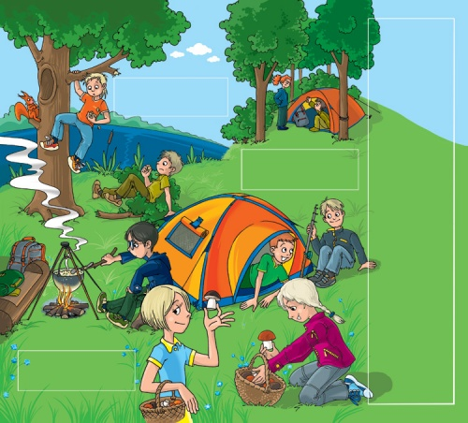

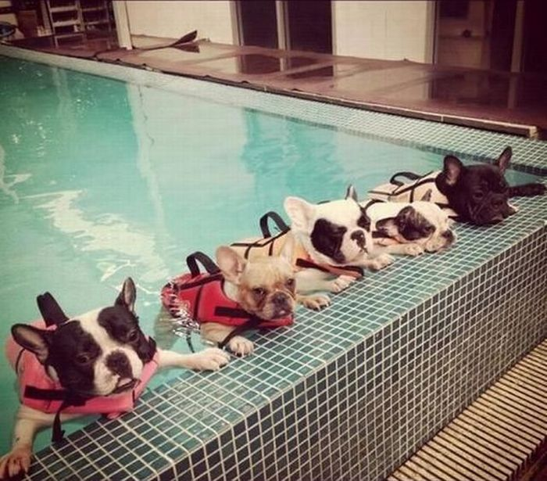
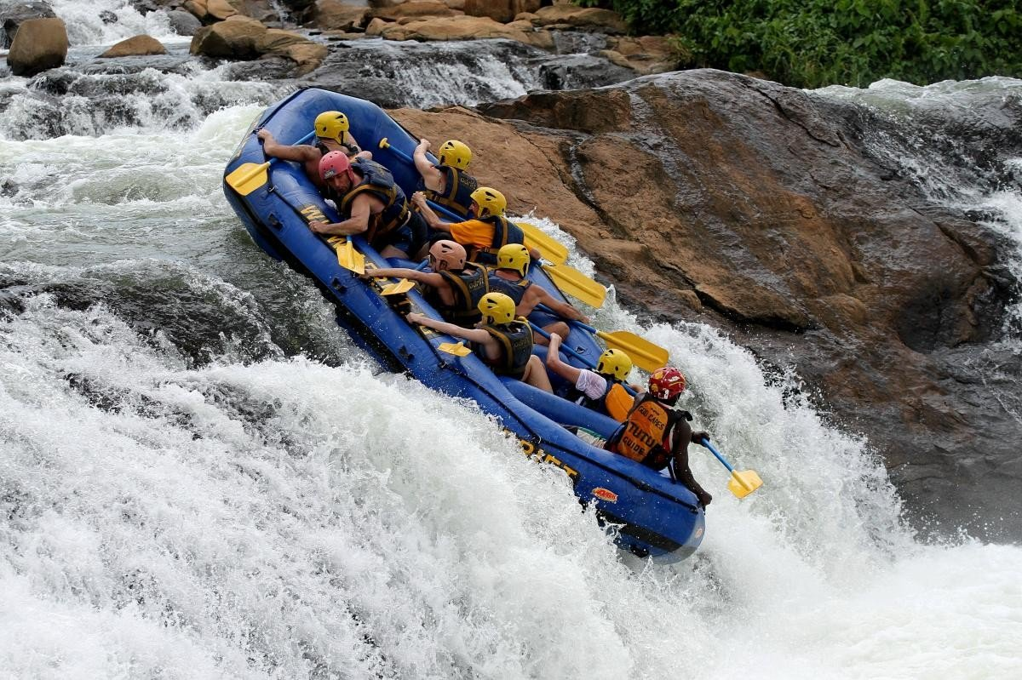

You have a plan.
Place: Where?
Weather: What the weather like today?
People: Who? How many?
Feelling: How do you feel?
Activity: What are they doing?
Activity description: What is this activity like?
(Sheets of Activities)
Place: It’s a forest/ a sea/ a river/ a beach/ a swimming pool.
Weather: It’s sunny/ windy/ cloudy/ hot
People: They are people/ friends/ relatives. This is a family.
They are two/ four/ five. There are a lot of people.
Feeling: They are bored/ excited/ tired/ happy.
Activity: They are hiking/ sunbathing/ swimming/ fishing/ sailing/ scuba diving/ white water rafting/ windsurfing.
Activity description: It is enjoyable/ relaxing/ exciting/ dangerous/ tiring/ boring/ fun/
13. Check your homework. You had to make an advert.
14. Выполнить задание на листочках.
15.Рефлексия.
-Чем мы сегодня занимались?
-Что мы для этого делали?
-Понравился урок?
-Где нам пригодится это умение?
-Поставьте себе сами отметку по 5-и бальной системе.
16. Сделать проект «My holidays»

