Travelling and Transport

I. Write the correct transport below the pictures.

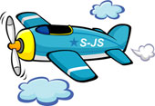 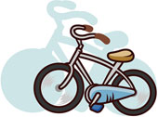 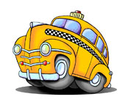 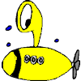 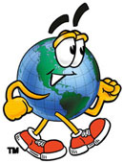 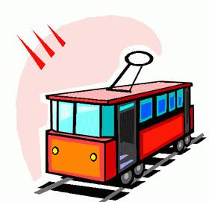 

__________ ___________ ___________ _____________ __________ __________ _________

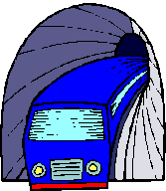 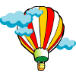 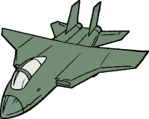 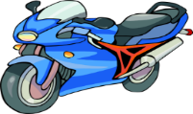 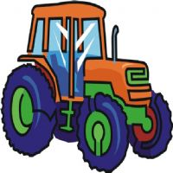 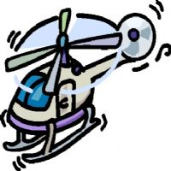 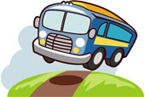

___________ __________ _____________ ___________ __________ __________ ____________

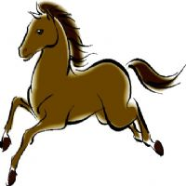 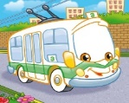 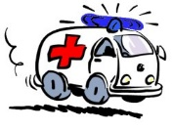 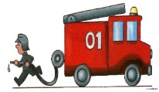 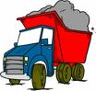 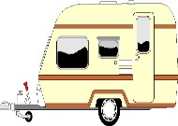 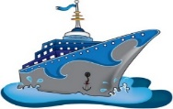 ___________ ____________ __________ ____________ ____________ _____________ ____________

II. Complete the table grouping the means of transport according to the place.

Car, boat, plane, jeep, van, shuttle, skateboard, ferry, balloon, yacht, jet, skis, police car, helicopter,double-decker, submarine, lorry, sled, scooter, skates.

|  |  |  |
| --- | --- | --- |
| Land transport | Water transport | Air transport |
|  |  |  |

III. Circle the odd one out.

1. car, bus, plane, bicycle 3. plane, ship, helicopter, balloon 5. parachute, ship, speed boat, jet skis
2. lorry, taxi, train, van 4. police car, fine engine, ambulance, car 6. bike, skis, skateboard, tractor

IV. Describe means of transport using adjectives from the box.

big, small, cheap, expensive, long, wide, short, tall, round, square, fast, slow, useful, comfortable, safe, dangerous

 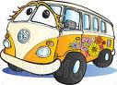 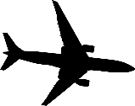 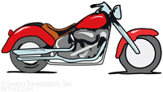

This is a balloon. This is a bus. This is a plane. This is a motorcycle.

It’s _______________ It’s _______________ It’s _____________ It’s ____________

It’s _______________ It’s _______________ It’s _____________ It’s ____________

It’s________________ It’s _______________ It’s _____________ It’s _____________

It’s________________ It’s _______________ It’s _____________ It’s ______________

V. Read the statements and say it is True (T) or False (F).

1. The train is faster than the plane. _____ 5. The bus is cheaper than the plane. _____

2. A policeman drives a van. _____ 6. The bike is slower than the motorbike. _____

3. Children go to school by taxi. ______ 7. The truck transports goods. _____

4. A fireman drives a fire engine. _____ 8. People can fly a submarine. _______

VI. Now write about your favourite transport and draw it.

My favourite transport is ……………………………………………………………………….

It is ……………………………………………………………………………………………………..

……………………………………………………………………………………………………………