**МБОУ «Новотроицкая школа № 4»**

**администрации Волновахского района ДНР**

**How to Write Informal Letters in English**

1. **Book)**

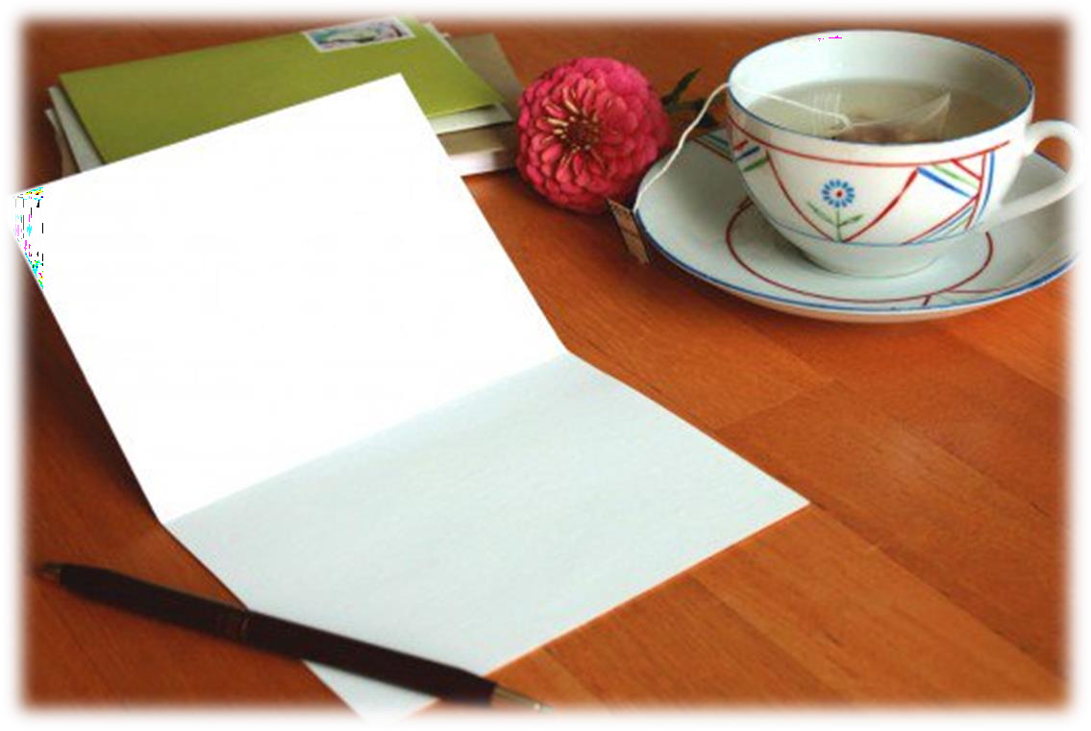

Автор:

Олейник Леся Ярославовна,

учитель английского языка

МБОУ «Новотроицкая школа № 4»

**2022-2023 учебный год**

Олейник Л.Я. «How to Write Informal Letters in English»: практическое пособие по написанию неофициальных писем в формате ОГЭ.— Новотроицкое, 2023. — 34 с.

Практическое руководство по написанию неофициальных писем поможет подготовиться к успешной сдаче ЕГЭ и ОГЭ по английскому языку (Раздел «Письмо») путём формирования навыков письменной речи на английском языке для решения практических целей, а именно: умение писать грамотно и передавать письменно необходимую информацию в такой форме как личное письмо. QR – коды содержат ссылки на полезные видео-уроки с практическими советами от ведущих англоязычных изданий (Cambridge University и Oxford University) Материал может быть использован учителями английского языка для работы с учащимися 9-11 классов и самостоятельной подготовки учащимися к сдаче ЕГЭ и ОГЭ.

Using this e-book, you will learn how to write informal letters in English with the help of sample opening and closing sentences and sample letters. By the time you are finished, you will know how to properly format the content of an informal letter, as well as what to write in between your greeting and signature.

**What Is the Difference Between Informal and Formal Letters?**

**Informal Letter**

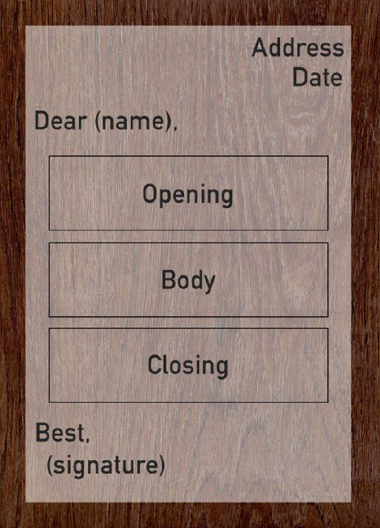An informal letter is a letter that is written in a personal fashion. You can write them to relatives or friends, but also to anyone with whom you have a non-professional relationship, although this does not exclude business partners or workers with whom you are friendly. There are different ways to carry out this type of letter depending on which country you are in.

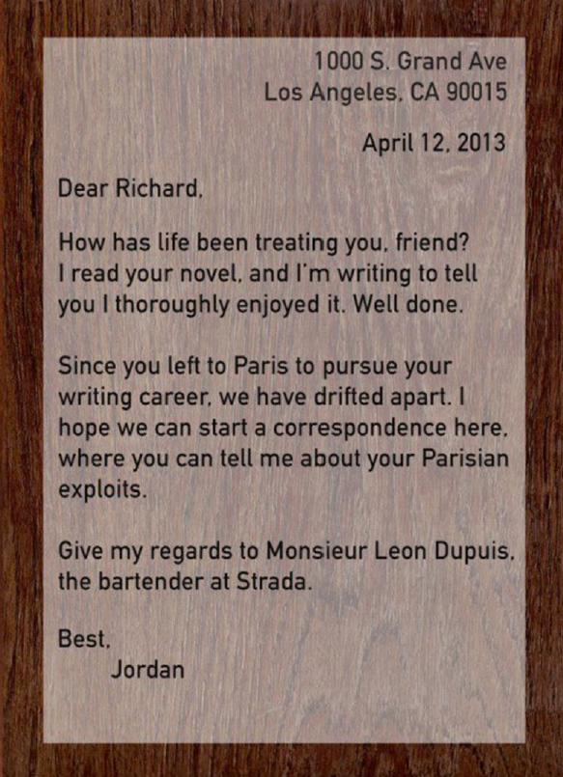

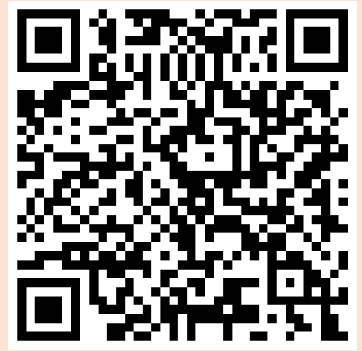

**Formal letter**

The formal letter, on the other hand, is written in a professional tone using carefully chosen and polite language for an official purpose. Unlike the informal letter, there is nothing friendly or quirky about this type of letter, which must adhere to a strict format.

**Format of an Informal Letter**

***How Do You Start Writing?***

**Address**

Your personal address should be the first thing you write on your letter. It should be located at the top right corner of the page, since you do not always know if someone has your address if they want to reply. Remember also to fill in your country of residence if you are sending the letter abroad.

**Format**

**•**Number and street name

•City, state and postal code

•Country

**Example**

1000 S. Grand Avenue Los Angeles, CA 90015 United States

**Date**

The date is usually located below your own address. The most common way to write the date includes the month, day and year. Sometimes, only the month and day are sufficient. In English, the names of months are always capitalized, but there are some differences in formatting between American

English and British English. See the table below for examples of each.

|  |  |  |
| --- | --- | --- |
| **Format** | **British English** | **American English** |
| A | 22nd November 2011 | November 22nd, 2011 |
| B | 22 November 2011 | November 22, 2011 |
| C | 22/11/2011 | 11/22/2011 |

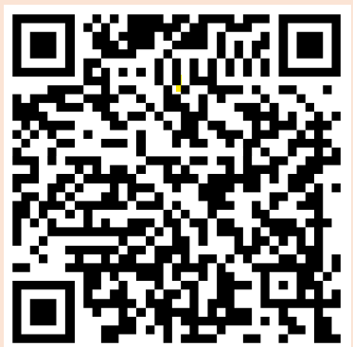

**How Do You Write an Informal Letter?**

An informal letter can be written in nearly any way you choose, but there are a few organizational guidelines you can follow if you are unsure of what to write or how to format your letter. The perfect informal letter consists of three sections:

***1.Opening***

***2.Body text***

***3.Closing***

There is one final part of an informal letter that does not need listed here: the signature, which consists of no more than a farewell remark and your name. Learn about each of the three main parts of an informal letter below.

**Opening**

The first step is addressing your reader. However, how do you address someone in English?This is fairly straightforward and is usually not as important as it would be with a business or formal letter. There are still a few things that you should know in terms of addressing someone properly in an informal letter.

First, British English does not employ the use of a period after abbreviated titles, but American English does.

•Mr Johnson (British English)

•Mr. Johnson (American English)

Secondly, if you are sending a letter to a married woman, the correct abbreviation is "Mrs," and if you are sending a letter to a non-married woman, the correct abbreviation is "Ms."

*Mrs. Johnson* is the **wife** of Mr. Johnson

*Ms. Johnson* and her **fiancé** will be married this summer

Choosing whether or not to use a title depends on how well you know the person to which the letter is addressed. If you are on very friendly terms, simply use their first name. The way in which you greet your reader is up to you. The examples below showcase some common greetings.

•***Dear Richard,***

***•Richard,***

***•Hi Richard,***

Be sure to never forget the comma after the name.

Finally, you have reached the part of the letter where you begin to write. Here, let your imagination run free. If you need some ideas to get started, some sample opening sentences are included below. Your opening should be casual and not as stiff as it would be if you were writing a professional or formal letter.

**The greeting/salutation**

•The greeting or salutation is written one line below the date, on the left hand of the page ended by the comma (,).

•The salutation used depends on how close you are to the person you are writing to

•***Dear ........*** is most often used and always correct. You can use it for anyone, from your mother to a new pen pal.

•***My dear........*** is used if you have a close relationship with someone, like your family or best friend.

****•***Dearest*** and ***My dearest........***are usually used only for people you love.

**Examples of Opening Sentences**

*How are you?*

*How have you been?*

*How is life treating you?*

*How are the kids?*

*I hope you are doing well.*

*I hope you, Mike, and the kids are having a great time in (location).*

**Opening Remarks:**

➢*How are you? I hope you are in the pink of health.*

*➢Thank you for your interesting letter.*

*➢I received your letter yesterday/ a few days ago.*

*➢What a surprise! It’s really good to hear from you.*

*➢How is everyone in the family? Well, I hope.*

*➢I am really glad to hear from you.*

*➢How are you? I am sorry I couldn’t write earlier.*

*➢This letter will probably come as a surprise to you.*

*➢What a pleasant surprise it was hear from you after such a long time.*

**Responding to Invitations/ Accepting Invitations:**

*I’d be glad to join you and your friends on the trip.*

*I’d love to come over to your house.*

*Thank you for your invitation. I’d be glad to come to your birthday party.*

*****Of course I would love to attend your brother’s weeding. Thank you for inviting me.*

**Declining Invitations:**

▪*Thanks for your invitation. However, I am sorry I will have to turn it down as I have already promise my father that I’d join him on a fishing trip.*

▪*Although I’d love to join you, I am sorry to say that I will not be able to make it.*

*▪I am sorry to inform you that I will not be able to attend your sister’s wedding.*

**To express Appreciation/ Gratitude:**

*Thank you for your advice.*

*It was really thoughtful of you to help us in our time of need.*

*How kind of you to think about us!*

*I truly appreciate your kindness.*

**To express thanking (thank you letter):**

•*Thank you so much for …*

*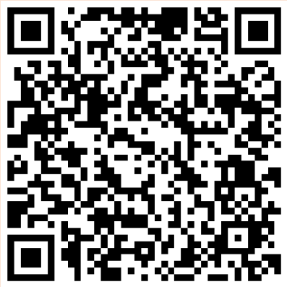•I want to thank you for …*

*•I want to express my gratitude …*

*•I am grateful for …*

*•I deeply appreciate …*

*•I feel touched that you …*

*•Your gesture was extremely …*

*•Your gift was incredibly …*

*•Your thoughtfulness was truly …*

**Keeping in Touch:**

*How long has it been since …*

*It has been ages since …*

*I cannot believe we have not heard from each other since …*

*I am sure you would be surprised to know that …*

*You may be interested to know that …*

*Can you recall the time when …*

*Do you remember when …*

**Body**

The contents of your letter should be written in a personal and friendly tone. However, it's important to adjust your use of language to the person you are writing to. A good way of assessing how you should write is to think about how you would interact with the person you are writing to in real life. Also, keep in mind that the people of England and America are fond of exchanging social niceties.

For example, they like asking a few polite questions "How are you?" or "How was your holiday?" In general, they are not as direct as most Europeans.

**Subjects to Include in the Body**

* ✓State your reason for writing
* ✓Expand on what you mentioned in the first paragraph
* ✓Ask about the person you are writing to
* ✓Make some concluding remarks
* ✓Invite the person to write back

**Closing**

**The closing is where you summarize your letter and say goodbye to the reader. The examples below offer some ideas of what to write in the closing section of your informal letter.

**Examples of Closing Sentences**

*I am looking forward to seeing you.*

*I can't wait to see you soon.*

*I can't wait to hear from you.*

*I am looking forward to hearing from you soon.*

*I hope to hear from you soon.*

*See you soon.*

*Send my love to...*

*I hope you are doing well.*

*Give my regards to...*

*That will be all for now. I shall write again when I have the time.*

*Please convey my warmest regards to your family.*

*Best wishes to you and your family.*

*Please give my love to Grandma.*

*Good luck in your coming examination.*

*Do write soon.*

*Do write again when you have the time.*

**Signature**

In terms of signing off, the choice is yours and you have a lot of freedom here. Below are some commonly used sign-offs that maintain a friendly, informal tone. After you've chosen one that fits the overall tone of your letter, simply sign your name.

**Examples of Signatures**



*•Best wishes,*

*•Best,*

*•Kindly,*

*•Kind regards,*

*•Best regards,*

*•Lots of love,*

*•Love,*

**Examples of the Informal Letters**

1.**You have received a letter from your English-speaking friend Julie who writes:**

…*You know, I’m preparing for my А-level exams. It’s so difficult to keep everything in mind. In England, the tutoring usually starts at least months before the date of examination. By the way, do you have the same practice in Russia? As for me, I have a special revision plan. What about you? Do you revise late at night before your exam?*

*As for my other news, we are going to redecorate our house.*

**Write a letter to Julie. In your letter**

•answer her questions;

•ask 3 questions about the house interior redecoration.

**Write 100-140 words. Remember the rules of the letter writing.**

*Dear Julie,*

*Thanks for your letter. I was so happy to get it. I am sorry for my late reply but I haven’t seen your post until now.*

*In your letter you asked me about the tutoring. Well, I asked for extra tutoring for the subjects I found difficulty in. It is important to get professional help before the exams.*

*Moreover, I have a revision timetable. Firstly, I never sit up late at night. Secondly, I start revising about six weeks before the exam.*

*I think any redecoration gives a new lease of life to a house. Have you chosen any wallpaper yet? Are you going to buy any new furniture? Do you usually search for house plans online?*

*Well, I must finish now. My friend is waiting for me.*

*Best wishes,*

*Helen*

2.**You have received a letter from your English-speaking friend Alice who writes:**

*... You know, I’m planning to sign up for a language course at our school I am aware that learning foreign languages takes time and dedication but as for me it is necessity. It happens that I am going to study in Spain. By the way, what is your favourite subject at school? How many English lessons a week do you have? What do you want to become?*

*As for my other news, next month I am going to Russia.*

**Write a letter to Alice. In your letter**

•answer her questions;

•ask 3 questions about her visit to Russia.

**Write 100-140 words. Remember the rules of the letter writing.**

*Dear Alice,*

*Thanks a lot for your letter. I was so happy to get it. I am sorry for my late reply but I haven’t seen your post until now.*

*In your letter you asked me about my favourite subject at school. Well, I love English. I believe that having a perfect command of English gives you more opportunities to find a highly-paid job. We have five English lessons a week. Besides, I master the language with my tutor. As for me, I want to become an interpreter. I hope to find a job in an international company and to be party to negotiations.*

*That’s great news about your coming to Ukraine! Which airport will you arrive at? What places of interest would you like to visit? Have you ever been to Lviv? I’m sure you’ll be greatly impressed by the beauty of my native country and kindness of its people!*

*Write back soon.*

*Love,*

*Inna*

**3.You have received a letter from your English-speaking friend Lisa who writes:**

*...Tomorrow I’m passing my first exam. Frankly speaking, I’m worried a bit. By the way, do you usually feel nervous before exams? Which subjects are you most prepared for? What are your plans for this summer?*

*As for my news, I’m going to Brazil next month...*

**Write a letter to Lisa. In your letter**

•answer her questions;

•ask 3 questions about her being a travel bug

**Write 100-140 words. Remember the rules of the letter writing.**

*Dear Lisa,*

*Thanks for your letter. I am sorry for my late reply but I haven’t seen you post until now.*

*In your letter you asked me about my exams. Well, I usually stay calm and focused. It is impossible to pass your exam successfully if you are preparing for it just a day before it.*

*As for my oncoming exam, English has always been my favourite subject. That’s why I shall undoubtedly succeed in my exam.*

*As for my holiday plans, I want to go to England and take a language course there.*

*By the way, have you ever been to Scotland? What is you dream country you would like to visit? Which countries have you visited so far?*

*I hope to hear from you soon.*

*Love,*

*Anna*

**4.You have received a letter from your English-speaking friend Michael who writes:**

*...You know, I want to study Spanish. I’m sure that my language skills will help me find a freelance job. Besides, this summer I’m going to Spain, where I will be able to practice Spanish with native speakers.*

*By the way, is it better to enroll for a language course or to find a private tutor? Which languages can you speak? How do you practice the language you are learning?*

*As for my other news, yesterday I watched the film that impressed me much.*

**Write a letter to Michael. In your letter**

•answer his questions;

•ask 3 questions about the film he liked

**Write 100-140 words. Remember the rules of the letter writing.**

*Dear Michael,*

*Thanks a lot for your letter. I was so glad to hear from you.*

*In your letter you asked me for advice. Well, I think it is more effective to study a language with a tutor than to sign up for a language course. A tutor will help you identify those areas in which you are weak and need special attention.*

*As for me, I can speak English and Spanish. Additionally, I can understand a little bit of German.*

*Talking about language practice, I consider socializing with native speakers is the best way to learn any language.*

*Oh, you’ve intrigued me with the film you saw before the day of writing this letter! What’s the title of the film? What is it about? Who directed the film?*

*Unfortunately, I’d better go now. Take care and keep in touch.*

*All the best,*

*Alex*

**5.You have received a letter from your English-speaking friend David who writes:**

*... You know, distance education in Great Britain is getting more and more popular nowadays. What about Russia? What are the advantages of distance learning? By the way, which university did you choose?*

*As for my other news, I am looking for a summer job.*

**Write a letter to David. In your letter**

•answer his questions;

•ask 3 questions about his job

**Write 100-140 words. Remember the rules of the letter writing.**

*Dear David,*

*Thanks a lot for your letter. I was so glad to hear from you.*

*In your letter, you asked me if distant learning is popular in Russia. Well, more than two million students are enrolled in distance learning programs. The statistics speak for themselves.*

*There are lots of benefits of online learning. Firstly, students can combine their job and studies. Secondly, you can simultaneously earn money and spend it for education. Thirdly, you can get education at any time and age.*

*As for me, I chose to apply for the University of Oxford. Wish me good luck. Have you found a job? How did you prepare for a job interview? Is it difficult to combine work and study?*

*Unfortunately, I’d better go now. Keep in touch.*

*All the best,*

*Alex*

**6.You have received a letter from your English-speaking friend Adam who writes:**

*... You know, my parents dislike my girlfriend because they don’t feel she is good enough for me. I’m trying to persuade them but every time I fail. What about your parents? Do they have control over your life? Do you often argue with your parents?*

*As for my other news, next week I’m going to attend a concert of a popular singer.*

**Write a letter to Adam. In your letter**

•answer his questions;

•ask 3 questions about the concert

**Write 100-140 words. Remember the rules of the letter writing.**

*Dear Adam,*

*Thanks a lot for your letter. It was nice to hear from you.*

*In your letter you told me that your parents disapprove of your girlfriend. Well, it happens very often.*

*Fortunately, I don’t have any conflicts with my parents. They get on well with my girlfriend. I always follow their advice because they have more life experience than I do.*

*However, if misunderstandings occur, we openly discuss any problems and try to come to a joint decision. My relations with parents are based on trust and mutual understanding rather than on domination or prohibition.*

*My congratulations on your going to the live concert! Have you ever attended any concerts? What is your favourite singer? Are you going there alone or with your friends?*

*I’d better go now. My friend is calling. Keep in touch.*

*Best regards,*

*Michael*

**7.You have received a letter from your English-speaking friend Mary who writes:**

*...You know, I am feeling emotionally drained. I’ve just quarreled with my dad. He is too exacting and stubborn. If you were me, how would you handle the situation? By the way, do your parents put a lot of pressure on you? What are your thoughts on “ideal parents”?*

*As for my other news, next month I am going to Italy on my holidays...*

**Write a letter to Mary. In your letter**

•answer her questions;

•ask 3 questions about her journey.

**Write 100-140 words. Remember the rules of the letter writing.**

*Dear Mary,*

*Thanks a lot for your letter. I was very happy to receive it. Sorry for my long silence but I have just returned from Spain.*

*In your letter you told me about your quarrel with your father. I understand your feelings.*

*If I were you, I would talk to him openly about everything.*

*As for my parents, I believe that they are the best ones and I am forever grateful. I can call my parents ideal. They are sincere, loving, careful and heedful of advice. They never put pressure on me. Otherwise, they always support me.*

*Will it be your first visit to Italy? Which sights are you going to visit? How long are you going to stay in Italy?*

*I am looking forward to your answer.*

*Love,*

*Anna*

**8.You have received a letter from your English-speaking friend Mary who writes:**

...You know; I want to live apart from my parents. It is a quite hard decision but I am sure all that happens, happens for the best. I want to be more independent and learn how to live life on my own. By the way, have you ever lived alone? Is it difficult to live apart from your family? What are the benefits of living alone?

As for my other news, we are going on a hiking trip.

**Write a letter to Mary. In your letter**

•answer her questions;

•ask 3 questions about the hiking tour

**Write 100-140 words. Remember the rules of the letter writing.**

*Dear Mary,*

*Thanks a lot for your letter. It was nice to hear from you.*

*In your letter you asked if I had ever lived alone. Well, last summer I stayed at home alone while my parents were on holidays.*

*I missed them much. As for me, moving out on your own is one of the toughest decisions. At first, you may feel lonely and confused but then you get used to it and feel more confident and independent.*

*As for benefits, you can do whatever you want and make your own decisions.*

*By the way, do you like hiking? Where do you like to go? Are you planning hiking alone or with a group?*

*I’d better go now. I’ve got lots of assignments to do. Keep in touch.*

*Best regards,*

*Anna*

9.**You have received a letter from your English-speaking friend Helen who writes:**

*... You know, my parents are demanding too much. They want to control every aspect of my life. They even try to influence my career choice. Do your parents impose their opinion on you? Do they affect your choice concerning your future career? Do your parents impose their unfulfilled dreams on you?*

*As for my other news, my parents gave me a laptop for my birthday.*

**Write a letter to Helen. In your letter**

•answer her questions;

•ask 3 questions about her birthday present

**Write 100-140 words. Remember the rules of the letter writing.**

*Dear Helen,*

*Thanks a lot for your letter. I was happy to hear from you.*

*In your letter you asked me if my parents influence my career choice. Well, we always make decisions together.*

*To my mind, if you want to find a career that fits you best, you should assess your skills, abilities and inclinations. As for my parents, sometimes they give advice but they are not overprotective and controlling.*

*Besides, it is absolutely wrong to impose aspirations on children. My wise parents are aware of generation gap and appreciate my position.*

*My congratulations on your getting a new gadget! Which laptop brand are you using? Would you prefer a laptop or a personal computer to use for your studies? When did you get your first computer?*

*I’d better go now. My mum is waiting for me.*

*Love,*

*Anna*

**10.You have received a letter from your English-speaking friend Mira who writes:**

*... You know, I am a bit upset. I have just quarreled with my parents. They make me work in the garden if I get bad marks. But frankly speaking, it breaks my motivation. What are your household chores?*

*Do you have enough time to help your parents? Do they punish you when you get bad marks?*

*As for my other news, my dad bought a new car yesterday.*

**Write a letter to Mira. In your letter**

•answer her questions;

•ask 3 questions about the car

**Write 100-140 words. Remember the rules of the letter writing.**

*Dear Mira,*

*Thanks a lot for your letter. I was glad to hear from you.*

*In your letter you asked me about my household chores. Well, I help my mom with cooking, ironing and washing up. Besides, I clean the dust, make the bed, and vacuum clean.*

*Honestly, I can’t say these chores are too difficult or take a lot of time. Just try doing it regularly!*

*Talking about bad marks, parents never punish me or tell me off. You see, I just don’t want to disappoint my parents who love me and want the best for me.*

*My congratulations! By the way, what colour is your dad’s car? Does your father let you drive his car? Can you drive a car?*

*I must fly. My friend is waiting for me. Take care and keep in touch.*

*Love,*

*Anna*

**11.You have received a letter from your English-speaking friend Diana who writes:**

*...I’ve got some news for you. Next Sunday we are going to celebrate my sister’s 15th birthday. I am a bit worried because I promised to organize a dream birthday party for her. I’ll do everything just to feel her happy. Is organizing parties your cup of tea? Do you like clubbing? Where do you usually have your birthday parties?*

*As for my other news, I have passed my driving test.*

**Write a letter to Diana. In your letter**

•answer her questions;

•ask 3 questions about the driving test

**Write 100-140 words. Remember the rules of the letter writing.**

*Dear Diana,*

*Thanks for your letter. I was so happy to hear from you.*

*In your letter you asked me if I like to organize parties. Well, I have never done it before but I’m a good helper. My friends always ask me to do different tasks like making a menu or sending birthday invitations.*

*Actually, I am a homester. I think staying at home is better than going to pubs or discos.*

*Talking about my birthday parties, I usually go on a picnic with my friends. We enjoy barbecue and play different games.*

*Congratulations on your passing a driving test! Was it a practice or a theory testing? How did you prepare for it? What age did you learn to drive?*

*I must fly now. My friend is waiting for me. Keep in touch.*

*Love,*

*Alexandra*

**12.You have received a letter from your English-speaking friend Mary who writes:**

*...You know, my friends always invite me out but I prefer to spend time with my family rather than to hang to with my friends. I’m much happier when I just stay at home doing nothing. What about you? How do you spend your leisure time?*

*What genre of movies do you like most? Can you cook?*

*As for my other news, I’m going to a summer camp this year…*

**Write a letter to Mary. In your letter**

•answer her questions;

•ask 3 questions about the summer camp

**Write 100-140 words. Remember the rules of the letter writing**

*Dear Mary,*

*Thanks for your letter. I was so glad to hear from you.*

*In your letter you asked me how I like to spend my free time. Well, I often go out if there is a party or go to the movies. Sometimes I go to cultural locations and events.*

*As for movies, I enjoy comedies and action films. I don’t like movies with lots of special effects. While watching a film, I usually try to escape the reality and to get the full story line.*

*You won’t believe but I’m crazy about cooking! It’s my cup of tea and I enjoy making something testy for my family and friends in my free time.*

*By the way, which summer camp activity do you like most? How long are you going to stay there? Will it be your first visit to this camp?*

*I must fly now. My friend is waiting for me. Take care and keep in touch.*

*Love,*

*Anna*

**13.You have received a letter from your English-speaking friend Mary who writes:**

... *I am off today. I am going to watch TV and play video games. I am not a couch potato and have lots of hobbies such as horse riding, swimming and skiing, but there are days when I want to spend some time in peace and quiet. By the way, what are your favourite TV programs? Do you like to surf the net? What do you usually do to lift up your spirits?*

*As for my other news, on Sunday I am going to have a dinner party.*

**Write a letter to Mary. In your letter**

•answer her questions;

•ask 3 questions about the cake

**Write 100-140 words. Remember the rules of the letter writing.**

*Dear Mary,*

*Thanks for your letter. It was so nice to hear from you.*

*In your letter you asked me about my favourite TV programs. Well, I like to watch the news, as well as some political and sports programs. I also enjoy watching soap operas and reality TV.*

*As for surfing the net, I enjoy chatting with my friends on social networking sites and playing online games. But if I want to unwind, I always turn up the volume and listen to soulful melodies as “nothing hits your heart like soul music.”*

*Do you like having people for dinner? Are you going to have a dinner party on a special occasion? How many guests have you invited yet?*

*I must run now. My friend is waiting for me. Take care.*

*Love,*

*Angela*

**14.You have received a letter from your English-speaking friend Mary who writes:**

*... Today I am going out with my friend. Frankly speaking, I am not the stay-at- home sort. I often go to night clubs and restaurants with my friends. Do you prefer restaurant or home-cooked meals? Do you often go to restaurants? What is your attitude towards fast food?*

*As for my news I am going to find a part-time job ...*

**Write a letter to Mary. In your letter**

•answer her questions;

•ask 3 questions about her job

**Write 100-140 words. Remember the rules of the letter writing.**

*Dear Mary*

*Thanks for your letter. I was so happy to receive it. How are your parents? Pass them my greetings.*

*In your letter you asked me about my food preferences. Well, I enjoy cooking. I guess that home-cooked meals are much cheaper and tastier than restaurant food. Frankly speaking, I go to restaurants only on special occasions. I prefer cosy home atmosphere to formal eating out.*

*I’m sure, fast food is unhealthy. It has high caloric value which can lead to overweight and obesity. I believe that keeping fit and leading a healthy lifestyle is important for everyone.*

*Well done! I support your idea of getting a part-time job. What sphere would you like to work in? Will it be possible to combine your work and studies? Do you feel nervous before an interview?*

*Write back soon.*

*Love,*

*Lisa*

**15.You have received a letter from your English-speaking friend Frank who writes:**

*... You know, I am writing a report on the meals in England to give out Russian-speaking visitors. I have to make a survey and need your help. Here are some questions that may help me with the research. I’d be very grateful! Are you ready? Do you know how many meals a day have the English? What information do you have about a traditional English breakfast? What is the Sunday Roast Dinner?*

*As for my other news, my parents have bought me the new recent iPhone model.*

**Write a letter to Frank. In your letter**

•answer his questions;

•ask 3 questions about his iPhone

**Write 100-140 words. Remember the rules of the letter writing.**

Dear Frank,

*Thanks for your letter. I was glad to hear from you.I hope I can help you with this issue. Well, there are four meals a day in England: breakfast, lunch, afternoon tea and supper.*

*As for traditional English breakfast, it usually consists of bacon, eggs, sausages, fried bread and baked beans. Some Englishmen prefer toasts with marmalade, a bowl of cereals together with a cup of coffee or tea with milk.*

*As regards the Sunday Roast Dinner, it is traditionally served on Sundays and consists of roast meat, potatoes and vegetables together with accompaniments such as Yorkshire pudding.*

*Congratulations! Are you happy with the purchase? Is it easy to use? What kind of case do you have on your iPhone?*

*I must fly now. Keep in touch.*

*Best regards,*

*Anton*

**16.You have received a letter from your English-speaking friend Mary who writes:**

*... You know, I do like surprises. Now I’m going to cook a festive dinner for my parents. I have already decorated my house and put lots of candles everywhere. It will be fun, believe me. By the way, what is the most popular food in Russia?*

*Can you cook? What is your favourite dish?*

*As for my other news, my parents got me a puppy for Christmas.*

**Write a letter to Mary. In your letter**

•answer her questions;

•ask 3 questions about her puppy

**Write 100-140 words. Remember the rules of the letter writing.**

*Dear Mary,*

*Thanks for your letter. I was glad to hear from you.In your letter you asked me about the most popular Russian food.*

*Well, here are some dishes which are on the menu in almost all households. Some of our favourite national dishes are borsch, cabbage rolls, pancakes with jam, vinaigrette, kvass and okroshka. Russians like treating their guests with vareniky – stuffed dumplings with mashed potato, cheese or cherries, depending on one’s taste.*

*As for my cooking skills, I learned how to cook in early childhood. Actually, cooking is my cup of tea.As regards my favourite meal, it is Russian meat jelly or “holodets”, which is also my personal signature dish.*

*Congratulations! Are you happy? Have you decided how to call your dog? How many times a day do you walk your dog?*

*I must fly now. My friend is calling. Take care.*

*Best regards,*

*Anna*

**17.You have received a letter from your English-speaking friend Lisa who writes:**

*...You know, my friend invited me for a dinner to her house. Frankly speaking, I am not the stay-at-home sort. I’d prefer to go out rather than sit at home. Which cuisine do you prefer most? Do you prefer to have meals alone or with lots of people? What is your favourite meal of the day?*

*As for my other news, I have just joined a sport club.*

**Write a letter to Lisa. In your letter**

•answer her questions;

•ask 3 questions about sport

**Write 100-140 words. Remember the rules of the letter writing.**

*Dear Lisa,*

*Thanks for your letter. I was glad to hear from you.*

*In your letter you asked me about my favourite cuisine. Well, Italian cuisine is definitely my cup of tea. I absolutely love pizza and pasta. My second favourite is French cuisine with its delicious cream-based sauces and hot chocolate.*

*I often eat out but there is nothing better than a homemade food. You know, our family has a tradition: we always have meals together. It really helps us to come close to each other.*

*As for my favourite dish, it is, of course, an apple pie. I’ve been taught to cook it by my granny, and everyone in my family asks me to bake it almost every Sunday!*

*How often do you exercise? Do you go to the gym to lose weight? What is the most popular summer sport in England?*

*I must fly now. My mom is waiting for me.*

*Love,*

*Anna*

**18.You have received a letter from your English-speaking friend Caroline who writes:**

*...You know, I am fasting for the first time. Actually, it is not about losing weight. As for me, Lent teaches tolerance and patience. Have you ever fasted in your life? What foods are allowed and forbidden for Lent? What do you usually eat during Lent?*

*As for my other news, I’ve decided to find a summer job.*

**Write a letter to Caroline. In your letter**

•answer her questions;

•ask 3 questions about her job

**Write 100-140 words. Remember the rules of the letter writing.**

*Dear Caroline,*

*Thanks for your letter. I was glad to hear from you.*

*In your letter you asked me about Lent. As for me, I follow the lent diet for forty days.*

*It is not allowed to eat animal food such as meat, poultry, eggs and some dairy produce. As for foods allowed during Lent, you may eat vegetables, fruit, rice, honey, etc.*

*Personally, I’m a huge fan of fruit. Every morning I cook an oil-free porridge on water and have it with tea and dried biscuits, honey and nuts. I also love grilled vegetables or mushrooms.*

*Is it easy to find a summer job in England? Are you preparing for an interview? What is your dream job?*

*I must fly now. My friend is waiting for me.*

*Best regards,*

*Helen*

**19.You have received a letter from your English-speaking friend Monica who writes:**

*... Today I am going to the party. You know; it is very difficult to choose a dress that fits your body perfectly. By the way, what do you usually wear when you go to parties? What style in clothes do you prefer in everyday life? Are you interested in fashion?*

*As for my other news, I’m looking forward Christmas…*

**Write a letter to Monica. In your letter**

•answer her questions;

•ask 3 questions about Christmas in England

**Write 100-140 words. Remember the rules of the letter writing.**

*Dear Monica,*

*I was so glad to get your letter. I am sorry for my long silence but I have just come back from Spain.*

*In your letter you asked me about party clothes. Well, I prefer wearing high heels and cocktail dresses. Moreover, I love smart rompers and stylish suits.*

*As for casual clothes, the most important thing is to feel comfortable. That’s why I usually wear jeans, sneakers and T-shirts.*

*Frankly speaking, I’m definitely a fashion addict. I try to follow the latest trends in fashion reading fashion magazines and watching runway shows.*

*By the way, how are you going to celebrate Christmas? What presents do you like to get? What is your favourite holiday?*

*I’ve got to go now. Take care and keep in touch.*

*Lots of love,*

*Helen*

**20.You have received a letter from your English-speaking friend Demy who writes:**

*... Frankly speaking, I am a bit nervous. I am choosing a dress for my school- leaving party. It is so exciting. By the way, have you already found your perfect outfit? Will you miss your schoolmates and teachers? Have you chosen your future profession?*

*As for my other news, I have found a summer job.*

**Write a letter to Demy. In your letter**

•answer her questions;

•ask 3 questions about her job

**Write 100-140 words. Remember the rules of the letter writing.**

*Dear Demy,*

*Thanks for your letter. I am sorry for my late reply. I was so busy the last few days. In your letter you asked me about the outfit for my school-leaving party. Well, I’ve bought a wonderful dress with matching shoes. I look like a princess in it.*

*However, most of the time I think about my future profession. Confucius said, “Choose a job you love, and you will never have to work a day in your life.”*

*My future job will surely give me a chance to fulfill myself. You see, I don’t want to reveal my choice now but you’ll be the first person to hear it after my exams will have been passed! When I leave school, I will definitely miss my teachers and friends.*

*Do you like your job? What are your duties? How many hours a week do you work? I’ve got to go now. Take care and stay in touch.*

*Love,*

*Lisa*

**21.You have received a letter from your English-speaking friend Mira who writes:**

*...Next week I am going to a carnival party. I want to be the best-dressed guest. To be honest, I am a fashion addict. I can’t live without shopping. But I have one small problem. When I’m in bad mood I even can end up buying lots of useless things. By the way, how often do you usually go shopping for clothes? Do you have any favourite fashion labels? What is your perfect outfit?*

*As for my other news, I have just spoken to my former classmate.*

**Write a letter to Mira. In your letter**

•answer her questions;

•ask 3 questions about her classmate

**Write 100-140 words. Remember the rules of the letter writing.**

*Dear Mira,*

*Thanks for your kind letter. I was glad to hear from you.*

*In your letter, you asked me how often I usually go shopping. Well, I only prefer online shopping because it is convenient and easy.*

*It’s so easy to do. All you need is to browse the style you want to purchase, add goods into your shopping bag and make a payment. I do the shopping quite often, at least twice a month.*

*As for my favourite fashion labels, I prefer Italian branded clothing, as for instance, Brunello Cucinelli. Talking about my perfect outfit, it is definitely my little black dress with luxurious pumps.*

*How long is it since you last saw your classmate? Are you still friends with your former schoolmates? Do you miss them?*

*I must fly now. Keep in touch.*

*Love,*

*Lisa*

**22.You have received a letter from your English-speaking friend Mary who writes:**

*... You know; I want to devote my life to fashion. Now I am just reading fashion magazines and books about style and beauty. However, in a couple of days I'll become a fashion design student. Are you interested in fashion? Do you have a lot of clothes? Do you follow the latest fashion?*

*As for my other news, I have just returned from Greece.*

**Write a letter to Mary. In your letter**

•answer her questions;

•ask 3 questions about her trip

**Write 100-140 words. Remember the rules of the letter writing.**

*Dear Mary,*

*Thanks for your letter. I was glad to hear from you. I am sorry I couldn’t answer straight away but I’ve just seen your post.*

*In your letter you asked me about fashion. Well, I am neither a fashion addict nor a shopaholic, but I enjoy watching catwalk shows and read glossy magazines.*

*I think clothes and colours must fit the occasion they are worn. So, in my wardrobe there are sleeping garments, school uniform, casual clothing, sportswear, house- wear and Sunday wear.*

*Undoubtedly, like every girl, I do my best to look fashionable and stylish.*

*What are your impressions of the country and Greek people? What souvenirs have you bought? Are there many places of interests in Greece?*

*I must fly. My friend is calling.*

*Love,*

*Lisa*

**23.You have just received a letter from your English-speaking friend Stephanie who writes:**

*...You know, yesterday at the fashion show I fell in love with the shoes. When I came back home, I surfed the Net but couldn’t find them anywhere. These shoes are the height of fashion. By the way, what kind of clothes do you usually wear?*

*Is it possible to look fashionable without spending a fortune on luxurious clothes? Are there many shopping centres in Russia?*

*As for my other news, this week I am going to the swimming pool. Now it is my favourite hobby and the best way to unwind.*

**Write a letter to Stephanie. In your letter**

•answer her questions;

•ask 3 questions about her new hobby

**Write 100-140 words. Remember the rules of the letter writing.**

*Dear Stephanie,*

*Thanks for your letter. I was glad to hear from you.*

*In your letter you asked me about my clothes. Well, I prefer casual style. Every new season I can’t stop myself from buying must-have jeans or fashionable sneakers.*

*To be honest, I never wear old-fashioned clothes. I think it is more important to have a sense of style rather than to wear the latest fashion. Personally, I know how to mix and match different items that go together.*

*As regards shopping malls, there are lots of them in the area I live. They offer off- the-peg clothes, accessories, cosmetics, shoes, etc.*

*How many times a week do you go to the swimming pool? Are you a good swimmer? Can you swim underwater?*

*I must fly now. Keep in touch.*

*Love,*

*Anna*

**24.You have received a letter from your English-speaking friend Caroline who writes:**

*...I’ve got to go now. My friend is waiting for me and we are going to the library. By the way, are you fond of reading? What genres do you like most of all? What is your favourite book?*

*As for my plans for the weekends, I want to unwind at the cinema…*

**Write a letter to Caroline. In your letter**

•answer her questions;

•ask 3 questions about her free time preferences

**Write 100-140 words. Remember the rules of the letter writing.**

*Dear Caroline,*

*I was happy to get your letter. How are you getting on? I hope everything is going well.*

*In your letter you asked me about books. Well, reading plays an important role in my life. Books are a great source of information, enlightenment and knowledge.*

*To tell the truth, I’m a book warm! I like almost all genres of books. However, most of all I love science fiction, novels, detective and horror stories.*

*My favourite book is definitely “Heaven has no favourites” by Remarque. This book teaches us to appreciate every breath we take and every moment we live.*

*By the way, how do you usually spend your free time? Do you prefer cinema or theatre? What is your favourite film?*

*I’ve got to go now. I must prepare for my exams. Take care and keep in touch.*

*Love,*

*Alice*

**25.You have received a letter from your English-speaking friend Mary who writes:**

*...I’m going to the library now. I want to find a real page-turner! Do you like e- books? Do you often read before going to sleep? Do you usually read book reviews?*

*As for my other news, my friend John has just returned from Japan.*

**Write a letter to Mary. In your letter**

•answer her questions;

•ask 3 questions about her friend’s trip

**Write 100-140 words. Remember the rules of the letter writing.**

*Dear Mary,*

*Thanks for your letter. I was glad to hear from you.*

*In your letter you asked me about digital books. Well, I like both e-books and printed ones. When it comes to new books, I always buy hardback editions. I like to hold a real book in my hands.*

*To be honest, I can’t live without bedtime reading. In this case, I prefer to read an e- book. It is very convenient, especially when everybody else is asleep or you have insomnia.*

*Talking about book reviews, I often read them carefully but anyhow I always rely on my own opinion.*

*Well, well, well. What souvenirs has your friend brought you? What are his impressions about Tokyo? Are you dreaming to go to Japan?*

*I must fly now. Keep in touch.*

*Love,*

*Diana*

**26.You have received a letter from your English-speaking friend Helen who writes:**

*...To be honest, I am not a cinemagoer. As for me, I enjoy watching movies with popcorn and cola at home. My friends make fun of me and call me “couch-*

*potato” but I don’t care because I know they are just kidding. By the way, how often do you go to the cinema? Do you prefer reading books or watching films? How important is a film score when watching a movie?*

*As for my other news, I’ve bought a beautiful dress.*

**Write a letter to Helen. In your letter**

•answer her questions;

•ask 3 questions about her dress

**Write 100-140 words. Remember the rules of the letter writing.**

*Dear Helen,*

*Thanks for your letter. I was glad to hear from you.*

*In your letter you asked me how often I go to the movies. Well, it doesn’t happen very often, only when my friends ask me out.*

*To be honest, cinemagoers enjoy a wealth of choices, including blockbusters and high budget films.*

*However, I am more a big-reader than a cinemagoer. There are lots of my favourite books which are real page-tumers. As for a film score, it makes no difference to me. Sometimes low-budget films are much more interesting than box-office hits.*

*Congratulations! What’s the colour of your new dress? Is it a prom dress? Have you bought matching shoes yet?*

*I must fly now. Take care and keep in touch.*

*Love,*

*Lisa*

**27.You have received a letter from your English-speaking friend Johanna who writes:**

*...You know, I can’t live without books. They are my best teachers. I have a huge library at home where I spend all my free time. How do you choose which book to read? Is there any book which you have reread several times? Do you read one book at a time, or several simultaneously?*

*As for my other news, yesterday my dad let me drive his car.*

**Write a letter to Johanna. In your letter**

•answer her questions;

•ask 3 questions about the car driving

**Write 100-140 words. Remember the rules of the letter writing.**

*Dear Johanna,*

*Thank you for your letter. I was glad to hear from you.*

*In your letter you asked me how I usually choose a book to read.Well; I usually try to find a book that suits my mood.*

*To be honest, there are books that I enjoy so much that I pick up every now and then and reread them from cover to cover. One of them is “Three comrades” by Remarque. Every time I read it I learn something new for myself.*

*Usually I am engrossed in reading one book. So, I can’t read several books simultaneously.*

*How interesting! What age can you get a license in your country? Who taught you to drive? How long did it take you?*

*I must fly now. Keep in touch.*

*Love,*

*Angela*

**28.You have received a letter from your English-speaking friend Helen who writes:**

*...I’m going to the cinema with my friend. It is a box-office hit of all times. By the way, what sort of films do you enjoy? Do you usually watch a trailer before watching a film? What is your favourite film?*

*As for my other news, next month I am going to visit Russia*.

**Write a letter to Helen. In your letter**

•answer her questions;

•ask 3 questions about her oncoming visit

**Write 100-140 words. Remember the rules of the letter writing.**

*Dear Helen,*

*Thanks for your letter. I was glad to hear from you.*

*In your letter you asked me about my favourite genres films. Well, I like action films with car chases and fights, thrillers, westerns and romcoms.*

*To be honest, I always try to catch the latest movies and watch a trailer to see some special effects and who is in the cast.*

*Besides, I read reviews to know more about the plot. As for my favourite movie, it’s “You are not you” starring Hilary Swank. It is pathetic and true-to-life.*

*I am so happy that you will come soon. What sights do you want to see? How long will you be staying in Russia? Will you come alone or with your sister?*

*I must run. See you soon.*

*Love,*

*Anna*