Методическая разработка внеклассных мероприятий

предметная неделя

иностранных языков в школе



**Неделя иностранных языков**

**План мероприятий**

|  |  |  |  |
| --- | --- | --- | --- |
| **день** | **мероприятие** | **класс** | **время** |
| ***понедельник***  ***23 января*** | ***Оформление школы*** | ***11Б***  ***9В*** | ***20.01*** |
| ***Просмотр мультфильмов на английском языке*** | ***2-5*** | ***в течение дня*** |
| ***Конкурс рисунков «Праздники Британии»*** | ***6*** | ***в течение дня*** |
| ***Выставка поделок (подведение итогов)*** | ***2-11*** | ***в течение дня*** |
| ***вторник***  ***24 января*** | ***Конкурс «Занимательная грамматика»*** | ***5-6*** | 9.40 ***к № 22*** |
| ***7-8*** | 9.40 ***к № 26*** |
| ***9-10*** | 9.40 ***к № 16*** |
| ***Конкурс стихотворений на английском языке*** | ***5*** | ***11.40 ММЦ*** |
| ***Флэшмоб*** | ***5-6*** | 9.40 ***ММЦ*** |
| ***Поем на английском*** | ***2*** | ***в течение дня*** |
| ***среда***  ***25 января*** | ***Страноведческая викторина*** | ***7-8*** | 9.40 ***к № 26*** |
| ***9-10*** | 9.40 ***к № 16*** |
| ***Викторина «Карусель» (кроссворды, головоломки, ребусы, загадки)*** | ***5-6*** | 9.40 ***к № 22*** |
| ***Лотерея «Кот в мешке»*** | ***3*** | ***в течение дня*** |
| ***четверг***  ***26 января*** | ***Квест-игра «I like English»*** | ***10-11*** | ***в течение дня; к № 22, 16, 32, 26*** |
| ***Тематический альманах «Musical Day with the Beatles»*** | ***8*** | ***в течение дня (26.01 -27.01)*** |
| ***Раскраски со стихами.*** | ***2*** | ***в течение дня*** |
| ***пятница***  ***27 января*** | ***Викторина «Что мы знаем об Англии»*** | ***4*** |  |
| ***Джек Лондон. Рассказы на английском языке*** | ***9*** | ***в течение дня (26.01 -27.01)*** |
| ***Конкурс чтецов (немецкий язык)*** | ***9*** | ***10.40 к № 32*** |
| ***Конкурс стенгазет. Подведение итогов*** | ***2-11*** |  |
| ***Подведение итогов*** |  |  |

Дорогие ребята!

***С 23 по 27 января в нашей школе объявлена неделя английского языка!***

***Вас ждут удивительные путешествия по странам, встреча с любимыми героями мультфильмов и сказок, конкурсы, много музыки, танцев, смеха, хорошего настроения и, конечно, награды!***

***К участию приглашаются ученики 2-11 классов.***

*Приложение 1*

***English   proverbs  &  sayings***

**Actions speak louder than words. – Дела говорят лучше, чем слова.**

**All days are short to Industry and long to Idleness. – В работе время бежит быстро.**

**An apple a day keeps the doctor away. – Одно яблочко в день, и к доктору не ходи. (В здоровом теле – здоровый дух)**

**An Englishman's home is his castle. – Мой дом – моя крепость**

**A change is as good as a rest. – Перемена (смена) работы так же хороша, как и отдых.**

**A friend in need is a friend indeed. - Настоящий друг познается в беде**

**A good beginning makes a good end. – Хорошее начало – полдела сделано.**

**A good conscience is a soft pillow. – С чистой совестью спится легко.**

**As you sow, so shall you reap. – Что посеешь, то и пожнешь.**

**Better late than never. – Лучше поздно чем никогда.**

**Clothes don't make the man. – Одежда не создает человека.**

**Every man is the architect of his own fortune. – Каждый строит свою судьбу сам.**

**Experience is the father of wisdom. – Опыт - отец мудрости.**

**He can who believes he can. – Сможет тот, кто верит в себя**

**Home is where the heart is. – Твой дом там, где твое сердце.**

**Knowledge in youth is wisdom in age. – Знания в юности – мудрость в старости.**

**Knowledge is power. – Знание сила.**

**Look before you leap. – Смотри пред тем, как прыгать.**

**No smoke without fire. – Нет дыма без огня.**

**No wind, no waves. – Нет ветра – нет волн.**

**Patience is a virtue. – Терпение – это достоинство.**

**The first step is the hardest. – Первый шаг – самый трудный!**

**Wisdom is better than strength. – Ум лучше, чем сила.**

**You are never too old to learn. – Учиться никогда не поздно.**

**Saying is one thing, doing is another. – Говорить – это одно, а делать – это другое.**

***Riddles (загадки)***

**1. It runs but has no legs.**

**2. It’s black when it’s clean.**

**3. It has teeth but it can’t bite.**

**4. Children don’t like to drink especially when it’s warm.**

**5. It is white. It is cold.**

**6. We can skate on it. What is it ?**

**7. What man cannot live inside the house?**

**8. An old man with twelve children.**

**Some short, some long, some cold, some hot.**

**What is he?**

**9. What goes up when the rain comes down?**

**10. He is not a tailor but carries needles with him.**

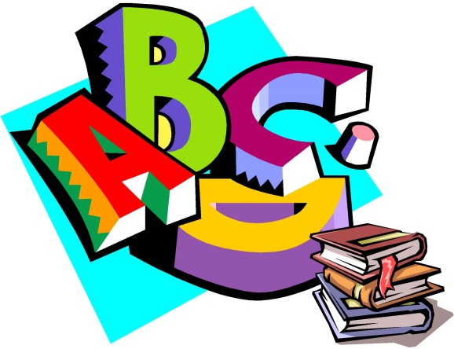

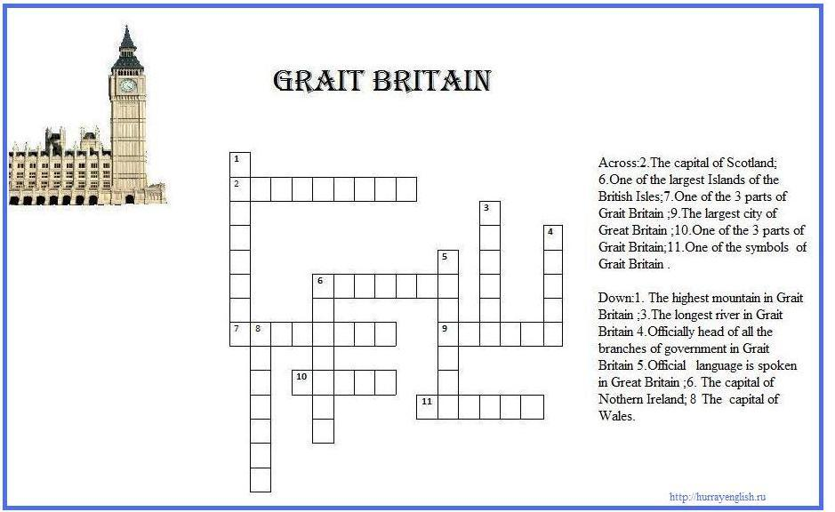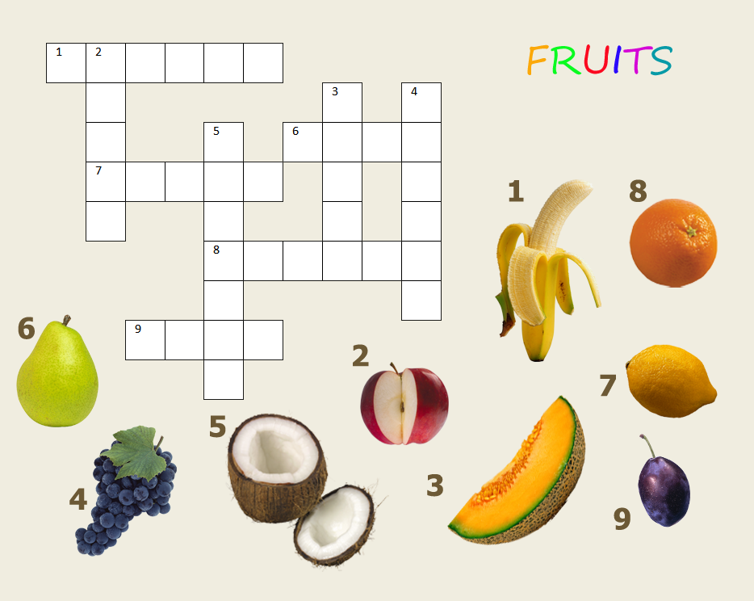

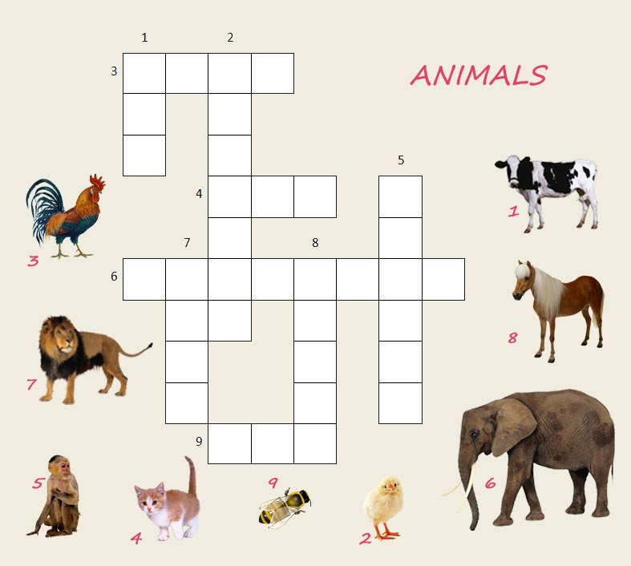

***Напиши зашифрованные слова. За каждой цифрой скрывается буква, а цифра указывает порядок этой буквы в алфавите. Смотрите пример.***

***За каждое слово – 2 балла.***

ПРИМЕР: 26 +15 + 15 = zoo

* 2 + 15 + 24 = ________________
* 2 + 9 + 18 + 4 = ________________
* 23 + 9 + 14 + 20 + 5 + 18 = _____________
* 20 + 8 + 1 + 14 + 11 = ________________
* 3 + 1 + 18 + 16 + 5 + 20 = ________________
* 19 + 14 + 15 + 23 = ________________
* 13 + 9 + 14 + 21 + 20 + 5 = ________________
* 16 + 15 + 19 + 20 + 3 + 1 + 18 + 4 + 19 = _____
* 11 + 9 + 20 + 3 + 8 + 5 + 14 = ________________
* 14 + 5 + 23 25 + 5 + 1 + 18 = _____________

***Зачеркни лишнее слово. За каждое верно зачеркнутое слово – 2 балла.***

* House, home, school, farmhouse.
* Flower, table, plant, tree.
* Cabbage, carrot, tomato, banana.
* Picture, pen, book, pencil.
* Pie, ham, cake, sweet.
* Visit, play, bed, enjoy.
* Minutes, wall, hours, time.
* Hot, warm, foggy, sun.
* Beautiful, ugly, nice, lovely.
* First, second, three, fourth.
* Girl, horse, dirty, shirt, bird.

***Поставьте слова в правильный порядок, чтобы получились логичные предложения.***

***За каждое правильное предложение – 5 баллов.***

***Если будет допущена одна ошибка – 2 балла, при двух и более ошибок – 0 баллов.***

* At the table, write, this, and, letter, sit. –___________________________________________
* Is, old, in, clock, there, an, my, room. –____________________________________________
* Are, house, no, our, in, pictures, there –____________________________________________
* Often, my, friend, me, visit. –____________________________________________________
* To his, long, Hobbit, friends, writes, letters. –_______________________________________
* Has, new, Ben, computer, a. –­___________________________________________________
* A dog, to have, I, like, would. – _________________________________________________
* Bigger, than, the road, is, the path. –______________________________________________
* In the, a monkey, zoo, lives. –___________________________________________________
* He, go, where, on Mondays, does? –______________________________________________
* Don’t, swim, but, rabbits, jump, like to, they, like to. –________________________________

***СКОЛЬКО ВРЕМЕНИ? Напишите цифрами время, которое у вас прописано прописью. За каждое правильно написанное время – 5 баллов.***

1. It is ten minutes past twelve - ______________________________
2. It is a quarter to eight - ______________________________
3. It is half past three - ______________________________
4. It is twenty four minutes past one - ______________________________
5. It is thirty two minutes to five - ______________________________
6. It is sixty seconds past seven - ______________________________
7. It is forty three minutes to eleven - ______________________________
8. It is fifty five minutes past nine - ______________________________
9. It is five minutes to two - ______________________________
10. It is a quarter past one - ______________________________
11. It is half past twelve - ­_______________________________
12. It is five minutes to eight - ____________________________

***Составь предложения, вставив нужные гласные буквы***

***(пропущены все гласные, кроме гласной “a”).***

***Если в предложении не будет допущено ошибок- 5 баллов (за каждое предложение), если одна ошибка- 3 балла, если от двух и более ошибок – 0 баллов.***

* Th__r__ __s a b__rd __n th__ tr ____.
* H__w man__ fl__w__rs ar__ th__r__ __n th__ p__an___?
* L__ttl__ ch__ldr__n l__k__ c__rnflak__s and j____c__.
* Jack has a p__ct__r__, a c__pb____rd w__th b____ks __n h__s r____m.
* Th__r__ __s a b__a__t__f__l fl__w__r __n th__ tabl__.
* Sh__ saw a sh____p __n th__ c____ntr__.
* H__ h__lps h__s m__th__r .
* You can r__d__ a str__ng and brav__ h__rs__.
* Th____ f____d l__ttl__ rabb__ts.
* Th__r__ ar__ f__v__ cha__rs __n th__ k__tch__n.
* W__ l__k__ t__ g__ t__ th__ park w__th d__gs.
* Ar__ th____ at h__m__?
* Wh__t d____s h__ l__k__ t__ r____d?

***Опиши мультгероя.***

***Опиши его внешность, характер и увлечения, глядя на изображение. За одно правильно составленное предложение (без грамматических и речевых ошибок) – 5 баллов. Если будут допущены ошибки, то от этих пяти баллов будет убираться по баллу за ошибку.***

***Ваш мультгерой:***

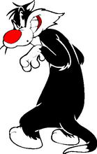

Приложение 3

*Викторина для 5-7 классов*

*“Do you know the Great Britain?”*

1. How many parts are there in the Great Britain?
2. What river is the capital situated on?
3. Who is the head of the country?
4. What is the home of the Queen?
5. What is the double-decker?
6. What is Big Ben?
7. What is the symbol of England?
8. Where did the detective Sherlock Holmes live?
9. What is the most famous lake in Scotland?
10. Why is the city Bath called so?
11. Who is the most famous woman-writer of detective stories?
12. What books of English writers do you know?
13. What is the oldest part of London?
14. What is the symbol of Scotland?
15. What is the symbol of Wales?
16. What is the Scottish national costume?
17. What is the national instrument of Scots?
18. When do British people celebrate Christmas?
19. Who wrote about Winnie the Pooh?
20. Who is the writer of “Mary Poppins”?
21. Who is the author of books about Harry Potter?
22. Can you guess:

* He was English. He was born in 1564. He was a writer and actor. *(W. Shakespeare)*
* He was born in London. Then he lived in the USA. He was a film actor *(Ch. Chaplin)*
* He conquered Great Britain. He was a king. He built the Tower of London *(William the Conqueror)*

*Викторина для 8 - 9 классов*

*“Do you know the USA?”*

1. What is the name of the Dutch settlement which became New York City?
2. Which country presented the USA with the statue of Liberty? What was the occasion?
3. In which famous place do people in New York City celebrate New Year’s Day?
4. Which American rock-and-roll star lived in Memphis, Tennessee?
5. What monument in Washington D.C. dedicated to an American President is nicknamed “The Pencil”?
6. What is the name of the famous collection of museums in Washington?
7. Explain the symbolism of the stars and stripes on the US flag.
8. On what river is the capital of the USA situated?
9. Where does the President of the USA live and work?
10. Which is the biggest state in the USA?
11. Who was the 1st President of the USA?
12. What do the Americans celebrate on the 4th of July?
13. In which city is Hollywood?
14. What street in New York is called “The Great White Way”?
15. What is the highest building in Washington?
16. Who was the 1st President lived in the White House?
17. What is the largest city in the USA?
18. In which state do the highest trees in the world grow? What are they called?
19. Which is the smallest state in the USA?
20. Who is the President killed by Oswald?
21. The first colonists started the tradition of a) Halloween, b) Independence Day, c) Thanksgiving Day, d) Memorial Day.
22. Who was the 42d President: a) Clinton, b) Kennedy, c)Johnson, d) Washington

*Викторина для учащихся 10-11 классов*

*“Do you know Australia?”*

1. What kind of state is Australia?
2. Who is the Head of Government?
3. Who is the Head of the State?
4. What colour is the flag of Australia?
5. Which are the national colours?
6. Where is the seat of the state government located?
7. How many chambers are there in the Australian Parliament?
8. Which city was the capital of Australia till 1917?
9. What are the languages in Australia?
10. What animals can be seen on Australia’s coat-of-arms?
11. Which is the hottest month of Australia?
12. Which is the highest point in Australia?
13. Which is the longest river in Australia?
14. What are the largest cities of Australia?
15. When was the first white settlement founded in Australia?
16. Who sailed to Botany Bay first?
17. When did the constitution come into effect?
18. When did the first shipload of free immigrants arrive?
19. Who was the first European settles in Australia?
20. Who discovered Australia?
21. What is the official name of Australia?
22. When do the Australians celebrate Australia’s Day?